3. Assessment of the Sablefish Stock in Alaska

Daniel R. Goethel, Matthew L.H. Cheng, Katy B. Echave, Craig Marsh, Cara J. Rodgveller, Kalei Shotwell, and Kevin Siwicke

November 2023

This report may be cited as:

Goethel, D.R., Cheng, M.L.H., Echave, K.B., Marsh, C., Rodgveller, C.J., Shotwell, K., and Siwicke, K. 2023. Assessment of the sablefish stock in Alaska. North Pacific Fishery Management Council, Anchorage, AK. Available from: Available here.

The last operational full assessment for sablefish was in 2021 and a full description of the final model *21.12* can be found in the 2021 SAFE document:

<https://www.fisheries.noaa.gov/resource/data/2021-assessment-sablefish-stock-alaska>

The following documents are associated with this report and can be found at the associated links:

**Appendix 3C. Ecosystem and Socioeconomic Profile** **(ESP)**: Available here

**Appendix 3D. Sablefish Bycatch in the Eastern Bering Sea**: Available here

**Appendix 3E. Catch Rates and Observations from the Fixed Gear Fleet**: Available here

**Appendix 3F. Observer Coverage and Sampling of the Sablefish Stock**: Available here

Executive Summary

Summary of Changes to the Assessment

Minor updates to data inputs and model structure were integrated into the sablefish (*Anoplopoma fimbria*) assessment for 2023 to align with AFSC assessment good practices, address comments from the North Pacific Fisheries Management Council’s (NPFMC) Science and Statistical Committee (SSC), and optimize model performance. The author recommended model for the 2023 SAFE is model *23.5*. A full description of model *21.12* can be found in the 2021 SAFE, and model *23.5* maintains the same primary structure.

Changes to the Input Data

New data included in the author recommended assessment model *23.5* were:

1. Relative abundance and length data from the 2023 NOAA domestic longline survey.
2. Relative biomass and length data from the 2023 NOAA Gulf of Alaska trawl survey, and removal of the 1984 and 1987 trawl survey index and length data (per AFSC best practice guidance).
3. Length data from the fixed gear fishery for 2022.
4. Length data from the trawl fisheries for 2022.
5. Age data from the longline survey and fixed gear fishery for 2022.
6. Finalized catch for 2022.
7. Preliminary catch for 2023 and projected catch for the portion of the fishing year not yet completed.
8. Non-commercial catch of sablefish in federal waters was included (per SSC request) and added to the fixed gear fishery total catch for 1977 to 2023.
9. For 2023, estimates of killer and sperm whale depredation in the fishery were held constant at 2022 values.
10. Fixed gear fishery catch-per-unit effort (CPUE) data from logbooks and observers were updated through 2022 and a new CPUE standardization approach (Cheng et al., 2023) that combined data from both hook-and-line and pot gear was implemented, which replaced the previously used nominal CPUE index that included only hook-and-line gear.

Changes to the Assessment Methodology

A total of five new model runs were developed for the 2023 SAFE, which culminated in the final author recommended model *23.5* that incorporated all individual changes. The models explored for 2023 were:

* *Model 21.12*: the continuity model matching the 2022 SAFE model but with updated data for 2023.
* *Model 23.1*: removed the 1984 and 1987 trawl survey biomass index and length composition data.
* *Model 23.2*: incorporated all sources of non-commercial catch in federal waters in the total catch.
* *Model 23.3*: revised the stock-recruit bias correction, updated selectivity parameter sharing, and remove unnecessarily estimated fishing mortality parameters.
* *Model 23.4*: implemented a standardized CPUE index that combined data from both the hook-and-line and pot gear types (Cheng et al., 2023).
* ***Model 23.5* (author recommended)**: integrated all updates from models *23.1—23.4*.

Summary of Results

The longline survey abundance index (relative population numbers, RPNs) demonstrated no change from 2022, which followed a 17% increase in 2022 and a 9% increase in 2021 (Figure 3.4). The trawl survey biomass index decreased by 50% from 2021 to 2023, but had previously increased by nearly five-fold from 2013 through 2021 (Figure 3.4). The standardized fishery CPUE index increased by 37% from 2021 to 2022 (Figure 3.4). Model *23.5* demonstrated good fit to the primary abundance indices, although the extreme decline observed in the 2023 trawl survey could not be replicated by the model (Figure 3.12). Mean fits to the compositional data were adequate, but year and age- or length-specific residual patterns were present (Figures 3.13—3.33). For instance, recent year classes tend to be initially overestimated and subsequently underestimated in the longline survey and fixed gear fishery age compositions. Yet, no strong diagnostic or retrospective issues were noted (Figures 3.45—3.46), and the model demonstrated consistent estimation with the 2022 model *21.12* (Figure 3.47).

The model estimates that all year classes since 2014 have been at or well above the time series average (Figure 3.38). Age-2+ biomass has nearly tripled from a time series low of 233,000 t in 2015 to 695,000 t in 2023, which represents sablefish population levels on par with those at the time the fishery developed in the 1960s (Figure 3.34). Similarly, spawning stock biomass (SSB) has nearly doubled from the time series low of 82,000 t in 2017 to 157,000 t in 2023 (Figure 3.34). Thus, the SSB in 2023 is at 52% of the unfished SSB (i.e., B100%). However, the lack of sablefish greater than 10 years of age (i.e., the age when sablefish are more than 90% mature), especially compared to historic levels of older and larger fish, remains concerning for a long-lived species, and should continue to be monitored (Figures 3.35 – 3.36). Survival of recent cohorts to fully mature age classes will be essential to ensure the long-term productivity of the resource and fishery, given that the 2014 through 2020 cohorts currently comprise more than 75% of the SSB (Figure 3.52). However, catch has been well below acceptable biological catch (ABC) with the proportion of the quota utilized averaging ~70% over the last three years. The declining ABC utilization, corresponding reductions in market value, and recent rapid fishery changes (i.e., transition from predominantly hook-and-line gear to pot gear), represent the only source of elevated risk table concern. The ‘fishery performance’ category was rated ‘level 2 – major concern’, while all other risk table scores were ‘level 1 – no concern’.

Sablefish are managed under Tier 3 of the NPFMC harvest control rule, which aims to maintain the population at *B40%*. Since projected female spawning biomass (combined areas) for 2024 is equivalent to *B62%*, sablefish is in sub-tier “a” of Tier 3. Spawning biomass is projected to increase rapidly in the near-term, and the maximum permissible value of *FABC* under Tier 3a is 0.086, which translates into **a Tier 3a maximum permissible 2024 ABC (combined areas) of 47,367 t**. **After adjusting for whale depredation, the final author recommended ABC is 47,146 t.** The OFL fishing mortality rate is 0.101, which translates into a 2024 OFL (combined areas) of 55,385 t. Thus, current model projections indicate that the Alaskan sablefish stock is not subject to overfishing, not overfished, and not approaching an overfished condition.

Summary Table

|  |  |  |  |  |
| --- | --- | --- | --- | --- |
|  | As estimated or  specified *last* year for (model *21.12*): | | As estimated or  recommended *this* year for (model *23.5*): | |
| **Quantity/Status** | 2023 | 2024* | 2024 | 2025** |
| *M* (natural mortality rate, estimated) | 0.105 | 0.105 | 0.113 | 0.113 |
| Tier | 3a | 3a | 3a | 3a |
| Projected total (age 2+) biomass (t) | 678,562 | 675,058 | 700,353 | 691,260 |
| Projected female spawning biomass (t) | 159,788 | 186,126 | 185,079 | 209,500 |
| *B100%* | 305,595 | 305,595 | 299,901 | 299,901 |
| *B40%* | 122,238 | 122,238 | 119,960 | 119,960 |
| *B35%* | 106,958 | 106,958 | 104,965 | 104,965 |
| *FOFL* | 0.096 | 0.096 | 0.101 | 0.101 |
| *maxFABC* | 0.081 | 0.081 | 0.086 | 0.086 |
| *FABC* | 0.081 | 0.081 | 0.086 | 0.086 |
| OFL (t) | 47,857 | 49,040 | 55,385 | 55,620 |
| **OFLw (t)^** | **47,390** | **48,561** | **55,084** | **55,317** |
| max ABC (t) | 40,861 | 41,876 | 47,367 | 47,572 |
| ABC (t) | 40,861 | 41,876 | 47,367 | 47,572 |
| **ABCw (t)^** | **40,502** | **41,539** | **47,146** | **47,350** |
| **Status** | As determined *last* year for: | | As determined *this* year for: | |
|  | 2021 | 2022 | 2022 | 2023 |
| Overfishing | No | n/a | No | n/a |
| Overfished | n/a | No | n/a | No |
| Approaching overfished | n/a | No | n/a | No |

*2022 SAFE projections for biomass and SSB were based on specified catch of 33,600 t in 2023 (based on the ratio of estimated catch to max ABC in 2022, which was 0.82 based on a 2022 estimated catch of 28,6300 t and an ABC of 34,863 t) used in place of maximum permissible ABC for 2023.

**The 2023 SAFE projections were based on specified catch of 31,500 t in 2024 (a yield ratio of 0.66 was assumed based on a 2023 specified catch of 27,200 t and an ABC of 40,500 t). This was done in response to management requests for a more accurate two-year projection. SSB and biomass are slightly less than presented when the full ABC is removed in 2024.

^ABCw and OFLw are the final author recommended ABCs and OFLs after accounting for whale depredation.

Spatial Catch Apportionment

Based on biological rationale, the SSC adopted a five-year average survey apportionment method in 2020. A five-year moving average of the longline survey proportions of biomass in each region are used to apportion catch to management area. The apportionment values are updated yearly as new survey data is collected.

### **Accounting for Whale Depredation**

For the final recommended ABC (ABCw) or OFL (OFLw), sperm and killer whale depredation in the fixed gear fishery is accounted for by reducing the maximum ABC by the last estimate of the three-year average of depredation estimates by area. By accounting for whale depredation in the assessment and associated catch projections, the approach does not create additional regulations or burden for in-season management.

#### **Whale Depredation ABC Table with Final Author Recommended 2024 ABC.**

|  |  |  |  |  |  |  |  |
| --- | --- | --- | --- | --- | --- | --- | --- |
| **Area** | **AI** | **BS** | **WG** | **CG** | **WY\*** | **EY\*** | **Total** |
| 2023 ABC | 8,892 | 8,450 | 4,533 | 9,972 | 2,970 | 6,044 | 40,861 |
| 2024 ABC | 13,108 | 11,474 | 4,718 | 9,670 | 2,683 | 5,714 | 47,367 |
| 2020 - 2022 Mean Depredation | 5 | 18 | 19 | 20 | 40 | 121 | 222 |
| Ratio 2024:2023 ABC | 1.47 | 1.36 | 1.04 | 0.97 | 0.90 | 0.95 | 1.16 |
| Deduct 3-Year Adjusted Mean | -7 | -24 | -20 | -19 | -36 | -114 | -221 |
| **\*\*2024 ABCw** | 13,100 | 11,450 | 4,699 | 9,651 | 2,647 | 5,599 | 47,146 |

*Before 95:5 hook and line : trawl split between WY and EY/SE shown below.

**ABCw is the author recommended ABC that accounts for whale depredation.

#### **Whale Depredation ABC Table with Final Author Recommended 2025 ABC.**

|  |  |  |  |  |  |  |  |
| --- | --- | --- | --- | --- | --- | --- | --- |
| **Area** | **AI** | **BS** | **WG** | **CG** | **WY\*** | **EY\*** | **Total** |
| 2023 ABC | 8,892 | 8,450 | 4,533 | 9,972 | 2,970 | 6,044 | 40,861 |
| 2025 ABC | 13,165 | 11,524 | 4,739 | 9,712 | 2,695 | 5,739 | 47,572 |
| 2020 - 2022 Mean Depredation | 5 | 18 | 19 | 20 | 40 | 121 | 222 |
| Ratio 2025:2023 ABC | 1.5 | 1.4 | 1.0 | 1.0 | 0.9 | 0.9 | 1.2 |
| Deduct 3-Year Adjusted Mean | -8 | -24 | -20 | -19 | -36 | -115 | -222 |
| **\*\*2025 ABCw** | 13,156 | 11,499 | 4,719 | 9,693 | 2,659 | 5,624 | 47,350 |

*Before 95:5 hook and line : trawl split between WY and EY/SE shown below.

**ABCw is the author recommended ABC that accounts for whale depredation.

#### **West Yakutat and East Yakutat/Southeast ABC Gear Adjustment Table.**

|  |  |  |
| --- | --- | --- |
| **Year** | **West Yakutat** | **E. Yakutat/ Southeast** |
| 2024 | 2,926 | 5,320 |
| 2025 | 2,940 | 5,343 |

*ABCs represent total regional ABCw across gears (after whale depredation adjustments), but with the 5% trawl allocation in EY/SE reallocated to WY.

#### **Whale Depredation OFL Table with Final Author Recommended 2024 and 2025 OFLs.**

|  |  |  |
| --- | --- | --- |
| **Year** | **2024** | **2025** |
| OFL | 55,385 | 55,620 |
| 3-Year Mean Depredation | 222 | 222 |
| Inflation Factor (Projected % Increase) | 1.36 | 1.36 |
| Deduct 3-Year Mean | -302 | -303 |
| **\*OFLw** | **55,084** | **55,317** |

*OFLw is the author recommended OFL that accounts for whale depredation.

Groundfish Plan Team Summary Table by Region

|  |  |  |  |  |  |  |
| --- | --- | --- | --- | --- | --- | --- |
| **Area** | **Year** | **Biomass(4+)\*** | **OFL\*\*** | **ABC#** | **TAC** | **Catch^** |
| GOA | 2022 | 240,600 | -- | 22,794 | 22,794 | 15,291 |
| 2023 | 317,000 | -- | 23,201 | 23,201 | 13,581 |
| 2024 | 337,300 | -- | 22,596 | -- | -- |
| 2025 | 330,200 |  | 22,695 | -- | -- |
| BS | 2022 | 168,000 | -- | 5,264 | 5,264 | 4,548 |
| 2023 | 151,000 | -- | 8,417 | 7,996 | 4,851 |
| 2024 | 194,100 | -- | 11,450 | -- | -- |
| 2025 | 190,000 | -- | 11,499 | -- | -- |
| AI | 2022 | 121,200 | -- | 6,463 | 6,463 | 2,067 |
| 2023 | 153,000 | -- | 8,884 | 8,440 | 1,924 |
| 2024 | 169,900 | -- | 13,100 | -- | -- |
| 2025 | 166,300 | -- | 13,156 | -- | -- |

*Biomass represents the value projected by the model used to determine the ABC in that year, while regional biomass is based on the longline survey proportions by area in the terminal year of the associated model.

**The OFL is set for the entire Alaska management region, so no area specific OFLs are provided.

#The ABC is based on model *21.12* and a 50% then 75% stair step from fixed apportionment to the 5-year average survey apportionment for 2022 and 2023 ABCs. For 2024 and 2025, model *23.5* was used and no stair step was applied for ABCs. Also, these values are after the whale depredation adjustments described above.

^As of October 10, 2023 Alaska Fisheries Information Network, ([www.akfin.org](http://www.akfin.org)).

Whale Adjusted Catch Tables by Region

|  |  |  |  |  |  |  |  |  |
| --- | --- | --- | --- | --- | --- | --- | --- | --- |
| **Year** | **2023** | | | | **2024** | | **2025** | |
| Region | OFLw | ABCw | TAC | Catch* | OFLw | ABCw** | OFLw | ABCw** |
| BS | -- | 8,417 | 7,996 | 4,851 | -- | 11,450 | -- | 11,499 |
| AI | -- | 8,884 | 8,440 | 1,924 | -- | 13,100 | -- | 13,156 |
| GOA | -- | 23,201 | 23,201 | 13,581 | -- | 22,596 | -- | 22,695 |
| WGOA | -- | 4,473 | 4,473 | 2,357 | -- | 4,699 | -- | 4,719 |
| CGOA | -- | 9,921 | 9,921 | 5,547 | -- | 9,651 | -- | 9,693 |
| **WYAK | -- | 3,205 | 3,205 | 2,068 | -- | 2,926 | -- | 2,940 |
| **EY/SEO | -- | 5,602 | 5,602 | 3,610 | -- | 5,320 | -- | 5,343 |
| Total | 47,390 | 40,502 | 39,637 | 20,357 | 55,084 | 47,146 | 55,317 | 47,350 |

*As of October 10, 2023 Alaska Fisheries Information Network, ([www.akfin.org](http://www.akfin.org)).

**After 95:5 trawl split shown above and after whale depredation methods described above.

Graphical Summary



## Responses to SSC and Plan Team Comments

### SSC Concerns on Assessments in General

This section lists new or outstanding SSC comments pertaining generally to AFSC assessments. SSC comments are provided in italics with responses to each comment directly following.

*The SSC suggests a revision to the [risk table] category levels: from the existing four to three categories (normal, increased, extreme).*

For 2023, category Level 2 (Substantially Increased Concern) is no longer being considered, with only Levels 1, 3, and 4 (Normal, Major Concern, and Extreme Concern) being used. Level 1 is revised from "Normal" to "No Concern" to align with the other categories. The current text for these categories are retained.

*There was some SSC discussion with the presenter about Dr. Monnahan’s recommendations regarding the use of one-step-ahead as opposed to Pearson residuals for evaluating compositional data fits within stock assessments. It was clarified that while this is an area of ongoing research, the JGPT did not have a formal recommendation for use or a process for updating SAFE guidelines at this time.*

A comparison of Pearson and one-step-ahead residuals was undertaken for sablefish in 2023. Initial results are provided in the next section in response to a comment on residuals specific to the sablefish assessment.

### SSC Concerns Specific to the Sablefish Assessment

This section lists new or outstanding SSC comments specific to the 2022 Alaskan sablefish assessment and 2023 model updates presented during the fall meetings. SSC comments are provided in italics with responses to each comment directly following.

*Annual updates to the [whale depredation] model may be unnecessary due to the limited amount of mortality. However, if data were lacking to inform the model and pot gear catch continues to increase, it may be worthwhile to provide stability and simplicity in how the estimates were applied. Additionally, the ESP could be an appropriate place to document changes in depredation.*

*The SSC agrees that in the future, particularly if pot gear catch continues to increase, it may be worth exploring ways to provide stability and simplicity in how the depredation estimates are applied and possibly update these estimates less frequently.*

*Given the relatively small magnitude of estimated whale depredation, the SSC supports only periodic updates of this information, but continued inclusion of the mortality in the assessment and projected ABC calculations.*

For 2023, the whale depredation estimates were maintained at the values estimated in 2022 (when the entire fishery whale depredation model was revised). The rationale for utilizing a static depredation estimate was that a primary data source for the whale depredation analysis (i.e., the catch-in-areas database) was not updated in time for the 2023 assessment. It is unclear if this database will be updated in future years. As such, given SSC and PT recommendations, it was determined that holding depredation estimates at a constant rate based on the 2022 estimates would be adequate for 2023. Moreover, given the increasing proportion of catch coming from the pot fishery (84% in 2023), which has no assumed depredation, it is believed that using 2022 values will be adequate (if not a slight overestimate of depredation).

*The Teams commended Matt for his work and look forward to reviewing a possible sablefish assessment configuration that includes this combined gear [standardized CPUE] index.*

As proposed during the 2022 assessment cycle, the standardized CPUE index that combines hook-and-line and pot gears replaced the nominal hook-and-line CPUE index for the 2023 author recommended model *23.5* (i.e., the impact of switching the CPUE index is demonstrated with model *23.4* and had minimal effect on assessment time series trends and parameter estimates; Figure 3.9).

*The SSC recommends including other sources of mortality (e.g., recreational and research catches) noting that they are of a comparable magnitude to whale depredation. Further, the SSC recommends consideration of whether there is biological justification for continuing to assess sablefish in federal waters and some State waters separately.*

*The SSC also reiterates its recommendation from December 2022 to incorporate additional sources of mortality within the assessment (e.g., recreational and survey/ research removals).*

As requested, all major sources of sablefish removals in federal waters are now accounted for in the assessment model by adding all non-commercial catch into the fixed gear fishery total catch. Non-commercial catch included the NOAA longline survey (the predominant source of non-commercial catch), the IPHC longline survey, the NOAA bottom trawl surveys, and the state of Alaska sport fishery catch not associated with ADFG managed and assessed sablefish stocks (i.e., occurring in areas not associated with the Northern Southeast Inside, NSEI, or Southern Southeast Inside, SSEI, fisheries). Because the magnitude of non-commercial catch was low in comparison to commercial catch (i.e., on the order of 1 - 3%), the impact of including this catch data in the assessment was negligible (Figure 3.9). Also, former appendix 3B, which detailed sources of non-commercial catch, is no longer being provided, because all of this data is now explicitly integrated into the assessment and the non-commercial catch is provided in Table 3.1.

*The SSC appreciates the analyses to date investigating the rapid transition from longline to pot gear in the sablefish fishery and the possible ways in which this shift can be best modeled in the stock assessment. There was considerable discussion on the relative merits of including a calibrated fishery CPUE series, separating the two gears into different fleets, allowing for changes in selectivity to reflect the change in gear types, or some combination of these approaches. The SSC recommends side-by-side comparisons of size and age distributions from the two gear types to better understand potential differences in selectivity. As recommended last year, the SSC would also like to see a model that allows for separate fleets, even if compositional data are sparse, to evaluate how important differences in selectivity might be to assessment results. The SSC recommends that this investigation be a high priority for the next assessment.*

Analysis of recent trends in the fixed gear fishery is provided in Appendix 3E. Age and length compositions differed between gear types early in the time series (Figure A), likely due to sample size limitations for pot gear and pot gear data only coming from the Bering Sea and Aleutian Islands (i.e., using conical pots). For recent years (i.e., post-2017, corresponding to when slinky pots were legalized in the GOA) when adequate sample sizes exist for both gear types, distributions demonstrate stronger overlap. In general, pot gear appears to select for slightly younger, smaller individuals (Figure A). However, understanding the selectivity of pot gear is complicated by its increasing use occurring concomitantly with rapid changes in the population (i.e., skewed towards smaller and younger fish due to the large recent recruitment events). Data collected as the population age structure expands may help to elucidate whether pot gear is less selective of larger, older fish or if this apparent trend is due to current population demographics.

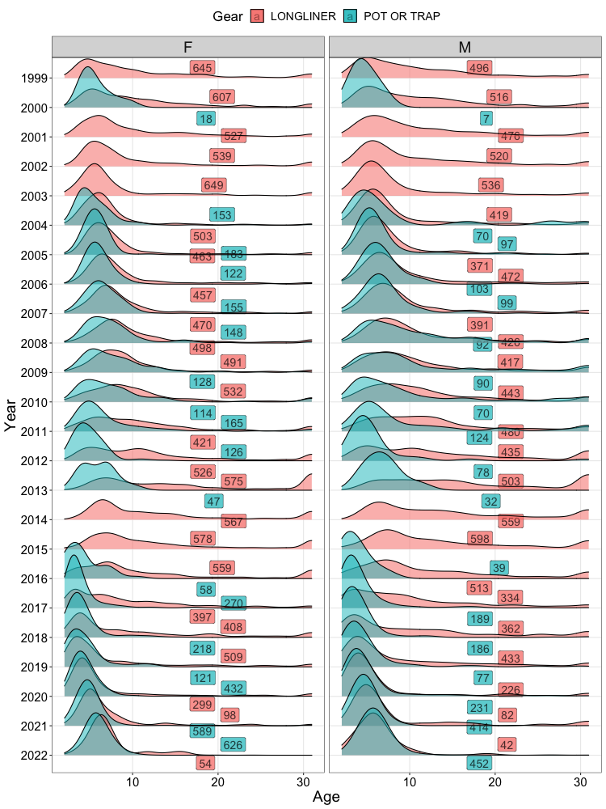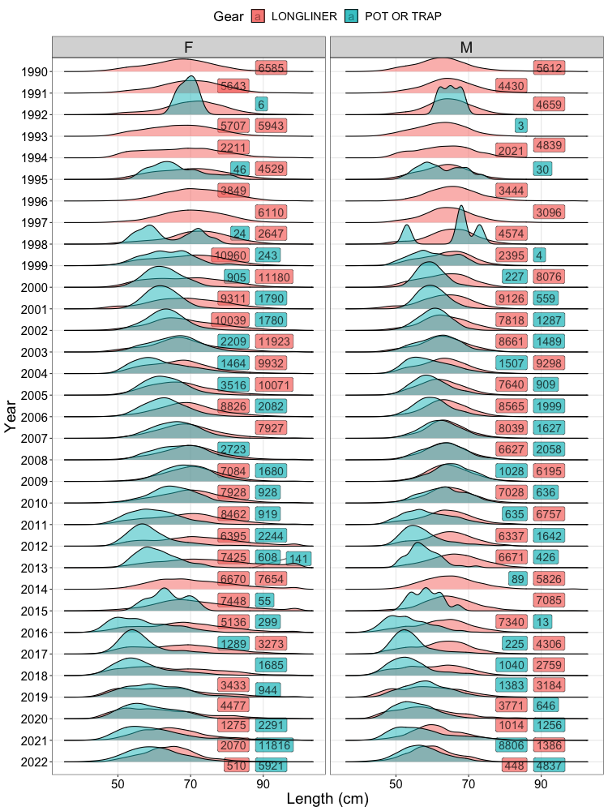

**Figure A.** Comparison of age (left panel) and length (right panel) compositions across years (y-axis), gears (colors), and sexes (panels). Numbers on the panels denote sample sizes for respective gear types.

Size distributions from hook-and-line gear and slinky pot gear from AFSC longline survey experimental legs are also available for the past three years (Figure B; Sullivan et al., 2022). In general, size distributions between hook-and-line and slinky pot gear were comparable, suggesting that contact selectivity between the two gears may be similar.

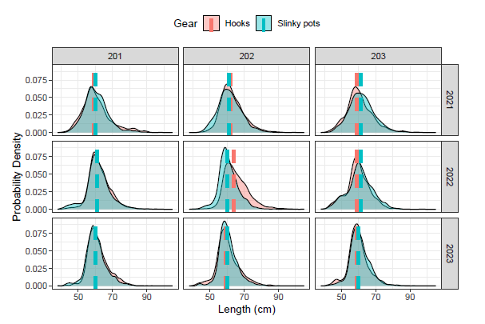

**Figure B.** Comparison of size distributions between hook-and-line gear and slinky pots from experiments conducted on the AFSC longline survey. Dotted lines represent the median size of individuals, column panels denote the stations where experiments took place, and row panels are the different years the experiments were conducted.

A model that reparametrizes the sablefish assessment to explicitly include a pot gear fleet was developed by M. Cheng (University of Alaska-Fairbanks) and has been accepted for publication (Cheng et al., In Press). Using the 2022 SAFE model (*21.12*), the fixed gear fleet was disaggregated with selectivity parameters and fishing mortality estimated for each gear. As expected, a combination of sparse compositional data across the model time series along with the extreme demographic state of the population (i.e., high abundance of small, young fish) when pot gear became a major source of removals impeded the ability to adequately estimate selectivity for the pot fleet. Thus, the reparametrized pot fleet model was only able to achieve adequate model performance for logistic selectivity when the selectivity slope parameters were shared with the hook-and-line fleet or when a highly constrained domed-shape gamma selectivity function was assumed (see Figure C).Although parameter estimates and population trends were consistent between model *21.12* and pot fleet parametrizations, recommended harvest levels (i.e., ABCs) were higher for the pot fleet model assuming gamma selectivity (Figure C). Increased ABCs for the model assuming domed-shape selectivity for the pot fleet is likely attributable to the reduction of mortality on large, old, and mature individuals, which are inherently no longer vulnerable to fishing with a strongly domed selectivity.

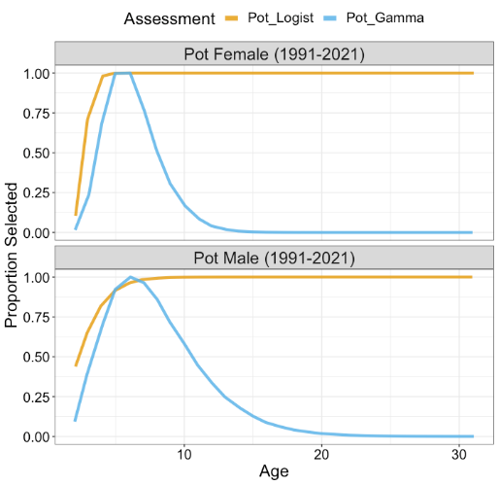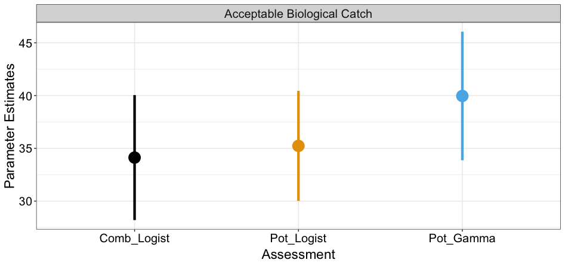

**Figure C.** Results from the Cheng et al. (In Press) pot gear fleet model explorations. Estimated selectivity (left panel) for the pot fleet model assuming logistic selectivity (orange line: Pot_Logist) and the pot fleet model assuming gamma selectivity (blue line: Pot_Gamma). Comparison of Acceptable Biological Catch (right panel) for model *21.12* (black: Comb_Logist), the pot fleet model assuming logistic selectivity (orange: Pot_Logist), and the pot fleet model assuming gamma selectivity (blue: Pot_Gamma).

Further work using simulation modeling (M. Cheng, UAF) is underway to identify optimal methods for addressing rapid changes in fishery fleet structure. Model evaluations will explore the impact of 1) disaggregating fleet structure, 2) using time-blocked selectivity, and 3) implementing continuous time-varying selectivity to account for transitions in fleet structure. Results will be presented during the 2024 assessment cycle. Based on the limited time series and associated sample sizes of data from pot gear along with unstable performance of the disaggregated pot gear model, it is not recommended that the sablefish assessment integrate a pot fleet at this time. As always, the structure of the sablefish model will be reevaluated in the future pending results from ongoing research, availability of new data, and observed changes in the biological resource, fishery dynamics, or assessment performance.

*Provide bubble plots of Pearson residuals for all age and length data including the sign and scale of residuals; this is standard practice to effectively evaluate tuning and lack of fit.*

Evaluating compositional model fits using Pearson residuals has the potential to result in spurious conclusions regarding lack of fit and/or independence, because correlated observations are retained. One-step-ahead (OSA) residuals, which decorrelate observations arising from multinomial distributions, are increasingly being recommended as best practice for interpreting stock assessment model fits (Trijoulet et al., 2023). The overall interpretation of OSA and Pearson residuals is similar: large magnitude (e.g., greater than three) or systematic trends in residuals could indicate model misspecification. Bubble plots of residuals were developed by M. Cheng (UAF) for both Pearson and OSA residuals, which are presented for the two primary compositional data sources (i.e., the longline survey and fixed gear fishery).

For fits to the age compositions from the NOAA longline survey, both OSA and Pearson residuals (Figure E) indicate a lack of fit (i.e., underestimating for OSA) to the recent large cohorts entering the population (e.g., since 2016). However, Pearson residuals incorrectly indicate a systematic pattern of negative residuals for intermediate to older age-classes. Comparing residual patterns of NOAA longline survey length compositions (females and males), Pearson residuals indicate systematic patterns in residuals throughout time, revealing runs of positive and negative residuals across a wide range of sizes (Figure F). Although some systematic patterns are also detected in OSA residuals, which manifest as runs of positive residuals at intermediate sizes, the lack of fit is less severe than suggested by Pearson residuals.

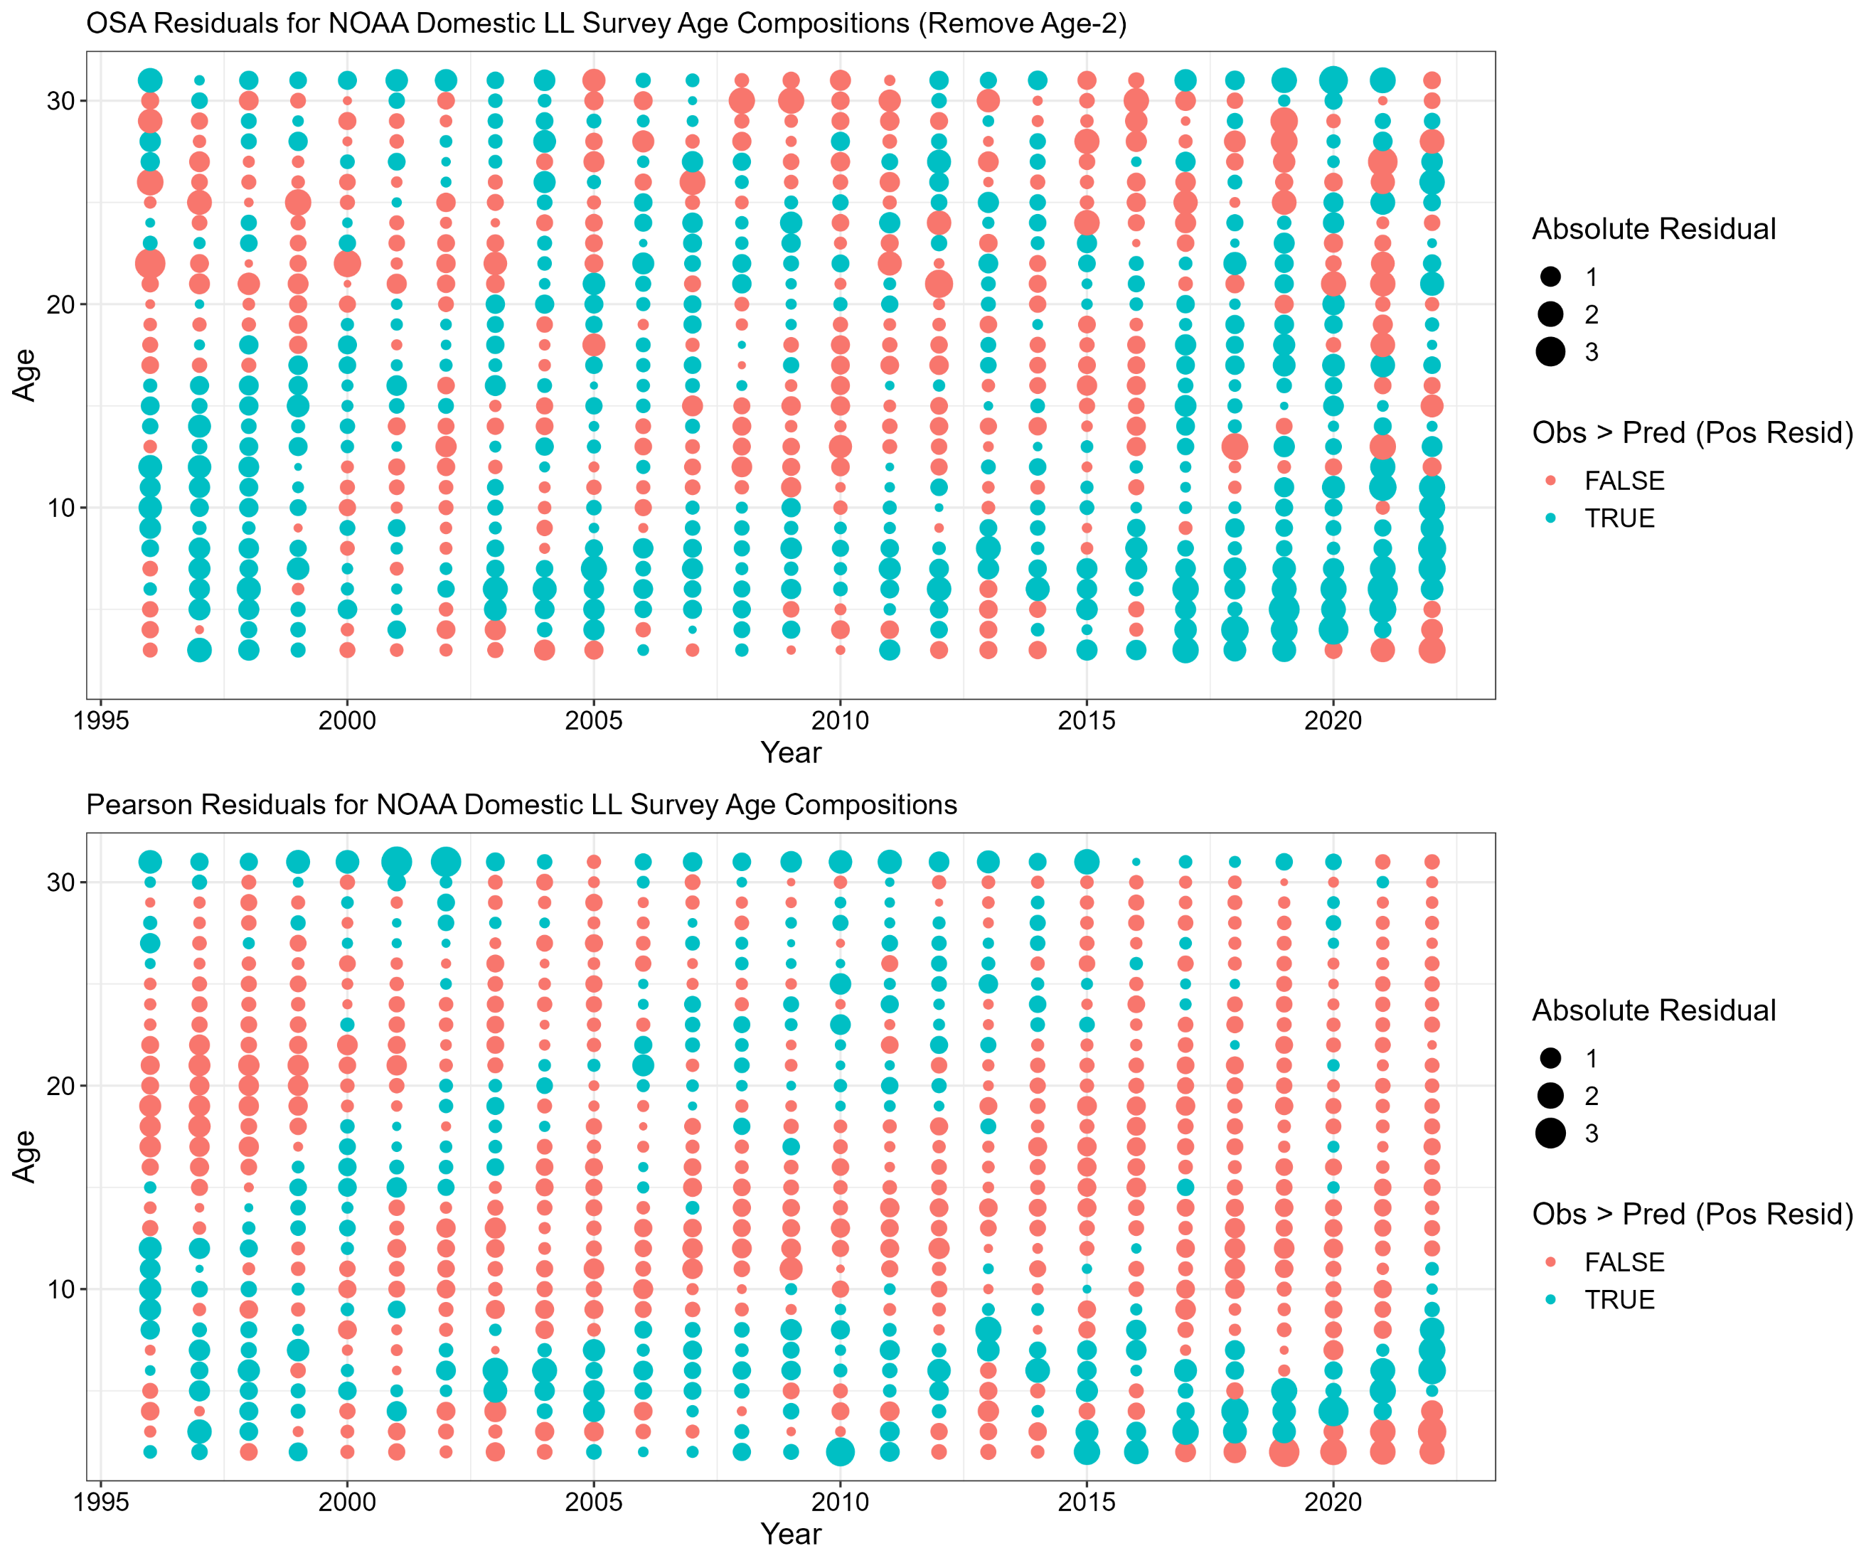

**Figure E.** One step ahead (OSA; top row) and Pearson residuals (bottom row) for age composition data from the NOAA domestic longline survey. Color denotes negative (red) or positive (blue) residuals.

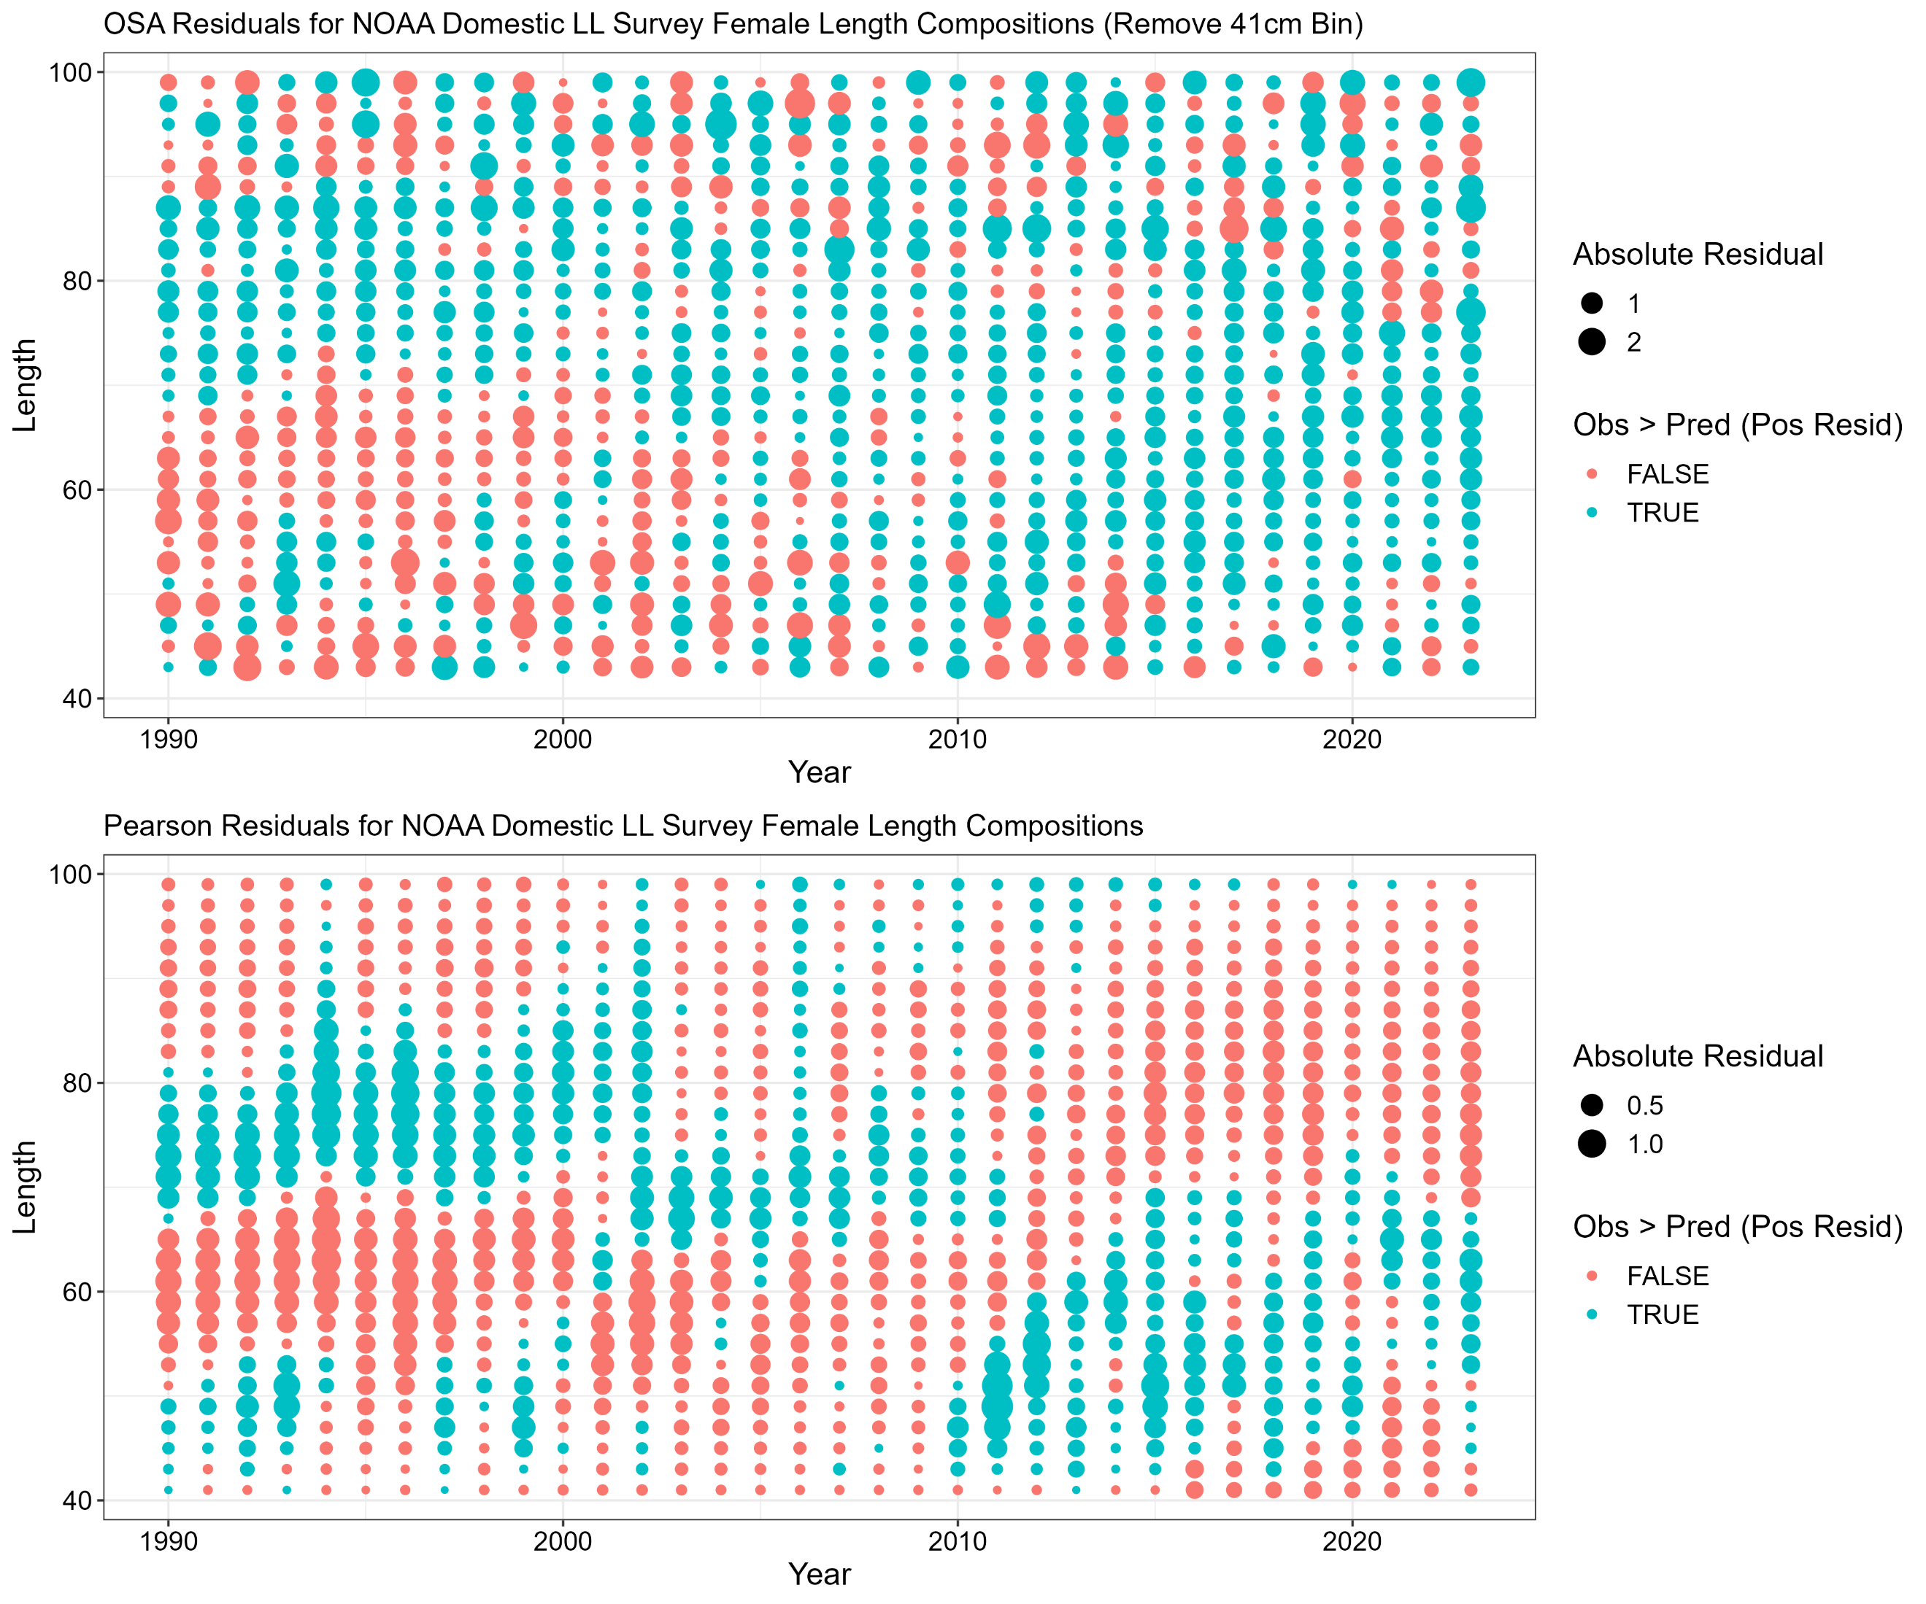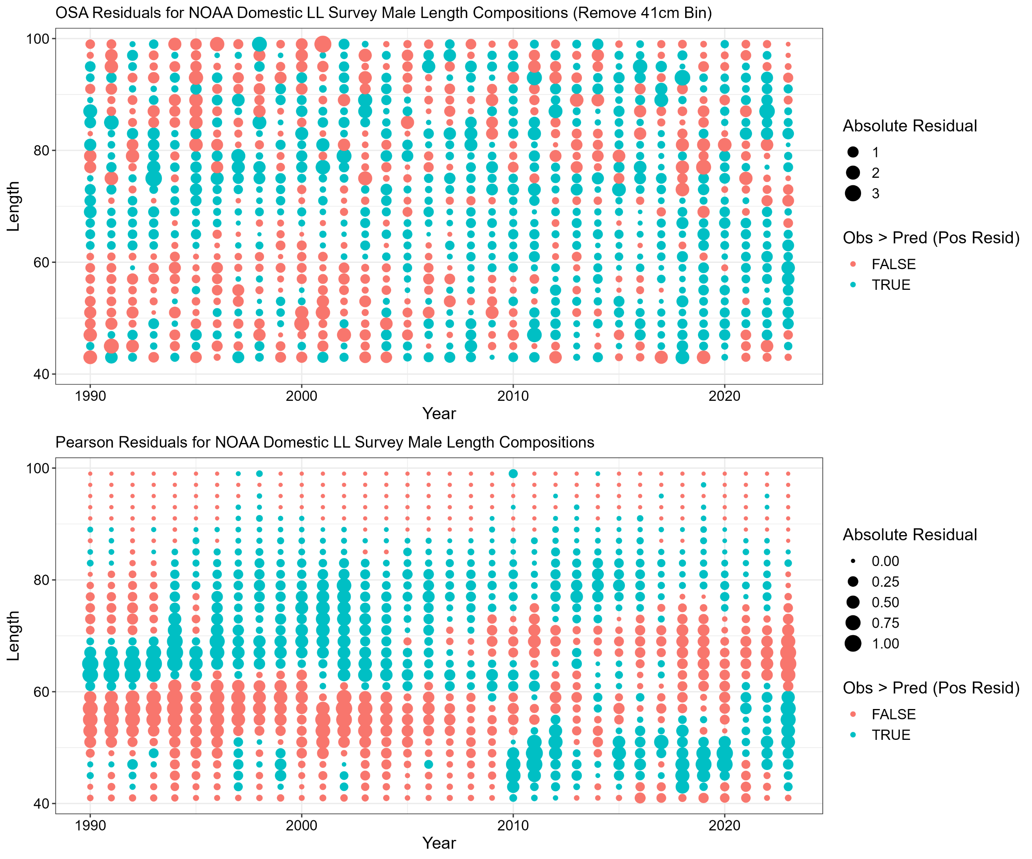

**Figure F.** One step ahead (OSA; top row) and Pearson residuals (bottom row) for length composition data (female lengths in left panel and male lengths in right panel) from the NOAA domestic longline survey. Color denotes negative (red) or positive (blue) residuals.

For the fixed gear fishery age compositions (Figure G), similar lack of fit to recent year classes is present, particularly in the OSA residuals. Furthermore, Pearson residuals indicate large patterns of negative residuals for a wide range of age classes. For OSA, positive runs of residuals are detected for younger age classes throughout time. For length compositions from the fixed gear fishery, Pearson residuals indicate systematic patterns through time, manifesting as multiple runs of positive and negative residuals for various size classes (Figure H). Similar to fits to the NOAA longline survey length composition data, these patterns are largely absent from OSA residuals. However, a run of negative residuals for intermediate size classes of females is present.

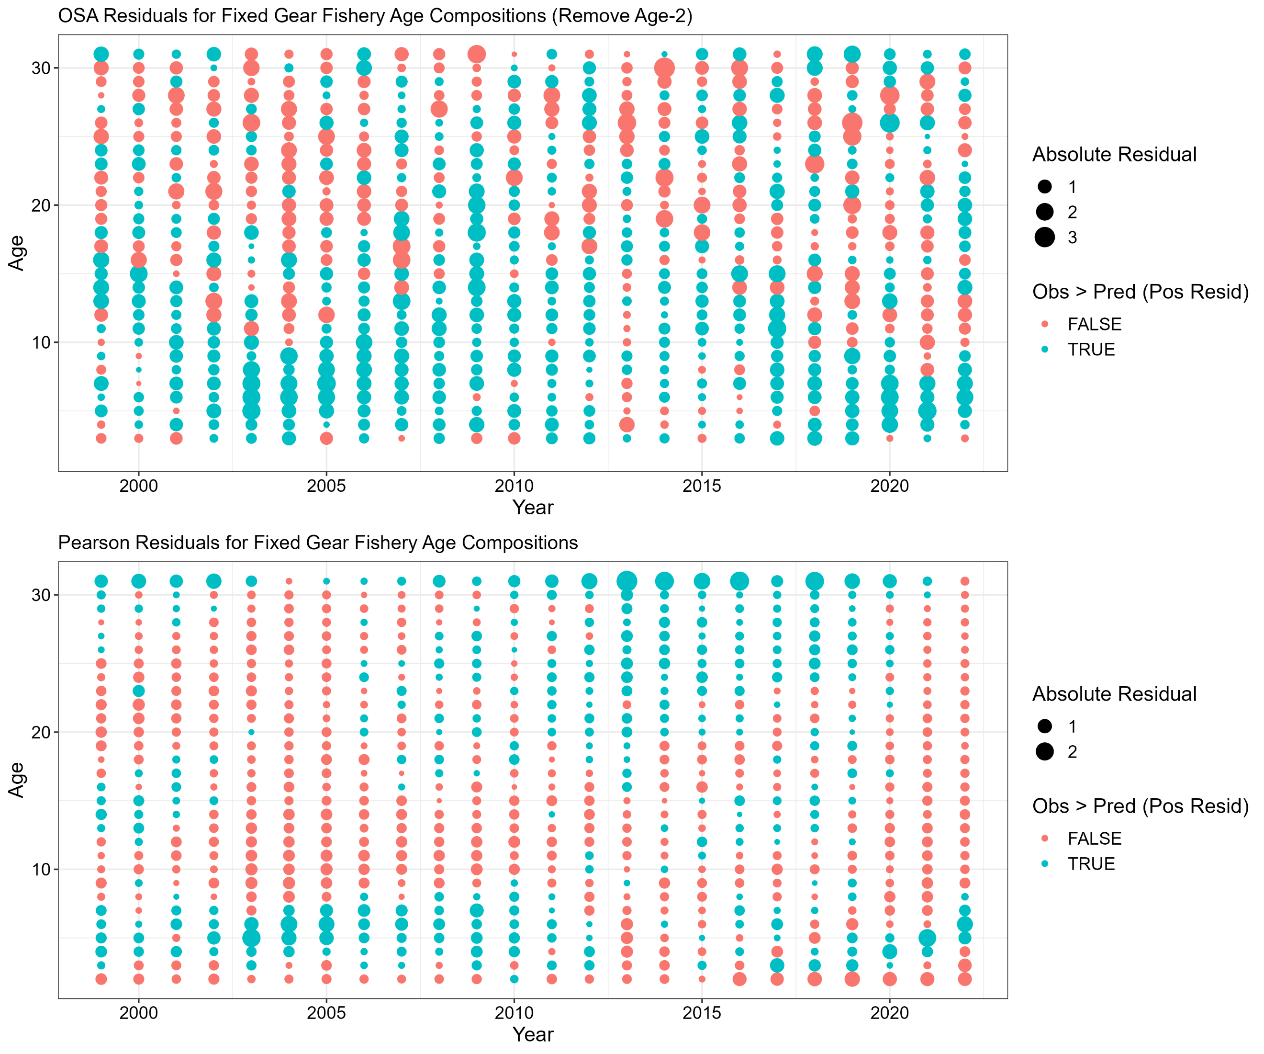

**Figure G.** One step ahead (OSA; top row) and Pearson residuals (bottom row) for age composition data from the fixed gear fishery. Color denotes negative (red) or positive (blue) residuals.

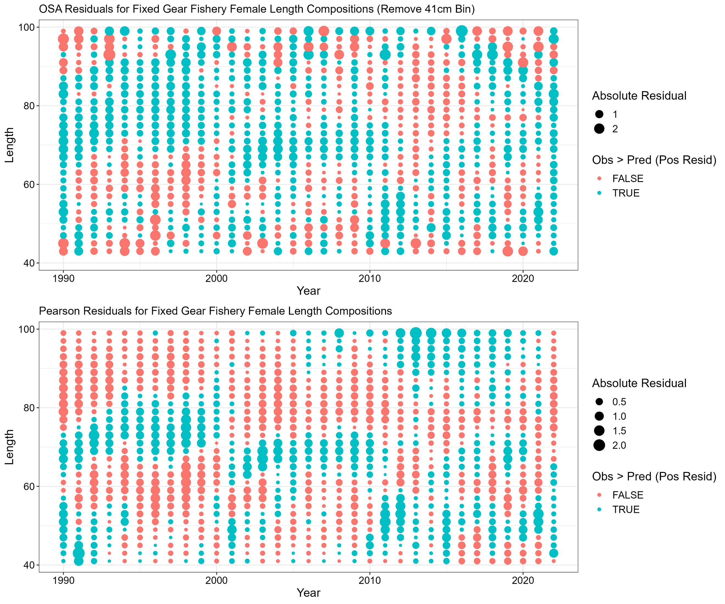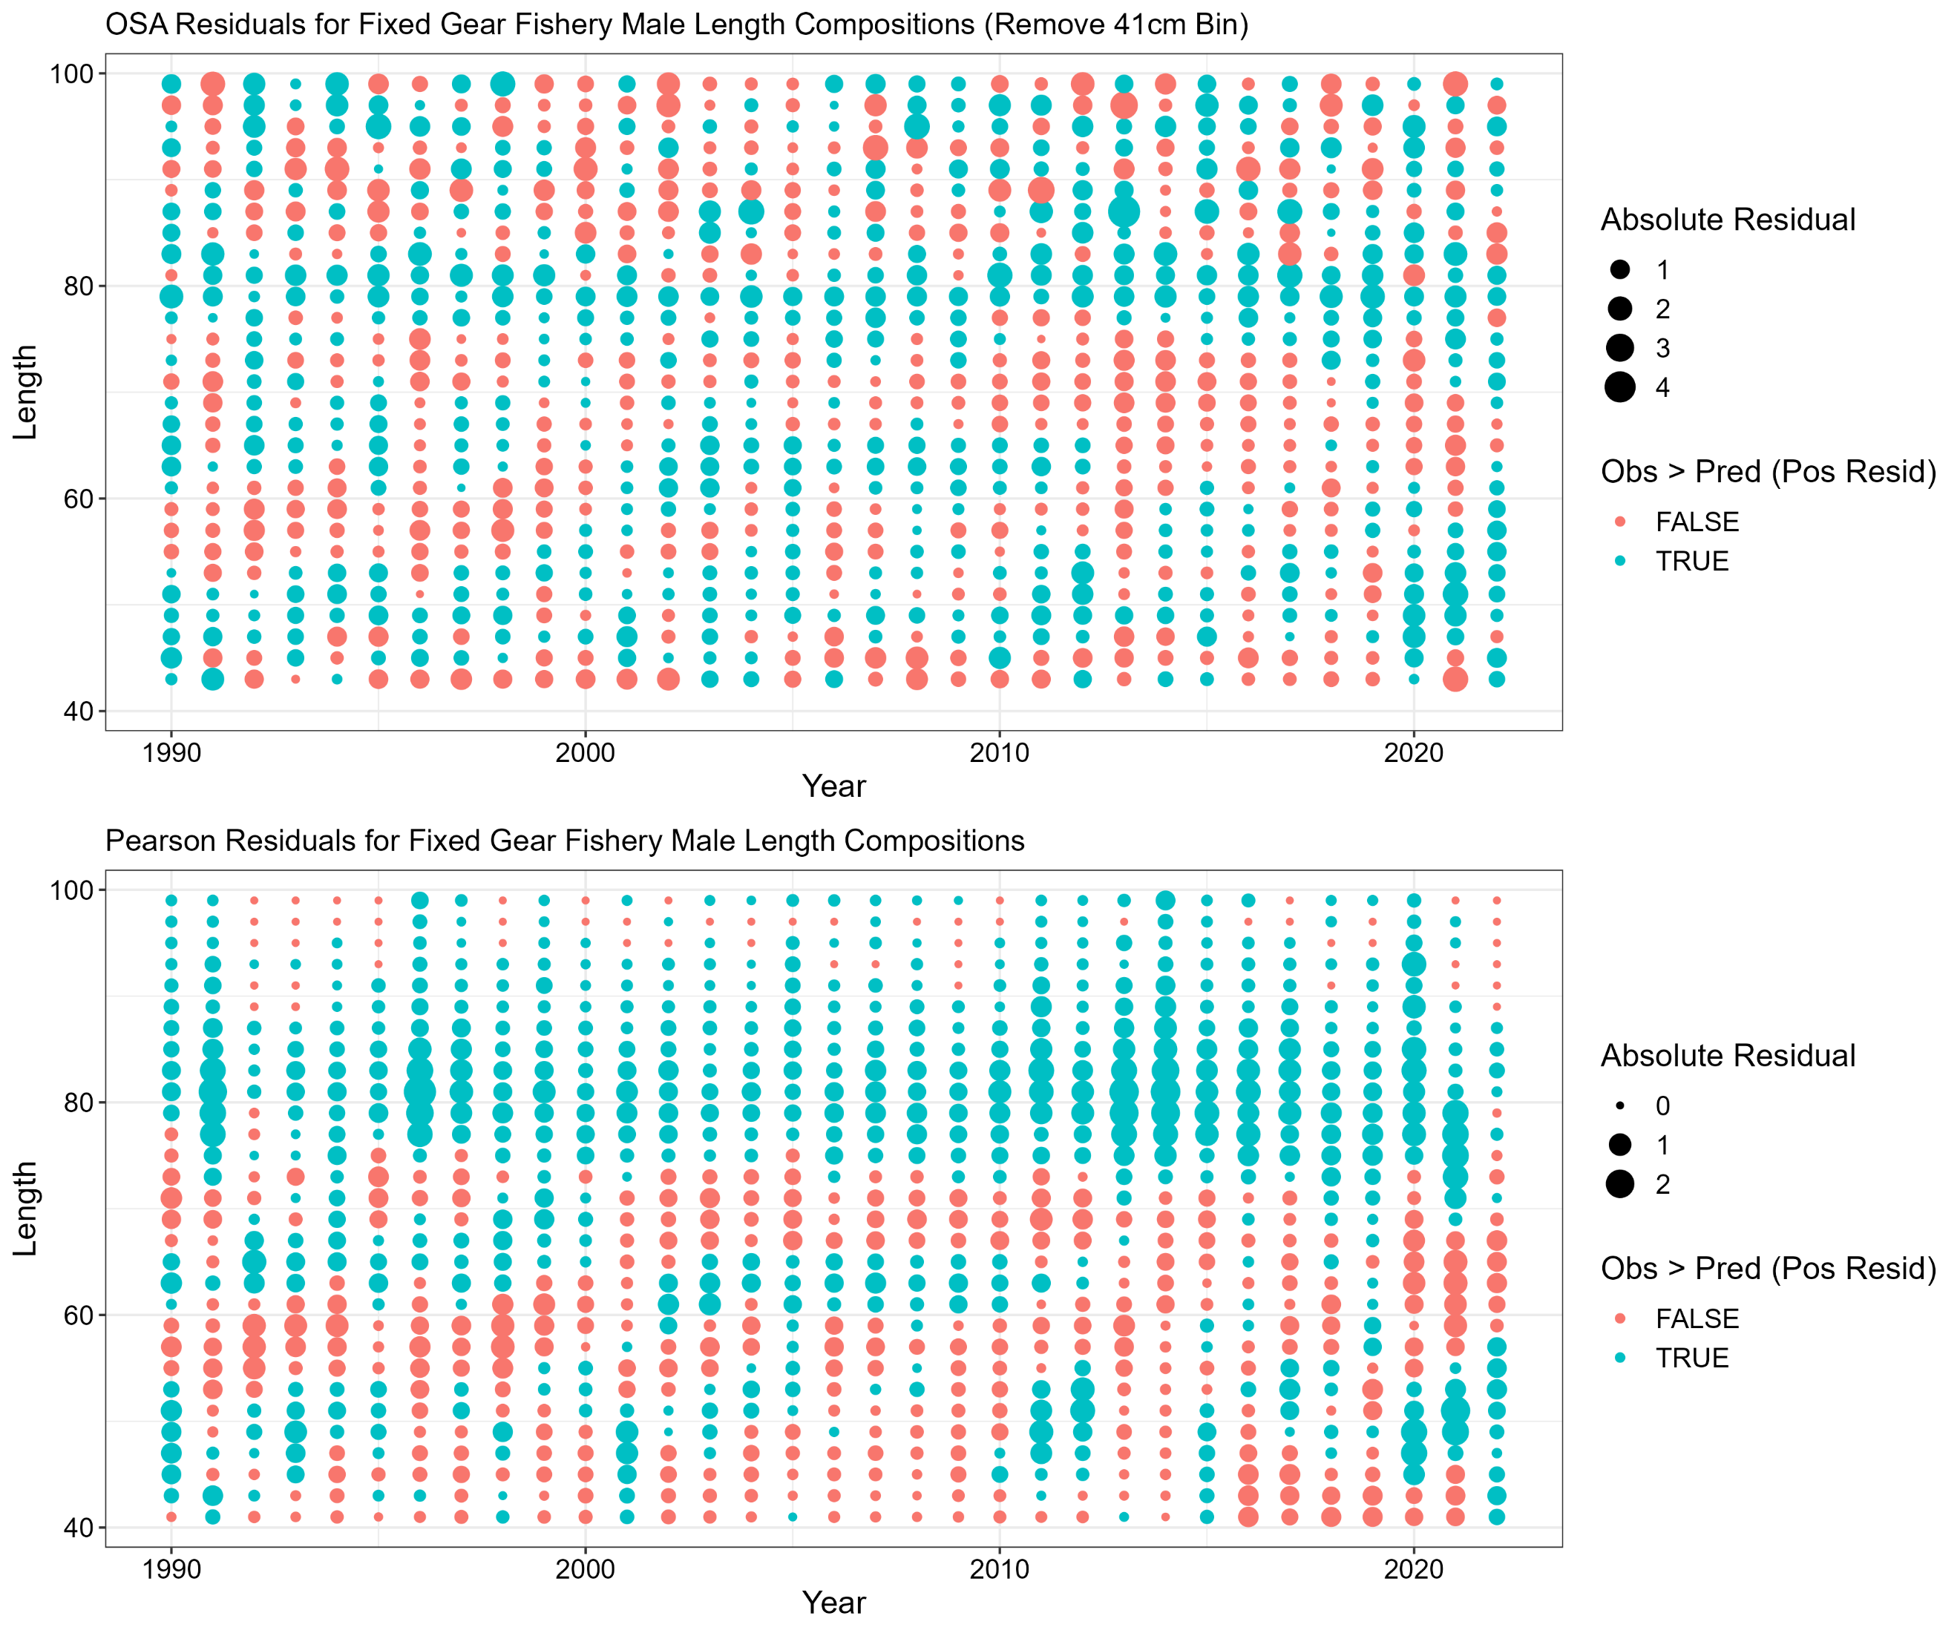

**Figure H.** One step ahead (OSA; top row) and Pearson residuals (bottom row) for length composition data (female lengths in the left panel and male lengths in the right panel) from the fixed gear fishery. Color denotes negative (red) or positive (blue) residuals.

Although the observed residual patterns are not ideal, the bubble plots may tend to exaggerate lack of model fit to compositional data, given that the aggregate fit to these data appears adequate (Figures 3.15, 3.17, 3.22, and 3.28). The underestimation of recent year classes at peak abundance in the compositional data (e.g., ages three through six) has been documented in recent SAFEs. However, the lack of fit has not been a major source of retrospective patterns or resulted in other concerning model diagnostics. Moreover, there are a number of model assumptions and parametrizations that may be causing poor fit to the data, which will be explored in the coming years. In particular, the model currently fits sex-aggregated age data and sex-disaggregated length data, which may limit information on sex-specific selectivity. Future assessment models will explore disaggregation of the age composition data. Moreover, there may be some discrepancy between the age and length data, which is causing model tension and difficulty fitting compositional data. Mainly, fewer fish are being observed at intermediate lengths from recent cohorts, primarily the very large 2016 year class, compared to what is being predicted by the model as it attempts to fit the corresponding age data. There are a variety of potential causes for the apparent model tension (e.g., density-dependent growth associated with recent large year classes, outdated ageing error, or unaddressed measurement error), which will be investigated in the coming years.

Plan Team Concerns Specific to the Sablefish Assessment

This section lists new or outstanding PT comments specific to the 2022 Alaskan sablefish assessment and 2023 model updates presented during the fall meetings. PT comments are provided in italics with responses to each comment directly following.

*The Teams recommended an evaluation of trends in abundance of the plus age group from the longline survey and fixed gear fishery along with a figure showing the plus group absolute abundance (as opposed to the proportions) in the future.*

A new figure showing the abundance by age across years has been added to the SAFE for both females and males (Figures 3.35 and 3.36).

*As is done in many tuna assessments, it may be more appropriate to implement an ‘index’ fishery that utilizes a time-invariant selectivity and density-weighted compositions (i.e., where the composition data by region is weighted by the CPUE and not the catch) along with the associated CPUE index.*

*The Teams supported all proposed modeling changes for the 2023 operational update assessment, including replacing the nominal CPUE index with a standardized index, and using the last assessments whale depredation values.*

The final author recommended model (*23.5*) utilizes the standardized CPUE index and whale depredation is fixed at the 2022 value. The alternate approach suggested for fitting the CPUE index (i.e., using an ‘index’ fishery with time-invariant selectivity) was not explored in 2023. Given uncertainty in the availability of the data used for the CPUE index in coming years, it may be necessary to remove the index from future assessments. Moreover, the limited impact of the CPUE index on assessment estimates make detailed analysis of how CPUE is fit in the model a relatively low priority.

Introduction

For a full description of the sablefish resource and fishery dynamics, see Goethel et al. (2021; available at <https://www.fisheries.noaa.gov/resource/data/2021-assessment-sablefish-stock-alaska>).

Sablefish are found from northern Mexico to the Gulf of Alaska (GOA), westward to the Aleutian Islands (AI), northward in the Bering Sea (BS), and into the northwestern Pacific Ocean off the Siberian coast of Russia and the Kuril Islands in Japan (Wolotira et al. 1993). Genetic work by Jasonowicz et al. (2017) found no population sub-structure throughout their range along the US West Coast to Alaska, and suggested that observed differences in growth and maturation rates may be due to phenotypic plasticity or are environmentally driven. Sablefish are assessed as a single, homogeneous population in Federal waters off Alaska, because of their high movement rates and panmictic stock structure. However, management is by discrete regions to distribute exploitation throughout their wide geographical range, including the Bering Sea, Aleutian Islands, Western Gulf of Alaska (GOA), Central GOA, West Yakutat, and East Yakutat/Southeast Outside.

Adult sablefish live at depths greater than 200 m and are highly mobile, though, exact movement patterns and drivers are not well understood. Spawning occurs in winter at depths of 300 - 500 m near the edges of the continental slope (Mason et al. 1983). Juvenile sablefish spend their first two to three years on the continental shelf of the GOA and the southeast BS. After their second summer, they begin moving offshore to deeper water, typically reaching their adult habitat, the upper continental slope, at 4 to 5 years of age. This corresponds to the age range when sablefish start becoming reproductively viable (Mason et al. 1983, Rodgveller et al. 2016).

Population Trends in Nearby Regions Not Incorporated in the Assessment Model

Alaska Northern Southeast and Southern Southeast Inside Waters

Sablefish in the Northern Southeast Inside (NSEI) Subdistrict waters and Southern Southeast Inside (SSEI) Subdistrict waters of Alaska are treated as separate stocks from the federal population, but some migration into and out of Alaska federal and state waters has been confirmed with tagging studies (Hanselman et al. 2015). NSEI sablefish continue to demonstrate similar population trends as the federal stock with strong recent recruitment observed, particularly the 2016-year class (Figure 3.1a). Although the biomass is increasing, CPUE and abundance remain well below levels seen in the 1980s and 1990s. In SSEI waters, the longline survey CPUE showed a 19% decline in 2022 after an overall upward trajectory between 2015 and 2021 (Figure 3.1a). Alaska state fisheries are seeing a similar rapid transition from hook-and-line gear to pot gear as the federal fishery, with a complete transition between the two gear types from 2019 to 2022.

Canada

The estimated biomass trend for the British Columbia (BC) stock of sablefish is similar to that in Alaska federal waters, with strong increases in the mid-2010s due to above average recruitment in 2016 – 2017. Spawning stock biomass has shown consistent increases in recent years (Figure 3.1b). The survey index value in 2022 was 10% greater than the 2021 value, representing the second highest in the time series. Total allowable catches (TACs) for the BC Sablefish stock are determined using a surplus production model implemented as part of a management procedure approach chosen through management strategy evaluation (Kendra Holt, pers. comm.).

United States West Coast (Washington, Oregon, and California)

For the United States west coast stock of sablefish (assessed by NOAA’s Northwest Fisheries Science Center), the estimated trajectory of relative spawning biomass across the times series is highly variable. The population increased rapidly in the 1970s to near unfished levels, declined for the next two decades to near *B40%* target biomass levels around 2000, and has increased again in recent years (Figure 3.1c). The above-average cohorts from 2008, 2013, 2015, 2016, 2020, and 2021 are driving the recent increase in spawning biomass. In particular, the recruitment events from 2020 and 2021 are two of the three largest in the time series.

Pacific Sablefish Transboundary Assessment Team (PSTAT)

Concurrent sablefish trends seen in Alaska, Canada, and the West Coast highlights the need to better understand the contribution to Alaska sablefish productivity from other areas. A Pacific Sablefish Transboundary Assessment Team (PSTAT) consisting of scientists from the U.S. (west coast and Alaska regions, including both federal and state scientists) and Canada has been working to better understand the dynamics, population trends, and biology of sablefish across the eastern Pacific Ocean (Fenske et al. 2019; <https://www.pacificsablefishscience.org/>). In 2023, the group completed the first phase of a stakeholder-informed management strategy evaluation (MSE) research project. Results indicated that the US West Coast appeared the most vulnerable to localized depletion, given differences in recruitment between the northern and southern regions. The group is also developing spatially explicit tagging analyses and operating models to explore the impacts of regional management measures on the coast wide population through MSE. Additionally, age reading groups across agencies have addressed sablefish ageing discrepancies by developing standardized ageing criteria through the Committee of Age Reading Experts (CARE) group.

Fishery

Sablefish have been exploited since the end of the 19th century with rapid fishery expansion in the 1960s when Japanese longliners began operations in the eastern BS (Table 3.1, Figures 3.2 and 3.3). Heavy fishing by foreign vessels expanded into the GOA during the 1970s and total catch peaked at 53,000 t in 1972, which led to a substantial population decline and implementation of fishery regulations in Alaska. By 1988 the U.S. harvested all sablefish taken in Alaska, primarily by hook-and-line gear in the eastern and central GOA. In 1995, individual fishery quotas (IFQs) were implemented for hook-and-line vessels. Since 2021, the majority of removals by the fixed gear fleet was taken by pot gear (Table 3.1, Figure 3.2), primarily driven by the increasing popularity of collapsible ‘slinky’ pots. Further details on the Alaskan sablefish fisheries can be found in Appendices 3D – 3F (links provided on title page). Appendix 3D describes the catch of small sablefish in the eastern Bering Sea in the various trawl fisheries. Appendix 3E provides a detailed analysis of the fixed gear fishery catch rates as well as comparisons of age- and length-based removals among gear types within the fixed gear sector. Appendix 3F summarizes sampling and observer coverage rates in the sablefish fisheries, including analysis of coverage rates by electronic monitoring (EM).

**Management Measures and Bycatch**

A summary of historical catch and management measures pertinent to sablefish in Alaska are provided in Table 3.2. Under current regulations, release of any sablefish by the sablefish IFQ fishery is prohibited, as long as there is remaining IFQ for persons onboard the fishing vessel. Sablefish discards in groundfish target fisheries are dominated by trawl fisheries in recent years, primarily in the BSAI due to an influx of recent large year classes in the BS, but discards declined substantially in 2023 (Table 3B.1; Appendix 3B). Bycatch of federally managed groundfish species in the sablefish target fishery has primarily been composed of shortspine thornyhead, arrowtooth flounder, halibut, skates, and shortraker and rougheye rockfish (Table 3B.2; Appendix 3B). In terms of non-target bycatch, grenadiers are consistently the primary species encountered in the target sablefish fishery (Table 3B.3; Appendix 3B). The predominant prohibited species catch (PSC) in both the BSAI and GOA sablefish target fisheries is golden king crab and tanner crab (Table 3B.4; Appendix 3B).

Data

A variety of data sources are included in the assessment and were updated for 2023 (Table 3.3), including fishery catch (Table 3.1), fishery and survey compositional data (Table 3.4), and various indices of abundance and biomass (Figure 3.4; Table 3.5). Japan and the U.S. conducted a cooperative longline survey for sablefish in the GOA annually from 1978 to 1994, adding the AI region in 1980 and the eastern BS in 1982 (Sasaki 1985). Since 1987, the NOAA domestic longline survey for sablefish has been conducted in the GOA with the aim of continuing the cooperative longline survey time series, with biennial sampling of the AI beginning in 1996 and biennial sampling of the eastern BS in 1997. Sablefish length data were randomly collected for all survey years. Since 1996, a random sample of otoliths has been collected and aged (~1,200 per year; Table 3.4). Relative population abundance in numbers (RPNs) are computed annually using survey catch rates scaled to management area size. The lowest RPN values in the domestic survey time series occurred in 2015, but have increased steadily with 2019 through 2023 survey RPNs representing some of the highest in the time series (Figure 3.4). Although RPNs had been trending upwards in most regions in recent years, RPNs were down slightly in the western GOA and BS in 2023 (Figures 3.5 – 3.6). The NOAA longline survey RPN indices are adjusted to account for whale depredation, but the impact on the final index is minimal (Figure 3.7; Hanselman et al., 2018). Interactions between the fishery and survey are described in Appendix 3A.

Since 1984, NOAA has conducted triennial or biennial trawl surveys in the GOA on the upper continental slope to 500 m depth. Since the full range of adult sablefish habitat is not always sampled and adult sablefish may also outswim the net, trawl survey indices are developed primarily as an index of juvenile sablefish biomass. The GOA trawl survey index was at its lowest level of the time series in 2013, more than quadrupled until 2021, then declined precipitously by ~50% in 2023 (Figure 3.4; Table 3.5). Lengths are sampled during each survey year (Table 3.4).

Records of catch weight and effort for vessels that target sablefish are collected by observers and by vessel captains in voluntary and required logbooks (see Appendix 3E for a complete description of these data). Based on Japanese longline fishery catch rate data, a nominal index of historical CPUE is included from 1964 – 1981 (Table 3.5). For the domestic fishery, a nominal CPUE index from hook-and-line gear was previously included in model *21.12*. A combined gear (i.e., including data from both hook-and-line and pot gear) standardized CPUE index has now been developed (Cheng et al., 2023), which better accounts for factors impacting catch rates, and is integrated in the author recommended model *23.5*. Since 2020, CPUE has been increasing rapidly, similar to rates of increase in the NOAA longline survey RPNs over the same period (Figure 3.4).

The catch used in this assessment (Table 3.1) represents total catch (landings plus bycatch or discards assuming 100% mortality), and includes catch from minor state-managed fisheries (i.e., these are reported by federal statistical areas and directly incorporated into the NOAA catch accounting system) in the northern GOA and in the AI region (constituting about 1% of the average total catch). Additionally, the author preferred model (*23.5*) incorporates all non-commercial sablefish removals, including research catches and Alaska state sport fishery removals not associated with the NSEI or SSEI fisheries. Whale depredation on hook-and-line gear has been pervasive in the fishery, and methods for estimating fixed gear fishery whale depredation are also integrated into the assessment and associated catch projections (Peterson and Hanselman, 2017). Estimated depredation is generally below 1,000 t per annum, often composing less than 1% of the total catch. Despite relatively low overall impact relative to total catch, the impact of depredation varies by area and species with orca depredation higher in western regions (primarily the WG) and sperm whale depredation more significant in the CG and EG (Figure 3.8). For 2023, fishery whale depredation was held constant at 2022 levels due to primary data sets used in the whale depredation analysis not being updated in time for the assessment.

Length compositions from the U.S. fixed gear (longline and pot) and U.S. trawl fisheries are both measured by sex (Table 3.4), and gear- and sex-specific proportions-at-length are fit in the assessment. Only years that have sample sizes of at least 300 per sex are included. The length compositions are weighted by catch (in numbers) in each Fisheries Management Plan (FMP) area to obtain a representative estimate of catch-at-length.

Age compositions from the U.S. fixed gear fishery are available since 1999 with adequate coverage and sample sizes (~1,200 otoliths aged yearly) to be fit in the assessment as sex-aggregated proportion-at-age (Table 3.4). The age compositions are weighted by the catch (in numbers) in each FMP area to obtain a representative estimate of catch-at-age.

Data Input Changes for 2023

Aside from updating the time series of each data set, there were four important changes to the inputs for the assessment in 2023, as integrated in the author recommended model *23.5* (i.e., the impact of each change is explicitly demonstrated by a new model run, see next section). Data changes included: assuming constant fishery whale depredation (i.e., fixing 2023 depredation estimates at 2022 values); removing the 1984 and 1987 trawl survey and associated length compositions (see model *23.1*); incorporating non-commercial catch in federal waters (see model *23.2*); and replacing the nominal hook-and-line fishery CPUE index with a standardized combined gear (i.e., hook-and-line and pot gear) index (see model *23.4*).

Analytic approach

Model Structure

The final author recommended model *23.5* utilizes the same general structure as the previously accepted sablefish model *21.12* with minor updates to recruitment bias correction and selectivity (see ‘Model Alternatives’ section). The complete model structure is described in the 2021 SAFE (full documentation is available at: <https://www.fisheries.noaa.gov/resource/data/2021-assessment-sablefish-stock-alaska>). The model was coded in the AD Model Builder software, a C++ based software for development and fitting of general nonlinear statistical models (Fournier et al. 2012).

An age structured statistical catch-at-age (SCAA) framework is utilized, which tracks population numbers-at-age by sex. The model assumed a single Alaska-wide stock. Recruitment occurs at age-2, and age-based dynamics are then tracked from age-2 to age-31+, where the terminal age is a plus group. Recruitment at age-2 is calculated as a yearly deviation from an average recruitment parameter. Primary demographic parameters are estimated outside the model and treated as fixed inputs, including maturity- (single time block), length- (two time blocks, pre- and post-1996), and weight-at-age (single time block; see Table 3.9 in Goethel et al., 2022 for age-based values for all inputs). The model assumes two primary fishing fleets (i.e., the directed fixed gear fishery and the combined trawl gear fishery) with independent dynamics. To allow fitting length data directly, predicted age compositions are converted to size compositions using input size-at-age transition matrices. Because sablefish can be difficult to age, an ageing error matrix is directly integrated into the assessment based on known-age otoliths (Hanselman et al. 2012).

Each of the data sources described in the previous section (see Table 3.3) are fit directly in the model, and a statistical maximum likelihood estimation (MLE) framework enables estimation of key parameters (i.e., a total of 249 parameters are estimated; Table 3.6). Projections of future catch limits (e.g., ABC and OFL) are handled externally and described in the ‘Harvest Recommendations’ section.

Definitions

Recruitment is the estimated number of age-2 sablefish (in millions of fish). Total biomass (in kilotons) is the abundance of all sablefish age-2 and older multiplied by sex-specific input weight-at-age. Spawning stock biomass (SSB) is the mass of mature (based on input age-based maturity) females (in kilotons). Summary fishing mortality is fully selected *F*, which is the instantaneous mortality at the age of maximum fishery selectivity, summed across fleets.

Model Alternatives and Justification

A total of five new model runs were developed for the 2023 SAFE, culminating in the final proposed *23.5* model, which includes all individual changes. The models explored for 2023 included:

* *Model 21.12*: a continuity model matching the previously accepted model for management of sablefish, which was the same as the 2022 SAFE model but with updated data for 2023 (note that 2023 whale depredation estimates were assumed equal to the 2022 estimates).
* *Model 23.1*: removed the 1984 and 1987 trawl survey biomass index and length composition data, per AFSC best practice recommendations (no other changes were made from model *21.12*).
* *Model 23.2*: incorporated all sources of non-commercial catch in federal waters into the total catch used in the assessment model, per SSC requests (no other changes were made from model *21.12*).
* *Model 23.3*: included minor updates to:
  + The stock-recruit bias correction in the model [i.e., rectified a legacy coding error; implemented the Methot and Taylor (2011) time-varying bias correction; allowed the model to estimate the recruitment variance term (*σR*); and added an early fixed recruitment variance term to help constrain estimation in years with very limited data].
  + Selectivity parametrization to aid model stability [i.e., shared all selectivity parameters between the domestic fixed gear fishery during the early time block (pre-1995) with the Japanese longline fishery; and shared all selectivity parameters between the NOAA domestic longline survey during the early time-block (pre-2016) with the Japanese cooperative longline survey].
  + Fishing mortality parametrization to remove unnecessarily estimated parameters (i.e., removed fishing mortality deviations for early years of the trawl fishery when no catch was reported; and no longer treated fishing mortality reference point parameters as estimated quantities).
* *Model 23.4*: replaced the nominal hook-and-line CPUE index with a standardized index that combined data from both the hook-and-line and pot gear types (Cheng et al., 2023), as recommended by the SSC and PT in 2022 (no other changes were made from model *21.12*).
* *Model 23.5*: integrated all updates from models *23.1—23.4*; this is the final author recommended model for sablefish management advice in 2023.

Most proposed model changes are updates to data that were recommended based on AFSC assessment good practices (i.e., dropping early trawl survey data, model *23.1*), requested by the SSC (i.e., integrating non-commercial catch, model *23.2*), or were approved during previous assessment cycles (i.e., utilizing the combined gear standardized CPUE index, model *23.4*). The minor model structural changes implemented in model *23.3* were primarily meant to improve model performance by rectifying any coding issues, integrating good practices in assessment modeling, and aiding model stability. All of the proposed model changes integrated in the author recommended model *23.5* are relatively minor, and each was examined in-depth to ensure that no major changes to model performance or population dynamics resulted.

Model Bridging and Final Model Development

Each of the updates to model *21.12* were implemented in isolation as defined in the previous section. The single change models were then examined for any major differences in performance or population trajectories from the previously accepted model *21.12*. All of the changes were then implemented simultaneously for the author recommended model *23.5*. Once the final author recommended model was selected, Francis data reweighting (i.e., accounting for correlations among ages or length bins in the compositional data; Francis, 2017) was applied to adjust data weights to account for the addition of the 2023 data. Finally, a jitter analysis was implemented to identify if altering the starting parameters led to an improved fit to the observed data. For the jitter analysis, the model was rerun 50 times with parameter values altered from the initial conditions by adding a small random deviation selected from a uniform distribution. If a given jitter run resulted in a lower total negative log-likelihood value, then that model was chosen as the final author recommended model. Thus, the final model *23.5* included all proposed data and model changes, integrated updated data weights, and was based on the best fit to the data after performing a jitter analysis.

Uncertainty

Two forms of uncertainty are evaluated for key parameters, including the Hessian approximations from the MLEs and the posterior distributions from Markov Chain Monte Carlo (MCMC) simulations. The posterior distributions from MCMC were computed based on one million parameter draws with the chain thinned to 5,000 to remove serial correlation between successive draws, and a 10% burn-in was used to remove draws from the beginning of the chain.

Model Diagnostic Analyses

Retrospective Analysis

Retrospective analysis is the examination of the consistency among successive estimates of the same parameters obtained as new data are sequentially removed from a model. A seven-year retrospective analysis (i.e., terminal years 2017 through 2023; the fishery and survey selectivity time blocks preclude informative retrospective analysis using peels before 2017) was undertaken to examine whether any significant time trends in spawning biomass or recruitment were present. ‘Mohn’s rho’ (*ρ*), a measure of overall retrospective bias, was calculated as the mean of the relative ‘bias’ across all retrospective peels.

Historical Assessment Retrospective Analysis

An historical assessment retrospective analysis addresses consistency across successive stock assessment applications with the actual data available in the terminal model year. Two versions of an historical retrospective analysis were conducted: the ‘all model’ historical retrospective compared the actual assessment outputs from the model used as the basis of management advice for a given SAFE year (i.e., going back to the 2016 SAFE; this included successive applications of models *16.5*, *21.12*, and *23.5*); the ‘current model’ historical retrospective utilized the current assessment model *23.5* applied to the actual data available at the time of the given SAFE (i.e., terminal years 2018 through 2023 were included). Mohn’s rho was calculated based on the difference between the projected SSB from a two-year projection to the corresponding realized SSB in the 2023 model.

Profile Likelihoods

Likelihood profiles allow exploration of how the likelihood response surface varies for different values of a given parameter. A likelihood profile was developed for the primary scaling parameter, mean recruitment.

Incremental Influence of New Data

A data building analysis was conducted to demonstrate how new data affected parameter estimates (e.g., the magnitude of the most recent year class). For this exercise, the 2023 catch data was added along with one additional new data source and the model was run. In the case of fishery independent surveys, the associated index was always added in combination with associated compositional data.

Index Sensitivity Analysis

An index sensitivity analysis was implemented to demonstrate the influence of each index by removing a given index and comparing model outputs. When a given fishery-independent index was removed, all associated age and length composition data were also removed from the model.

Results

Model Bridging and Final Model

None of the changes to the data (i.e., models *23.1*, *23.2*, and *23.4*) had an appreciable impact on population trajectories or data fits compared to model *21.12* (Figure 3.9). Removing the historical trawl survey data (model *23.1*) led to slight increases in recruitment and scaling in the early part of the time series, while adding the non-commercial catch (model *23.2*) and standardized CPUE (model *23.4*) had similar minor impacts on scaling in the latter half of the time series (Figure 3.9). Changes to model structure (model *23.3*) led to increased recruitment in the 1960s followed by slightly reduced recruitment in the 1970s compared to model *21.12* (Figure 3.9). However, model *23.3* led to much more reasonable estimates of initial age structure (i.e., model *21.12* estimates extreme year class sizes for certain ages in the initial age distribution) and more stable recruitment estimates in periods of reduced data (i.e., pre-1977 cohorts). Because model *21.12* estimates such extreme cohort sizes in the initial age structure, it results in a rapid increase in SSB in the mid-1960s before rapidly declining with the onset of foreign fishing (Figure 3.9). The spawning stock biomass (SSB) trend in model *23.3* is much more reasonable and does not demonstrate the same initial rapid increases, which were model artefacts of the instability in initial age structure estimation (Figure 3.9). With the change in the initial biomass trends, model *23.3* has a slightly lower population scaling compared to model *21.12*, but differences in scaling are offset by changes in the reference points leading to ABCs that differ by less than 3%. Simultaneously implementing all proposed model changes (model *23.5*) led to slightly reduced recruitment estimates compared to model *23.3*, but overall differences were negligible. ABCs from model *21.12* and model *23.5* were within 1% of each other, despite limited differences in recruitment and population scaling (Figure 3.9). Given that model *23.5* implements minor changes that align with assessment good practices, improves model stability and estimation performance, and does not greatly alter population trends or fits to observed data compared to model *21.12*, it is being recommended as the author preferred model for the 2023 SAFE.

Data Reweighting

Francis reweighting was applied after incorporating all of the new data for 2023. The updated ‘lambdas’ (overall weight) for each data source only varied slightly from the 2022 model (Table 3.7). The Francis approach continues to emphasize fishery length compositions over associated age compositions. In the future, the age data should be disaggregated by sex (as is done for length data) to provide more information on sex-specific dynamics (and which may lead to more appropriate data weights). The data reweighting had no appreciable impact on model dynamics (Figure 3.9).

Jitter Analysis

The jitter analysis identified a handful of model runs with slightly lower total negative log-likelihoods, which provided minimally improved fits to the observed data compared to the initial run of model *23.5*. Thus, the final author recommended model *23.5* utilized the jitter run with the minimum negative log-likelihood (Figure 3.10, dashed line). The resulting final model *23.5* had slightly reduced population scaling, though recruitment estimates remained unchanged compared to the initial version of model *23.5* (Figure 3.9). Compared to model *21.12*, there was a moderate downward scaling of population SSB and mean recruitment in the final version of model *23.5*, but resultant ABCs were identical (i.e., 0% difference).

Model Evaluation

The objective function values by data source indicated that the compositional data, particularly the NOAA longline survey ages and the fixed gear fishery lengths, had the largest contributions (Figure 3.10). Although trends in one-step-ahead (OSA) residuals were noted for the compositional data (see ‘Response to SSC and Plan Team Comments’ Section), the aggregate fits to compositional data appeared adequate. Moreover, there were essentially no changes to data fits compared to the 2022 SAFE (model *21.12*; Goethel et al., 2022).

Goodness of fit

Model *23.5* demonstrated good fit to the indices with predicted values generally within the confidence intervals of the observations, except for a few years of the trawl survey biomass index (i.e., early values and the large decline in 2023) and the Japanese CPUE index (Figure 3.12). The lack of fit to the 2023 trawl survey decline is not surprising, given that this trend is not reflected in any of the other data sources. Also, because the trawl survey is a juvenile index, lack of fit to current year trawl index values may be driven by the assumption of fixed (i.e., at the time series mean) terminal year recruitment values (especially if the trawl index indicates low terminal year recruitment, as is the case for 2023; Figures 3.26 – 3.27). Mean fits to the compositional data were adequate, but some strong year and age- or length-specific residual patterns were present (Figures 3.13 – 3.33). For instance, recent year classes tend to be initially overestimated and subsequently underestimated (i.e., at ages when these year classes reach their peak abundance) in the longline survey and fixed gear fishery age compositions (Figures 3.11 – 3.18). Thus, primary estimation uncertainty pertains to the magnitude of recent year classes. The aggregated fits to the length composition data demonstrated a general tendency to overestimate fish in the 55cm to 65cm range, then underestimate the proportion of fish in the 65cm to 75cm range (Figures 3.19 – 3.33). However, in recent years, the trend is reversed with an underestimation of small fish and overestimation of the proportion of larger fish (e.g., in the NOAA longline survey, Figures 3.23 – 3.24, and the fixed gear fishery, Figures 3.29 – 3.30). The recent patterns may be indicative of changing dynamics in the population that is not well accounted for in the model (e.g., reduced growth within recent extreme year classes or reduced availability of large fish to the gears) or may represent discrepancies in the age and length data (e.g., due to measurement error) that the model is not able to rectify. For instance, given the extreme magnitude of the 2016 cohort in the age composition data in 2022, the model is likely expecting there to be a preponderance of fish in the 62 – 70cm size bins in the 2022 and 2023 NOAA longline survey and fixed gear fishery length data. However, the survey data shows few fish greater than 60 – 64 cm (Figures 3.23 –3.24) with a similar, though less pronounced, pattern in the fishery data (Figures 3.29 – 3.30). Length compositions from the trawl gear tend to be more variable and are not well fit (Figures 3.25 – 3.27 for the survey and 3.31 – 3.33 for the fishery).

Time Series Results

Sablefish abundance and biomass dropped throughout much of the 1960s and 1970s (Table 3.8, Figure 3.34), as the population began to be heavily exploited, with catches peaking at 53,000 t in 1972 (Table 3.1, Figure 3.2). The population recovered in the mid-1980s due to a series of strong year classes in the late 1970s (Figures 3.35 – 3.36). The population subsequently declined as these strong year classes were removed, with a slight rebound in the early 2000s due to a handful of above average year classes in the late 1990s, then declined to a time series low in 2015 (Figure 3.34). Associated with a series of above average recruitment events since 2014, age-2+ biomass has nearly tripled since 2015 to 695,000 t in 2023, which represents sablefish population levels on par with those at the time the fishery developed in the 1960s (Figure 3.34). Although increased abundance at younger ages has driven increases in population biomass, the population age structure remains truncated compared to historical levels (Figures 3.35 – 3.37). SSB typically lags behind biomass with less pronounced extremes and, aside from a ten-year upswing in the 1980s, had been on a downward trajectory for the entire time series (Table 3.8; Figure 3.34). SSB has nearly doubled from the time series low of 82,000 t in 2017 to 157,000 t in 2023 (Figure 3.34). However, SSB remains well below time series high levels observed in the 1960s.

Sablefish are characterized by highly spasmodic recruitment events with periodic year classes that are well above average, then prolonged periods of depressed recruitment (Figure 3.38). Moreover, no apparent relationship between SSB and subsequent recruitment exists, with many of the larger cohorts being spawned from relatively low SSB (Figure 3.39). However, the large recruitment events in the late 1970s and early 1980s were associated with a more balanced age structure (Figures 3.35 – 3.36), which may indicate a potential age diversity and spawning portfolio effect on recruitment success (e.g., Griffiths et al., 2023). The largest historical recruitment event was the 1977 year class followed by the 1980 year class, but below average recruitment events then occurred throughout much of the 1980s and early 1990s (Table 3.8, Figure 3.38). Since 2014, recruitment has been at or above the time series mean (Figure 3.38). The 2016 and 2017 year classes are the two largest cohorts in the time series (Table 3.8). However, the size of recent strong recruitment events (e.g., the 2018 through 2020 year classes) is uncertain, given that they are informed by limited age and length composition data. Thus, it is common for variability to exist in estimates of recent year class strength in subsequent SAFE models. For instance, the 2022 SAFE estimated a large 2019 cohort, which was being driven by the 2021 trawl survey, but that estimate decreased in the 2023 model *23.5* with the addition of age and length data from other sources (Figure 3.40). It is expected that a similar, but opposite, pattern will be observed with the 2020 year class, which is being estimated at a relatively low value (i.e., compared to recent cohorts), primarily due to the strong decline in the 2023 trawl survey index. Thus, the size of this cohort will likely increase in subsequent assessments.

Generally, selectivity has shifted towards younger fish for the longline survey and fixed gear fishery over time (Figure 3.41). Males tend to be selected at an older age than females in all fleets, likely because they are smaller at a given age. Compared to the fixed gear, younger fish are more vulnerable and older fish are less vulnerable to trawl gear, because trawling often occurs on the continental shelf in shallower waters (< 300 m) where young sablefish reside (i.e., this is reflected in the dome-shaped trawl gear selectivity patterns).

Fishing mortality was estimated to be high in the 1970s, relatively low in the early 1980s, then increased in the 1990s before undergoing a gradual decline throughout the 2000s (Figure 3.42). Over the last five years, fishing mortality has steadily declined and is on par with the low levels of the early 1980s. Recent management has generally constrained fishing mortality to below limit reference point values, while biomass is above limit reference point values indicating that the resource is not overfished and overfishing is not occurring (Figure 3.43).

Uncertainty

MLE and MCMC estimates of parameters were similar with the MLE values closer to the MCMC medians. The magnitude of recent recruitment events tended to show slight divergence, with MCMC estimates generally higher than MLE (Table 3.12). Similarly, estimates of uncertainty in key parameters were comparable, where MCMC estimates demonstrated larger variability. The MLE estimates of projected spawning biomass for 2024 (185,079 t) and 2025 (209,5004 t; based on the maximum permissible ABC and specified catch projections) fall near the center of the posterior distribution of spawning biomass from MCMC, while the MCMC distributions indicate an extremely high probability of being above *B40%* in both years (Figures 3.44).

Comparison to Last Year’s Model

Despite a slight downward scaling of model *23.5* compared to *21.12* in terms mean recruitment, SSB, and reference points (see Summary Table), model trends are generally consistent (Table 3.10). The only major differences occur at the beginning of the time series, primarily in terms of early recruitment trends, which are due to the reparameterization of the recruitment bias adjustment in model *23.5*. However, recent estimates of SSB and biomass are consistent among models, with the 2022 SAFE projected biomass for 2023 being within 3,000 t of the realized 2023 SSB as estimated by model *23.5*; both models indicate the stock was at *B52%* in 2023. One main difference among model estimates, which was predicted in the 2022 SAFE, was that the magnitude of the 2019 year class (i.e., the 2021 recruitment event) has been moderately downgraded (Figure 3.40). Because the 2019 year class was being primarily informed by the 2021 trawl survey data in the 2022 model, it was expected that this estimate would change once updated age and length observations from other data sources were available.

Model Diagnostic Analyses

Retrospective Analysis

The retrospective analysis indicated that the model is quite consistent, demonstrating a slight tendency to underestimate population scale and terminal SSB (Mohn’s *ρ* = -0.03; Figure 3.45). Although variability exists in the estimates of recent year class strength, there is no consistent directional trend (Figure 3.46). However, there is a tendency to initially overestimate year class strength, which may reflect the over influence of trawl survey data as it provides the first observations of new cohorts. Given that the trawl survey often conflicts with subsequent data from fishery and longline survey age and length compositions, the initial year class estimates tend to undergo a downward scaling in subsequent years. However, uncertainty in recruitment estimates and associated recruitment retrospective patterns do not lead to retrospective patterns in SSB, because by the time a year class begins to significantly contribute to the SSB (e.g., by around age-5) the estimate of year class strength has already stabilized (Figure 3.46).

### **Historical Assessment Retrospective Analysis**

Aside from former model *16.5* (i.e., used as the basis of management advice prior to 2021), which tended to severely overestimate population SSB growth, recent models have been highly consistent from one year to the next (i.e., based on the ‘all model’ historical retrospective; Figure 3.47). As noted, the 2023 projected SSB from the 2022 implementation of model *21.12* was only 3,000 t higher than the realized SSB from model *23.5* in 2023, and there was no difference in stock status (i.e., the population was at *B52%* in both model implementations).

Furthermore, applying model *23.5* to the data available at the time of previous assessments (i.e., the ‘current model’ retrospective) demonstrated that the two-year projections were again consistent (Figure 3.48). There was a slight pattern of increased population scaling as new data is added with concomitant underestimation of SSB in previous years, as was seen in the normal retrospective analysis. The observed patterns are primarily driven by the uncertainty in recent recruitment events and the assumption of average recruitment in the model terminal year as well as ABCs not being fully harvested in recent years. Mainly, as the most recent recruitment value goes from being fixed at the time series mean to being an estimated parameter in the following year, it is estimated to be larger (i.e., as has been the case most years since 2014), which leads to an increase in mean recruitment and population scale. Concomitantly, fewer fish are being harvested than projected in previous years, leading to more optimistic estimates of SSB in subsequent assessments.

Profile Likelihoods

A profile likelihood analysis for the log of the mean recruitment parameter demonstrated slight model tension among data sources with the indices and length composition data supporting much higher values than the age composition data (Figure 3.49).

Incremental Influence of New Data

As new data were added to the model, there were no strong changes in model dynamics or population trajectories (Figure 3.50). As was expected based on similar analyses in previous years, the biggest differences across model runs as new data points were added was the magnitude of recent recruitment events. Despite strong declines in the trawl survey biomass index in 2023, it is still supporting higher estimates of the 2019 year class compared to other data sources (e.g., the longline survey age compositions). Conversely, the trawl survey data is now indicating smaller estimates of the 2016 year class and lower values for the 2020 year class than other data sources. Given that the strong decline in the 2023 trawl survey index was not supported by other indices, it is expected that the 2020 year class will likely increase in coming years as the longline survey and fishery age compositions begin to observe the 2020 cohort.

Index Sensitivity Analysis

As was observed with the incremental data analysis, the primary differences when various indices were removed is in the interpretation of recent recruitment (Figure 3.51). Removal of the trawl survey index led to a large decrease in the 2019 year class estimate and a similar increase in the 2020 year class. Thus, apparent tension among the trawl survey index and length compositions compared to the NOAA longline survey index and compositional data is likely a primary driver of fluctuations in year class estimates from one model year to the next as well as recruitment retrospective patterns (Figure 3.46). Future explorations into the removal of the trawl survey data from the sablefish assessment may be warranted, given that the trawl survey does not consistently sample the entire sablefish population distribution, only encounters juvenile sablefish, and appears to provide conflicting signals as to the magnitude of sablefish recruitment events. Conversely, removal of the CPUE index had little impact on model results. As expected, removing the NOAA longline survey index greatly reduced both recruitment and SSB estimates, given that this is the primary data source informing model scale and productivity.

Harvest Recommendations

## Population Projections

A standard set of seven projections is required for each stock managed under Tiers 1, 2, or 3 by the NPFMC. Five of the seven standard scenarios support the alternative harvest strategies analyzed in the Alaska Groundfish Harvest Specifications Final Environmental Impact Statement. The seven projection scenarios are (“*max* *FABC*” refers to the maximum permissible value of *FABC*):

* + *Scenario 1*: In all future years, *F* is set equal to *max* *FABC*.
  + *Scenario 2*: In 2024 and 2025, *F* is set equal to the *F* associated with the specified catch, which is the whale corrected ABC multiplied by the fraction of the 2023 ABC that was harvested (i.e., a harvest ratio of 66% was assumed in 2023). For the remainder of the future years, maximum permissible ABC is used.
  + *Scenario 3*: In all future years, *F* is set equal to 50% of max *FABC*.
  + *Scenario 4*: In all future years, *F* is set equal to the 2018 – 2022 average *F*.
  + *Scenario 5*: In all future years, *F* is set equal to zero.
  + *Scenario 6*: In all future years, *F* is set equal to *FOFL*. This scenario determines whether a stock is overfished. If the stock is expected to be 1) above its *BMSY* level in 2023, or 2) above ½ of its *BMSY* level in 2023 and above its *BMSY* level in 2032 under this scenario, then the stock is not overfished.
  + *Scenario 7*: In 2024 and 2025, *F* is set equal to *max* *FABC*, and in all subsequent years, *F* is set equal to *FOFL*. This scenario determines whether a stock is approaching an overfished condition. If the stock is 1) above its *BMSY* level in 2025, or 2) above 1/2 of its *BMSY* level in 2025 and expected to be above its *BMSY* level in 2035 under this scenario, then the stock is not approaching an overfished condition.

Spawning biomass, fishing mortality, and yield are tabulated for the seven standard projection scenarios (Table 3.11). In Scenario 2 (Specified Catch), the specified catches are used to increase the accuracy of the short-term projections. For current year catch, an expansion factor is applied to the observed catch (at the time the data is downloaded for the assessment in early October), which is calculated as a 3-year average of catch removals between October 1 and December 31 in the last three complete catch years (i.e., 2020 – 2022 for the 2023 catch). For catch projections in the two years following the assessment terminal year, the ratio of the terminal year catch to terminal year ABC is used to determine the fraction of the ABC to be removed in each projection year. This method results in slightly higher future ABCs due to the lower initial removals in the initial projection years.

Status Determination

For the purpose of ABC and OFL reporting, the specified catch projections (Scenario 2) are used and reported in the executive summary. Under the Magnuson-Stevens Fishery Conservation and Management Reauthorization Act, the Secretary of Commerce is required to report on the status of each U.S. fishery with respect to overfishing. This report involves the answers to three questions: 1) Is the stock being subjected to overfishing? 2) Is the stock currently overfished? 3) Is the stock approaching an overfished condition?

The official catch estimate for the most recent complete year (2022) is 26,900 t, which is less than the 2022 OFL of 34,500 t. Therefore, the stock is not being subjected to overfishing. Because 2023 SSB is at *B52%* (i.e., above *B35%*), sablefish are not overfished. Similarly, given that the 2025 SSB is projected to be at *B70%* (i.e., above *B35%*), sablefish are not approaching an overfished condition (Table 3.11).

Thus, **overfishing is not occurring** on Alaskan sablefish and the stock **is not overfished nor is it approaching an overfished condition.**

Acceptable Biological Catches (ABCs) and Overfishing Limits (OFLs)

Sablefish are managed under Tier 3 of the NPFMC harvest control rule, which aims to maintain the population at *B40%*. The updated point estimate of *B40%* is 119,960 t. Since projected female spawning biomass (combined areas) for 2024 is 185,079 t (equivalent to *B62%*), sablefish is in sub-tier “a” of Tier 3. The updated point estimates of *F40%,* and *F35%* from this assessment are 0.086 and 0.101, respectively. Thus, the maximum permissible value of *FABC* under Tier 3a is 0.086, which translates into a 2024 ABC (combined areas, before whale adjustments) of 47,367 t. The OFL fishing mortality rate is 0.101, which translates into a 2024 OFL (combined areas) of 55,385 t. **After adjusting for whale depredation, the final author recommended ABCw is 47,146 t in 2024 and 47,350 t in 2025. The whale adjusted OFLw is 55,084 t in 2024 and 55,317 t in 2025.**

Fishing Mortality to Achieve Previous Year’s OFL

The NOAA Species Information System (SIS) requires reporting the fishing mortality rate from the current model that would have produced a catch for the previous year equivalent to the previous year’s OFL. The OFL for last year (2022) was 40,400 t. The fishing mortality rate required to harvest the OFL would have been 0.082 based on the 2023 model.

Risk Table ABC Considerations

The risk table approach is used to highlight externalities to the assessment across four categories (i.e., assessment, population dynamics, environmental and ecosystem, and fishery performance) that may indicate potential issues that should be considered when managers are determining future ABC recommendations. In particular, high risk table scores can be used to justify setting an ABC below the maximum permissible ABC.

### Assessment Related Considerations

The sablefish assessment is data-rich and the quality of the data that goes into the model is generally considered to be high. All sablefish indices have indicated rapid population growth in recent years, aside from the terminal year decline in the trawl survey. Similarly, the age and length composition data continue to indicate strong recent recruitment. Despite some minimal data conflicts, the suite of diagnostic analyses implemented demonstrate that the author recommended sablefish assessment is robust and consistent. No strong retrospective patterns exist, though SSB tends to be slightly underestimated as new data are added to the model. The primary assessment uncertainty is the magnitude of recent recruitment events, but catch projections are generally robust to this uncertainty. Moreover, the rapid transition to pot gear, which is implicitly handled through a selectivity time block in the fixed gear fishery fleet and the integration of a combined gear CPUE index, remains another potential source of uncertainty. However, the lack of explicit modeling of the pot gear fleet does not appear to be detrimentally impacting assessment performance at this time (see ‘Response to SSC and PT Comments’ Section for results from a gear disaggregated assessment model). **Therefore, the assessment related concern is ‘level 1 – no concern’.**

### Population Dynamics Considerations

Overall, sablefish productivity remains high and the population continues to grow rapidly. However, the lack of sablefish greater than 10 years of age (i.e., the age when sablefish are greater than 90% mature), especially compared to historic levels of older and larger fish, remains concerning for such an extremely long-lived species, and needs to be carefully monitored (Figures 3.35 – 3.36). The resulting evenness of the age distribution of sablefish has dropped rapidly as has the diversity in the ages contributing to the overall SSB (Figure 3.52). The model projects that the 2014 – 2020 year classes will comprise over 75% of total SSB in 2024, despite none of these cohorts being fully mature. Unfortunately, the NPFMC harvest control rule does not recognize the potential importance of a well-distributed age composition in the population (i.e., all fish considered mature are treated equally in the model). Similarly, if the recent increase in productivity is associated with transient environmental or ecosystem conditions, then it is likely that the sablefish resource and fishery will be reliant on these handful of year classes for a decade or more. For instance, the sudden appearance of numerous large year classes starting in 2014 occurred at historically low SSB levels (Figure 3.39), which suggests that these recruitment events may be environmentally driven. Because the exact drivers are not known, a transition to more depressed recruitment levels (as has typically happened following periods of high recruitment) may occur at any time (Figure 3.53). However, large year classes (e.g., 2016 and 2017) are helping to expand the age structure and will likely reach fully mature ages at relatively high abundance. Thus, population trends are generally positive and indicate continued growth of the population. **Hence, the population dynamics related concern is a ‘level 1 – no concern’.**

### Environmental and Ecosystem Considerations

Environmental conditions indicate that temperatures were within, or slightly cooler than, known optimal ranges for young-of-the-year and juvenile sablefish. However, spring chlorophyll-a concentrations were the lowest in the time series in the GOA and second lowest in the Bering Sea with peak spring bloom timing occurring late in the GOA, which may have negative implications for the prey base of larval sablefish. Conversely, the foraging opportunities for juvenile and pre-recruit sablefish were likely sufficient, given an adequate zooplankton and forage fish prey base, though levels were reduced from 2022. Similarly, above average condition factors for large female sablefish indicate that food supply was adequate in recent years. Predation by other groundfish likely remains low, whereas competition for zooplankton prey may have increased in 2023 (i.e., due to high returns of pink salmon in the GOA and a continued increase in other groundfish populations across the GOA and BSAI). Based on the ecosystem information related to Alaskan sablefish provided in the 2023 EBS and GOA Ecosystem Status Reports (ESRs) along with the sablefish Ecosystem and Socioeconomic Profile (ESP; Appendix 3C), the **environmental and ecosystem related concern is a ‘level 1 – no concern’**.

### Fishery Performance Considerations

In recent years, there has been an increasing shift to pot gear in the Gulf of Alaska (i.e., in less than five years it has gone from a negligible portion of the total catch to over 80% of the fixed gear removals), which is not explicitly accounted for in the assessment model. However, the newly integrated combined gear standardized CPUE index better reflects catch rates in the fixed gear fishery compared with the nominal index used in previous assessments that included data from only hook-and-line gear. Perhaps more importantly, the rapid decline in overall market conditions, particularly due to the influx of small sablefish, may be contributing to differences in targeting and selectivity in all fisheries. For example, if there is active avoidance of small fish and shifting effort onto larger, mature fish, then it may place additional pressure on the spawning stock and be hard to detect quickly. However, as ABCs have increased recently (Figure 3.53), the proportion of the quota utilized has declined (i.e., averaging around 70% over the last three years). Catch levels well below the maximum permissible ABC may provide additional biological protection. However, the socioeconomic factors driving low fishery value (see ESP, Appendix 3C) and below maximum utilization of the resource merit consideration, and require further analysis from an economic and social science perspective. **Given the extent of recent rapid change in the fishery and limited analysis of socio-economic drivers of resource utilization, the fishery performance concern is a ‘level 2 – major concern’.**

### Risk Table Summary

For the 2023 sablefish risk table, three scores were a ‘level 1 – no concern’ with the fishery performance category rated ‘level 2 – major concern’. Given the lack of major concerns for sablefish, no additional reductions in ABC are being recommended (though deductions for whale depredation are still incorporated). Although the projected maximum permissible ABC would represent the second largest catch on record, the ABC has not been fully harvested in recent years. Moderate concerns still exist due to the contracted population age structure, especially considering that over 75% of SSB will be from the 2014 to 2020 year classes. In the future, alternative harvest control rules (e.g., capped quota increases) or SSB metrics (e.g., based on changes in age structure over time; Griffiths et al., 2023) might be warranted for sablefish to increase the long-term harvest value, while helping to stabilize long-term sablefish dynamics (i.e., to prevent cyclical declines as the resource transitions between high and low recruitment levels; e.g., Licandeo et al., 2020).

Area Apportionment of Harvests

An apportionment method that tracks regional biomass, or a proxy thereof, is likely the best defense against localized depletion or other conservation concerns (e.g., disproportionately targeting spawners in only a handful of regions or population strongholds). Based on a biological perspective, the five-year average survey apportionment method was recommended by the SSC in 2020, because it tracks biomass across management regions to the best of our current ability (i.e., by using estimates of regional biomass from the yearly longline survey that targets sablefish in primary adult habitat). Because a moving five-year average is used, the apportionment values change each year as new survey data is added into the calculation. Because sablefish are assumed to be a single population across the GOA and BSAI, area-specific OFLs are not implemented. The final area-apportioned ABCs can be found in the summary tables in the ‘Executive Summary’.

Data Gaps and Research Priorities

A better understanding of juvenile distribution, spawning locations, and habitat utilization (e.g., through integration of electronic and satellite tagging studies with existing conventional mark-recapture work) is needed and ongoing. In terms of the assessment model, the following research is being considered:

1. Explore the impact of the removal of various data sources that may no longer be updated or may not be reflective of population trends across the entire population.
2. Pending NPFMC action on small sablefish release amendments, explore methods for handling discards in the assessment model.
3. Transition the assessment model from AD Model Builder (ADMB) to Template Model Builder (TMB; work has been completed, model testing is ongoing).
4. Explore selectivity and fleet assumptions using simulation (ongoing work led by M. Cheng, UAF).
5. Explore best practices for sex-specific models (e.g., allow for fitting sex-specific age compositions and estimation of sex ratio) through simulation (ongoing work led by M. Cheng, UAF).
6. Develop quantitative methods to inform recent recruitment based on analysis of environmental data and alternate data sets available in the ESP (ongoing work led by K. Oke, NOAA post-doc).
7. Implement a spatially explicit, tag-integrated assessment model for sablefish that can be used as a companion to the single region operational assessment (work is wrapping up, led by C. Marsh, NOAA post-doc)
   1. Expand the spatial model into a full life cycle model that incorporates larval individual-based modeling outputs to inform connectivity during early life history stages and ecosystem drivers of settlement success (work ongoing).
8. Develop a closed loop simulation model to explore alternate SSB-metrics and capped management procedures (work is ongoing and a post-doctoral researcher is being sought).
9. Develop a coast wide sablefish operating model through the Pacific Sablefish Transboundary Assessment Team (PSTAT; work ongoing, led by M. Kapur, AFSC).
10. Consider new strategies for incorporating variation in growth (e.g., through internal estimation of growth parameters) and maturity, including accounting for cohort effects and skipped spawning.
11. Develop stock assessment parametrizations that address time- and age-varying natural mortality.

Acknowledgments

The authors wish to acknowledge the many additional contributors that help make this sablefish assessment possible each year, particularly Bridget Ferriss and Elizabeth Siddon. The feedback we receive from industry participants is vital in aiding our understanding of patterns in the fishery and the stock. The careful data collection by fishery observers and survey biologists is greatly appreciated and form the backbone of all of our assessments. Finally, we thank our excellent AFSC Age and Growth program.

Literature Cited

Cheng, M.L.H., Rodgveller, C.J., Langan, J.A., and Cunningham, C.J. 2023. Standardizing fishery-dependent catch-rate information across gears and data collection programs for Alaska sablefish (*Anoplopoma fimbria*). ICES Journal of Marine Science. 80 (4): 1028–1042. Doi: 10.1093/icesjms/fsad037

Cheng, M.L.H., Goethel, D.R., and Cunningham, C.J. In Press. Addressing complex fleet structure in fishery stock assessment models: Accounting for a rapidly developing pot fishery for Alaska sablefish (*Anoplopoma fimbria*). Fisheries Research.

Fenske, K. H., A. M. Berger, B. Connors, J.M. Cope, S. P. Cox, M. A. Haltuch, D. H. Hanselman, M. Kapur, L. Lacko, C. Lunsford, C. Rodgveller, and B. Williams. 2019. Report on the 2018 International Sablefish Workshop. U.S. Dep. Commer., NOAA Tech. Memo. NMFS-AFSC-387, 107 p. <https://www.afsc.noaa.gov/Publications/AFSC-TM/NOAA-TM-AFSC-387.pdf>

[Fournier, D.A., H.J. Skaug, J. Ancheta, et al. 2012. AD Model Builder: using automatic differentiation for statistical inference of highly parameterized complex nonlinear models. Optim. Methods Softw. 27, 233-249.](http://tandfonline.com/doi/abs/10.1080/10556788.2011.597854)

Francis, R.I.C. 2017. Revisiting data weighting in fisheries stock assessment models. Fisheries Research. 192: 5-15.

Goethel, D.R.,Hanselman, D.H., Rodgveller, C., Echave, K.B., Williams, B.C., Shotwell, S.K., Sullivan, J.Y., Hulson, P.F., Malecha, P.W., Siwicke, K.A., and Lunsford, C.R. 2021. Assessment of the sablefish stock in Alaska. *In* Stock assessment and fishery evaluation report for the groundfish resources of the GOA and BS/AI as projected for 2021. North Pacific Fishery Management Council, 605 W 4th Ave, Suite 306 Anchorage, AK 99501.

Goethel, D.R., Rodgveller, C., Echave, K.B., Shotwell, Siwicke, K.A., Hanselman, D.H., Malecha, P.W., Cheng, M., Williams, M., Omori, K., and Lunsford, C.R. 2022. Assessment of the sablefish stock in Alaska. *In* Stock assessment and fishery evaluation report for the groundfish resources of the GOA and BS/AI as projected for 2022. North Pacific Fishery Management Council, 605 W 4th Ave, Suite 306 Anchorage, AK 99501.

Griffiths, C. A., Winker, H., Bartolino, V., Wennhage, H., Orio, A., & Cardinale, M. 2023. Including older fish in fisheries management: A new age-based indicator and reference point for exploited fish stocks. Fish and Fisheries. Doi: 10.1111/faf.12789

Hanselman, D.H., W. Clark, J. Heifetz, and D. Anderl. 2012. Statistical distribution of age readings of known-age sablefish (*Anoplopoma fimbria*). Fish. Res. 131: 1-8.

Hanselman, D.H., J. Heifetz, K.B. Echave, and S.C. Dressel. 2015. Move it or lose it: Movement and mortality of sablefish tagged in Alaska. Canadian Journal of Fish and Aquatic Sciences. 72(5): 238-251. [doi: 10.1139/cjfas-2014-0251](http://www.nrcresearchpress.com/doi/abs/10.1139/cjfas-2014-0251)

Hanselman, D.H., B.J. Pyper, and M.J. Peterson. 2018. Sperm whale depredation on longline surveys and implications for the assessment of Alaska sablefish. Fish. Res. 200: 75-83. Doi: 10.1016/j.fishres.2017.12.017

Jasonowicz, A. J., F. W. Goetz, G. W. Goetz, and K. M. Nichols. 2017. Love the one you’re with: genomic evidence of panmixia in the sablefish (Anoplopoma fimbria). Can. J. Fish. Aquat. Sci. 74:377-387.

Johnson, K. F., Wetzel, C. R., and Tolimieri, N. 2023. Status of sablefish (Anoplopoma fimbria) along the U.S. West Coast in 2023. Pacific Fisheries Management Council, Portland, Oregon. 173 p.

Licandeo, R., Duplisea, D.E., Senay, C., Marentette, J.R., and McAllister, M.K. 2020. Management strategies for spasmodic stocks: a Canadian Atlantic redfish fishery case study. Can. J. Fish. Aquat. Sci. 77(4): 684-702. Doi: 10.1139/cjfas-2019-0210

Mason, J. C. R. J. Beamish, and G. A. McFarlane. 1983. Sexual maturity, fecundity, spawning, and early life history of sablefish (Anoplopoma fimbria) off the Pacific coast of Canada. Can. J. Fish. Aquat. Sci. 40: 2126-2134.

Methot, R.D., and Taylor, I.G. 2011. Adjusting for bias due to variability of estimated recruitment in fishery assessment models. Canadian Journal of Fisheries and Aquatic Sciences. 68: 1744-1760. doi:10.1139/F2011-092

Peterson, M.J. and D.H. Hanselman. 2017. Sablefish mortality associated with whale depredation in Alaska. ICES J. Mar. Sci. 74(5): 1382-1394. doi: 10.1093/icesjms/fsw239.

Rodgveller, C. J., J. W. Stark, K. B. Echave, and P.-J. Hulson. 2016. Age at maturity, skipped spawning, and fecundity of female sablefish (Anoplopoma fimbria) during the spawning season. Fish. Bull. 114:89-102.

Sasaki, T. 1985. Studies on the sablefish resources in the North Pacific Ocean. Far Seas Fishery Laboratory. Shimizu, Japan.

Sullivan, J., J. A. Dimond, and P. Malecha. 2022. Slinky pot and hook-and-line comparison project during the experimental leg of the 2021 AFSC sablefish longline survey. 18p. Alaska Fish. Sci. Cent., NOAA, Natl. Mar. Fish. Serv., Juneau, AK.

Trijoulet, V., Albertsen, C.M., Kristensen, K., Legault, C.M., Miller, T.J., and Nielsen, A. 2023. Model validation for compositional data in stock assessment models: calculating residuals with correct properties. Fisheries Research. 257: 106487. Doi: 10.1016/j.fishres.2022.106487

Wolotira, R. J. J., T. M. Sample, S. F. Noel, and C. R. Iten. 1993. Geographic and bathymetric distributions for many commercially important fishes and shellfishes off the west coast of North America, based on research survey and commercial catch data, 1912-1984. NOAA Tech. Memo. NMFS-AFSC-6. 184 pp.

Tables

**Table 3.1.** Alaska sablefish total catch (t). Eastern GOA includes West Yakutat and East Yakutat / Southeast. 2023 catches are as of October 10, 2023 (from www.akfin.org). The 2023 catch value is incomplete and does not include specified catch. The values in this table are not adjusted for whale depredation. Abbreviations are: Bering Sea (BS), Aleutian Islands (AI), Western Gulf of Alaska (WGOA), Central Gulf of Alaska (CGOA), Eastern Gulf of Alaska (EGOA), West Yakutat (WY), East Yakutat/Southeast Outside (EY/SEO), non-commercial (Non-Comm.), Hook and Line (HAL).

|  |  |  |  |  |  |  |  |  |  |  |  |  |  |
| --- | --- | --- | --- | --- | --- | --- | --- | --- | --- | --- | --- | --- | --- |
|  | **By Area** | | | | | | | | | **By Gear** | | | |
| **Year** | **Total** | **AI** | **BS** | **WGOA** | **CGOA** | **EGOA** | **WY** | **EY/SEO** | **Non-Comm.** | **HAL** | **Trawl** | **Pot** | **Percent Trawl** |
| 1960 | 3,100 | - | 1,861 | - | - | 1,193 | - | - | - | 3,100 | - | - | - |
| 1961 | 16,100 | - | 15,627 | - | - | 451 | - | - | - | 16,100 | - | - | - |
| 1962 | 26,400 | - | 25,989 | - | - | 390 | - | - | - | 26,400 | - | - | - |
| 1963 | 16,900 | 664 | 13,706 | 266 | 1,324 | 941 | - | - | - | 10,600 | 6,300 | - | 37 |
| 1964 | 7,300 | 1,541 | 3,545 | 92 | 955 | 1,140 | - | - | - | 3,300 | 4,000 | - | 55 |
| 1965 | 8,700 | 1,249 | 4,838 | 764 | 1,449 | 433 | - | - | - | 900 | 7,800 | - | 90 |
| 1966 | 15,600 | 1,341 | 9,505 | 1,093 | 2,632 | 1,012 | - | - | - | 3,800 | 11,800 | - | 76 |
| 1967 | 19,200 | 1,652 | 11,698 | 523 | 1,955 | 3,368 | - | - | - | 3,900 | 15,300 | - | 80 |
| 1968 | 31,000 | 1,673 | 14,374 | 297 | 1,658 | 12,938 | - | - | - | 11,200 | 19,800 | - | 64 |
| 1969 | 36,800 | 1,673 | 16,009 | 836 | 4,214 | 14,099 | - | - | - | 15,400 | 21,400 | - | 58 |
| 1970 | 37,800 | 1,248 | 11,737 | 1,566 | 6,703 | 16,604 | - | - | - | 22,700 | 15,100 | - | 40 |
| 1971 | 43,500 | 2,936 | 15,106 | 2,047 | 6,996 | 16,382 | - | - | - | 22,900 | 20,600 | - | 47 |
| 1972 | 53,000 | 3,531 | 12,758 | 3,857 | 11,599 | 21,320 | - | - | - | 28,500 | 24,500 | - | 46 |
| 1973 | 36,900 | 2,902 | 5,957 | 3,962 | 9,629 | 14,439 | - | - | - | 23,200 | 13,700 | - | 37 |
| 1974 | 34,600 | 2,477 | 4,258 | 4,207 | 7,590 | 16,006 | - | - | - | 25,500 | 9,100 | - | 26 |
| 1975 | 29,900 | 1,747 | 2,766 | 4,240 | 6,566 | 14,659 | - | - | - | 23,300 | 6,600 | - | 22 |
| 1976 | 31,700 | 1,659 | 2,923 | 4,837 | 6,479 | 15,782 | - | - | - | 25,400 | 6,300 | - | 20 |
| 1977 | 21,403 | 1,897 | 2,718 | 2,968 | 4,270 | 9,543 | - | - | 3 | 18,900 | 2,500 | - | 12 |
| 1978 | 10,414 | 821 | 1,193 | 1,419 | 3,090 | 3,870 | - | - | 14 | 9,200 | 1,200 | - | 12 |
| 1979 | 12,031 | 782 | 1,376 | 999 | 3,189 | 5,391 | - | - | 131 | 10,400 | 1,500 | - | 12 |
| 1980 | 10,584 | 275 | 2,205 | 1,450 | 3,027 | 3,461 | - | - | 184 | 8,400 | 2,000 | - | 19 |
| 1981 | 12,838 | 533 | 2,605 | 1,595 | 3,425 | 4,425 | - | - | 238 | 11,000 | 1,600 | - | 12 |
| 1982 | 12,348 | 964 | 3,238 | 1,489 | 2,885 | 3,457 | - | - | 348 | 10,200 | 1,800 | - | 15 |
| 1983 | 12,082 | 684 | 2,712 | 1,496 | 2,970 | 3,818 | - | - | 282 | 10,200 | 1,600 | - | 13 |
| 1984 | 14,511 | 1,061 | 3,336 | 1,326 | 3,463 | 4,618 | - | - | 411 | 10,300 | 3,800 | - | 26 |
| 1985 | 15,076 | 1,551 | 2,454 | 2,152 | 4,209 | 4,098 | - | - | 576 | 13,000 | 1,500 | - | 10 |
| 1986 | 29,419 | 3,285 | 4,184 | 4,067 | 9,105 | 8,175 | - | - | 519 | 21,600 | 7,300 | - | 25 |
| 1987 | 35,666 | 4,112 | 4,904 | 4,141 | 11,505 | 10,500 | - | - | 466 | 27,600 | 7,600 | - | 21 |
| 1988 | 39,107 | 3,616 | 4,006 | 3,789 | 14,505 | 12,473 | - | - | 707 | 29,300 | 9,100 | - | 23 |
| 1989 | 35,564 | 3,704 | 1,516 | 4,533 | 13,224 | 11,852 | - | - | 764 | 27,500 | 7,300 | - | 21 |
| 1990 | 30,880 | 2,120 | 2,330 | 1,993 | 12,066 | 11,707 | - | - | 664 | 25,532 | 4,684 | - | 15 |
| 1991 | 27,092 | 2,190 | 1,209 | 1,931 | 11,178 | 9,938 | 4,069 | 5,869 | 645 | 23,349 | 3,097 | - | 11 |
| 1992 | 24,574 | 1,553 | 613 | 2,221 | 10,355 | 9,158 | 4,408 | 4,750 | 674 | 20,977 | 2,910 | 13 | 12 |
| 1993 | 26,099 | 2,078 | 669 | 740 | 11,955 | 9,976 | 4,620 | 5,356 | 682 | 22,912 | 2,506 | - | 10 |
| 1994 | 24,174 | 1,727 | 694 | 539 | 9,377 | 11,243 | 4,493 | 6,750 | 594 | 20,614 | 2,938 | 29 | 12 |
| 1995 | 21,080 | 1,119 | 930 | 1,747 | 7,673 | 9,223 | 3,872 | 5,352 | 388 | 18,062 | 2,613 | 18 | 12 |
| 1996 | 17,834 | 764 | 648 | 1,649 | 6,773 | 7,558 | 2,899 | 4,659 | 441 | 15,147 | 2,187 | 59 | 12 |
| 1997 | 14,951 | 781 | 552 | 1,374 | 6,234 | 5,666 | 1,930 | 3,735 | 344 | 12,975 | 1,632 | 1 | 11 |
| 1998 | 14,242 | 535 | 563 | 1,432 | 5,922 | 5,422 | 1,956 | 3,467 | 368 | 12,386 | 1,487 | 1 | 10 |
| 1999 | 13,977 | 683 | 675 | 1,488 | 5,874 | 4,867 | 1,709 | 3,159 | 390 | 11,566 | 1,985 | 37 | 14 |
| 2000 | 15,894 | 1,049 | 742 | 1,587 | 6,173 | 6,020 | 2,066 | 3,953 | 324 | 13,402 | 2,019 | 149 | 13 |
| 2001 | 14,435 | 1,074 | 864 | 1,588 | 5,518 | 5,021 | 1,737 | 3,284 | 370 | 12,057 | 1,783 | 225 | 12 |
| 2002 | 15,205 | 1,118 | 1,144 | 1,865 | 6,180 | 4,441 | 1,550 | 2,891 | 457 | 11,993 | 2,243 | 512 | 15 |
| 2003 | 16,797 | 1,118 | 1,012 | 2,118 | 6,994 | 5,170 | 1,822 | 3,347 | 386 | 13,671 | 2,060 | 680 | 12 |
| 2004 | 17,896 | 955 | 1,041 | 2,173 | 7,310 | 6,041 | 2,241 | 3,801 | 376 | 15,042 | 1,656 | 822 | 9 |
| 2005 | 16,951 | 1,481 | 1,070 | 1,930 | 6,706 | 5,399 | 1,824 | 3,575 | 366 | 13,741 | 1,556 | 1,288 | 9 |
| 2006 | 15,904 | 1,151 | 1,078 | 2,151 | 5,921 | 5,251 | 1,889 | 3,362 | 353 | 13,218 | 1,246 | 1,087 | 8 |
| 2007 | 16,284 | 1,169 | 1,182 | 2,101 | 6,004 | 5,502 | 2,074 | 3,429 | 326 | 13,087 | 1,235 | 1,636 | 8 |
| 2008 | 14,857 | 899 | 1,141 | 1,679 | 5,495 | 5,337 | 2,016 | 3,321 | 305 | 12,490 | 1,122 | 940 | 8 |
| 2009 | 13,364 | 1,100 | 916 | 1,423 | 4,967 | 4,656 | 1,831 | 2,825 | 302 | 11,370 | 1,057 | 635 | 8 |
| 2010 | 12,275 | 1,048 | 752 | 1,354 | 4,512 | 4,270 | 1,579 | 2,692 | 339 | 10,422 | 1,005 | 510 | 8 |
| 2011 | 13,328 | 1,027 | 707 | 1,395 | 4,922 | 4,936 | 1,902 | 3,034 | 341 | 11,251 | 1,180 | 556 | 9 |
| 2012 | 14,144 | 1,205 | 744 | 1,352 | 5,328 | 5,243 | 2,033 | 3,210 | 272 | 12,259 | 1,102 | 511 | 8 |
| 2013 | 13,851 | 1,082 | 635 | 1,358 | 5,187 | 5,349 | 2,102 | 3,246 | 240 | 12,134 | 1,037 | 439 | 7 |
| 2014 | 11,806 | 813 | 314 | 1,194 | 4,736 | 4,489 | 1,671 | 2,817 | 259 | 10,195 | 1,025 | 326 | 9 |
| 2015 | 11,179 | 422 | 210 | 998 | 4,626 | 4,677 | 1,866 | 2,811 | 246 | 9,721 | 1,090 | 122 | 10 |
| 2016 | 10,472 | 340 | 531 | 1,052 | 4,195 | 4,106 | 1,651 | 2,455 | 248 | 8,701 | 1,336 | 187 | 13 |
| 2017 | 12,552 | 588 | 1,150 | 1,181 | 4,838 | 4,510 | 1,694 | 2,816 | 285 | 8,464 | 2,272 | 1,531 | 18 |
| 2018 | 14,494 | 664 | 1,536 | 1,389 | 5,778 | 4,881 | 1,861 | 3,019 | 246 | 8,690 | 3,780 | 1,778 | 26 |
| 2019 | 16,912 | 663 | 3,162 | 1,533 | 6,280 | 4,915 | 1,802 | 3,113 | 360 | 8,268 | 5,154 | 3,130 | 30 |
| 2020 | 19,416 | 1,232 | 5,329 | 1,462 | 6,041 | 4,971 | 1,835 | 3,137 | 381 | 5,813 | 7,493 | 5,730 | 39 |
| 2021 | 21,748 | 1,578 | 4,169 | 1,994 | 7,325 | 6,201 | 2,329 | 3,872 | 481 | 4,644 | 4,853 | 11,771 | 22 |
| 2022 | 27,420 | 2,230 | 5,514 | 3,028 | 8,165 | 7,971 | 2,750 | 5,221 | 512 | 4,056 | 5,366 | 17,485 | 20 |
| 2023 | 20,762 | 1,924 | 4,851 | 2,357 | 5,547 | 5,677 | 2,068 | 3,610 | 405 | 2,384 | 5,316 | 12,657 | 26 |

**Table 3.2.** Summary of management measures with time series of catch, ABC, OFL, and TAC. All values are in tons. 2023 catches are as of October 10, 2023 (from www.akfin.org). The 2023 catch value is incomplete and does not include specified catch as incorporated in the assessment model. Catch does not include non-commercial catch (i.e., as opposed to Table 3.1).

|  |  |  |  |  |  |  |  |  |  |  |
| --- | --- | --- | --- | --- | --- | --- | --- | --- | --- | --- |
| **Year** | **Catch** | **OFL** | **ABC** | **TAC** | **Management measure** | | | | | |
| 1980 | 10,400 |  |  | 18,000 | Amendment 8 to the Gulf of Alaska Fishery Management Plan established the West and East Yakutat management areas for sablefish. | | | | | |
| 1981 | 12,600 |  |  | 19,300 |  |  |  |  |  |  |
| 1982 | 12,000 |  |  | 17,300 |  |  |  |  |  |  |
| 1983 | 11,800 |  |  | 14,500 |  |  |  |  |  |  |
| 1984 | 14,100 |  |  | 14,800 |  |  |  |  |  |  |
| 1985 | 14,500 |  |  | 13,500 | Amendment 14 of the GOA FMP allocated sablefish quota by gear type: 80% to fixed gear and 20% to trawl gear in WGOA and CGOA and 95% fixed to 5% trawl in the EGOA. | | | | | |
| 1986 | 28,900 |  |  | 21,400 | Pot fishing banned in Eastern GOA. | | | | | |
| 1987 | 35,200 |  |  | 27,700 | Pot fishing banned in Central GOA. | | | | | |
| 1988 | 38,400 |  | 44,200 | 36,400 |  |  |  |  |  |  |
| 1989 | 34,800 |  | 37,100 | 32,200 | Pot fishing banned in Western GOA. | | | | | |
| 1990 | 30,200 |  | 33,400 | 33,200 | Amendment 15 of the BSAI FMP allocated sablefish quota by gear type: 50% to fixed gear in and 50% to trawl in the EBS, and 75% fixed to 25% trawl in the Aleutian Islands. | | | | | |
| 1991 | 26,400 |  | 28,800 | 28,800 |  |  |  |  |  |  |
| 1992 | 23,900 | 34,100 | 25,200 | 25,200 | Pot fishing banned in Bering Sea (57 FR 37906). | | | | | |
| 1993 | 25,400 | 33,200 | 25,000 | 25,000 |  |  |  |  |  |  |
| 1994 | 23,600 | 35,900 | 28,800 | 28,800 |  |  |  |  |  |  |
| 1995 | 20,700 | 25,700 | 25,300 | 25,300 | Amendment 20 to the Gulf of Alaska Fishery Management Plan and 15 to the Bering Sea/Aleutian Islands Fishery Management Plan established IFQ management for sablefish beginning in 1995. These amendments also allocated 20% of the fixed gear allocation of sablefish to a CDQ reserve for the Bering Sea and Aleutian Islands. | | | | | |
| 1996 | 17,400 | 22,800 | 19,600 | 19,400 | Pot fishing ban repealed in Bering Sea except from June 1-30. | | | | | |
| 1997 | 14,600 | 45,600 | 17,200 | 16,800 | Maximum retainable allowances for sablefish were revised in the Gulf of Alaska. The percentage depends on the basis species. | | | | | |
| 1998 | 13,900 | 27,800 | 16,800 | 16,800 |  |  |  |  |  |  |
| 1999 | 13,600 | 24,700 | 15,900 | 15,400 |  |  |  |  |  |  |
| 2000 | 15,600 | 21,500 | 17,200 | 17,200 |  |  |  |  |  |  |
| 2001 | 14,100 | 20,700 | 16,900 | 16,900 |  |  |  |  |  |  |
| 2002 | 14,700 | 26,100 | 17,300 | 17,300 |  |  |  |  |  |  |
| 2003 | 16,400 | 28,900 | 20,900 | 20,900 |  |  |  |  |  |  |
| 2004 | 17,500 | 30,800 | 23,000 | 22,600 |  |  |  |  |  |  |
| 2005 | 16,600 | 25,400 | 21,000 | 21,000 |  |  |  |  |  |  |
| 2006 | 15,600 | 25,300 | 21,000 | 20,700 |  |  |  |  |  |  |
| 2007 | 16,000 | 23,700 | 20,100 | 20,100 |  |  |  |  |  |  |
| 2008 | 14,600 | 21,300 | 18,000 | 18,000 | Pot fishing ban repealed in Bering Sea for June 1-30 (74 FR 28733). | | | | | |
| 2009 | 13,100 | 19,000 | 16,100 | 16,100 |  | | | | | |
| 2010 | 11,900 | 18,000 | 15,200 | 15,200 |  | | | | | |
| 2011 | 13,000 | 19,000 | 16,000 | 16,000 |  | | | | | |
| 2012 | 13,900 | 20,400 | 17,200 | 17,200 |  | | | | | |
| 2013 | 13,600 | 19,200 | 16,200 | 16,200 |  | | | | | |
| 2014 | 11,500 | 16,200 | 13,700 | 13,700 |  | | | | | |
| 2015 | 10,900 | 16,100 | 13,700 | 13,700 | NPFMC passes Amendment 101 to allow pot fishing in the GOA. | | | | | |
| 2016 | 10,200 | 13,400 | 11,800 | 11,800 | Whale depredation accounted for in survey and fishery. | | | | | |
| 2017 | 12,300 | 15,400 | 13,100 | 13,100 | Pot fishing begins in the GOA. | | | | | |
| 2018 | 14,200 | 29,500 | 15,000 | 15,000 |  | | | | | |
| 2019 | 16,600 | 32,800 | 15,100 | 15,100 |  | | | | | |
| 2020 | 19,000 | 50,500 | 22,000 | 18,300 | TAC set below ABC based on AP recommendation. | | | | | |
| 2021 | 21,300 | 60,400 | 29,600 | 26,100 |  | | | | | |
| 2022 | 26,900 | 40,400 | 34,500 | 34,500 | OFL changed to Alaska-wide. | | | | | |
| 2023 | 20,400 | 47,400 | 40,500 | 39,600 |  | | | | | |

**Table 3.3**. Data used in the 2023 assessment model (model *23.5*). Years in **bold** are data new to this assessment.

|  |  |  |
| --- | --- | --- |
| **Source** | **Data** | **Years** |
| Fixed Gear Fisheries | Catch | 1960 – **2023** |
| Trawl Fisheries | Catch | 1960 – **2023** |
| Non-Commercial Catch | Catch | 1977 – **2023** |
| Japanese Longline Fishery | Catch-per-Unit-Effort (CPUE) | 1964 – 1981 |
| U.S. Fixed Gear Fisheries | CPUE, Length | 1990 – **2022** |
| Age | 1999 – **2022** |
| U.S. Trawl Fisheries | Length | 1990,1991,1999, 2005 – **2022** |
| Japan-U.S. Cooperative Longline Survey | RPNs, Length | 1979 - 1994 |
| Age | 1981, 1983, 1985, 1987, 1989, 1991, 1993 |
| NOAA Domestic Longline Survey | RPNs, Length | 1990 – **2023** |
| Age | 1996 – **2022** |
| NOAA GOA Trawl Survey | Biomass index | 1990, 1993, 1996, 1999, 2003, 2005, 2007, 2009, 2011, 2013, 2015, 2017, 2019, 2021, **2023** |
| Lengths | 1990, 1993, 1996, 1999, 2003, 2005, 2007, 2009, 2011, 2013, 2015,2017, 2019, 2021, **2023** |

**Table 3.4.** Sample sizes for age and length data. Japanese fishery data are from Sasaki (1985), U.S. fishery data are from the observer databases, and longline survey data are from longline survey databases. Trawl survey data are from AKFIN. All fish were sexed before measurement, except for the Japanese fishery data.

|  |  |  |  |  |  |  |  |  |
| --- | --- | --- | --- | --- | --- | --- | --- | --- |
|  | **Age Samples** | | | **Length Samples** | | | | |
| **Year** | **Japanese Coop LL Survey** | **NOAA LL Survey** | **US Fixed Gear Fishery** | **Japanese Coop LL Survey** | **NOAA LL Survey** | **NOAA GOA Trawl Survey** | **US Fixed Gear Fishery** | **US Trawl Gear Fishery** |
| 1979 |  |  |  | 19,349 |  |  |  |  |
| 1980 |  |  |  | 40,949 |  |  |  |  |
| 1981 | 1,146 |  |  | 34,699 |  |  |  |  |
| 1982 |  |  |  | 65,092 |  |  |  |  |
| 1983 | 889 |  |  | 66,517 |  |  |  |  |
| 1984 |  |  |  | 100,029 |  |  |  |  |
| 1985 | 1,294 |  |  | 125,129 |  |  |  |  |
| 1986 |  |  |  | 128,718 |  |  |  |  |
| 1987 | 1,057 |  |  | 102,639 |  |  |  |  |
| 1988 |  |  |  | 114,239 |  |  |  |  |
| 1989 | 655 |  |  | 115,067 |  |  |  |  |
| 1990 |  |  |  | 78,794 | 101,530 | 5,115 | 32,936 | 1,204 |
| 1991 | 902 |  |  | 69,653 | 95,364 |  | 28,182 | 655 |
| 1992 |  |  |  | 79,210 | 104,786 |  | 20,929 |  |
| 1993 | 1,178 |  |  | 80,596 | 94,699 | 7,552 | 21,943 |  |
| 1994 |  |  |  | 74,153 | 70,431 |  | 11,914 |  |
| 1995 |  |  |  |  | 93,413 |  | 17,735 |  |
| 1996 |  | 1,176 |  |  | 84,038 | 4,296 | 14,416 |  |
| 1997 |  | 1,214 |  |  | 86,690 |  | 20,330 |  |
| 1998 |  | 1,191 |  |  | 57,773 |  | 8,932 |  |
| 1999 |  | 1,186 | 1,141 |  | 79,451 | 4,020 | 28,070 | 447 |
| 2000 |  | 1,236 | 1,148 |  | 62,513 |  | 32,208 | 471 |
| 2001 |  | 1,214 | 1,003 |  | 83,726 | 3,501 | 30,315 | 422 |
| 2002 |  | 1,136 | 1,059 |  | 75,937 |  | 33,719 | 527 |
| 2003 |  | 1,128 | 1,185 |  | 77,668 | 4,949 | 36,077 | 463 |
| 2004 |  | 1,185 | 1,145 |  | 82,767 |  | 31,199 | 717 |
| 2005 |  | 1,187 | 1,114 |  | 74,433 | 4,607 | 36,213 | 2,541 |
| 2006 |  | 1,178 | 1,154 |  | 77,758 |  | 32,497 | 898 |
| 2007 |  | 1,174 | 1,115 |  | 73,480 | 3,665 | 29,854 | 2,142 |
| 2008 |  | 1,184 | 1,164 |  | 71,661 |  | 23,414 | 2,268 |
| 2009 |  | 1,197 | 1,126 |  | 67,978 | 3,455 | 24,674 | 1,897 |
| 2010 |  | 1,176 | 1,159 |  | 75,010 |  | 24,530 | 1,634 |
| 2011 |  | 1,199 | 1,190 |  | 87,498 | 2,061 | 22,659 | 1,877 |
| 2012 |  | 1,186 | 1,165 |  | 63,116 |  | 22,203 | 2,533 |
| 2013 |  | 1,190 | 1,157 |  | 51,586 | 1,178 | 16,093 | 2,674 |
| 2014 |  | 1,183 | 1,126 |  | 52,290 |  | 19,524 | 2,210 |
| 2015 |  | 1,190 | 1,176 |  | 52,110 | 2,027 | 20,056 | 2,320 |
| 2016 |  | 1,197 | 1,169 |  | 66,232 |  | 12,857 | 1,630 |
| 2017 |  | 1,190 | 1,190 |  | 71,202 | 2,830 | 12,345 | 2,625 |
| 2018 |  | 1,188 | 1,174 |  | 71,912 |  | 13,269 | 3,306 |
| 2019 |  | 1,193 | 1,140 |  | 102,725 | 7,541 | 13,537 | 2,620 |
| 2020 |  | 1,186 | 1,188 |  | 104,723 |  | 9,122 | 9,421 |
| 2021 |  | 1,189 | 1,183 |  | 91,599 | 8,166 | 15,762 | 7,681 |
| 2022 |  | 1,193 | 1,174 |  | 76,836 |  | 16,152 | 6,485 |
| 2023 |  |  |  |  | 67,824 | 2,790 |  |  |

**Table 3.5.** Sablefish abundance or biomass index values used in the assessment model. Relative population number equals CPUE in numbers weighted by respective strata areas (in 1000s of fish). Relative population weight equals CPUE in weight multiplied by strata areas (in kilotons). NMFS trawl survey biomass estimates (kilotons) are from the Gulf of Alaska at depths < 500 m.

|  |  |  |  |  |  |  |  |
| --- | --- | --- | --- | --- | --- | --- | --- |
|  | **Relative Population Numbers (RPNS)** | | **Relative Population Weights (RPWs) or Biomass** | | | | |
| **Year** | **NOAA Domestic LL Survey\*** | **Japanese COOP LL Survey\*** | **NOAA Domestic LL Survey\*** | **Japanese COOP LL Survey\*** | **NOAA GOA Trawl Survey** | **Japanese Fishery CPUE** | **Fixed Gear Fishery CPUE** |
| 1964 |  |  |  |  |  | 1,452 |  |
| 1965 |  |  |  |  |  | 1,806 |  |
| 1966 |  |  |  |  |  | 2,462 |  |
| 1967 |  |  |  |  |  | 2,855 |  |
| 1968 |  |  |  |  |  | 2,336 |  |
| 1969 |  |  |  |  |  | 2,443 |  |
| 1970 |  |  |  |  |  | 2,912 |  |
| 1971 |  |  |  |  |  | 2,401 |  |
| 1972 |  |  |  |  |  | 2,247 |  |
| 1973 |  |  |  |  |  | 2,318 |  |
| 1974 |  |  |  |  |  | 2,295 |  |
| 1975 |  |  |  |  |  | 1,953 |  |
| 1976 |  |  |  |  |  | 1,780 |  |
| 1977 |  |  |  |  |  | 1,511 |  |
| 1978 |  |  |  |  |  | 942 |  |
| 1979 |  | 413 |  | 1,075 |  | 809 |  |
| 1980 |  | 387 |  | 968 |  | 1,040 |  |
| 1981 |  | 458 |  | 1,146 |  | 1,343 |  |
| 1982 |  | 613 |  | 1,572 |  |  |  |
| 1983 |  | 621 |  | 1,632 |  |  |  |
| 1984 |  | 685 |  | 1,804 |  |  |  |
| 1985 |  | 903 |  | 2,569 |  |  |  |
| 1986 |  | 838 |  | 2,456 |  |  |  |
| 1987 |  | 667 |  | 2,068 |  |  |  |
| 1988 |  | 707 |  | 2,088 |  |  |  |
| 1989 |  | 661 |  | 2,177 |  |  |  |
| 1990 | 642 | 449 | 2,103 | 1,454 | 214 |  |  |
| 1991 | 580 | 386 | 2,031 | 1,321 |  |  |  |
| 1992 | 499 | 402 | 1,718 | 1,390 |  |  |  |
| 1993 | 550 | 395 | 1,842 | 1,318 | 250 |  |  |
| 1994 | 477 | 366 | 1,846 | 1,288 |  |  |  |
| 1995 | 489 |  | 1,759 |  |  |  | 0.35 |
| 1996 | 507 |  | 1,941 |  | 145 |  | 0.34 |
| 1997 | 478 |  | 1,850 |  |  |  | 0.37 |
| 1998 | 475 |  | 1,678 |  |  |  | 0.33 |
| 1999 | 527 |  | 1,788 |  | 104 |  | 0.33 |
| 2000 | 456 |  | 1,576 |  |  |  | 0.33 |
| 2001 | 535 |  | 1,780 |  |  |  | 0.31 |
| 2002 | 551 |  | 1,895 |  |  |  | 0.32 |
| 2003 | 517 |  | 1,710 |  | 189 |  | 0.35 |
| 2004 | 540 |  | 1,663 |  |  |  | 0.33 |
| 2005 | 542 |  | 1,654 |  | 179 |  | 0.36 |
| 2006 | 571 |  | 1,844 |  |  |  | 0.30 |
| 2007 | 509 |  | 1,627 |  | 111 |  | 0.31 |
| 2008 | 461 |  | 1,530 |  |  |  | 0.32 |
| 2009 | 415 |  | 1,399 |  | 107 |  | 0.28 |
| 2010 | 459 |  | 1,528 |  |  |  | 0.26 |
| 2011 | 556 |  | 1,680 |  | 84 |  | 0.25 |
| 2012 | 445 |  | 1,294 |  |  |  | 0.27 |
| 2013 | 421 |  | 1,292 |  | 60 |  | 0.22 |
| 2014 | 484 |  | 1,467 |  |  |  | 0.21 |
| 2015 | 386 |  | 1,201 |  | 67 |  | 0.19 |
| 2016 | 495 |  | 1,373 |  |  |  | 0.17 |
| 2017 | 562 |  | 1,399 |  | 119 |  | 0.19 |
| 2018 | 611 |  | 1,260 |  |  |  | 0.17 |
| 2019 | 900 |  | 1,798 |  | 211 |  | 0.19 |
| 2020 | 1,187 |  | 2,614 |  |  |  | 0.20 |
| 2021 | 1,298 |  | 2,888 |  | 291 |  | 0.27 |
| 2022 | 1,517 |  | 3,580 |  |  |  | 0.37 |
| 2023 | 1,524 |  | 3,346 |  | 142 |  |  |

*Indices were extrapolated for survey areas not sampled every year, including Aleutian Islands (1979, 1995, and subsequent odd numbered years) or Bering Sea (1979-1981, 1995, 1996, and subsequent even numbered years).

**Table 3.6.** Summary of the parameters estimated within the assessment model.

|  |  |  |
| --- | --- | --- |
| **Parameter Name** | **Symbol** | **Number of Parameters** |
| Catchability | *q* | 7 |
| Mean recruitment | *μr* | 1 |
| Recruitment Variance | *σR* | 1 |
| Natural mortality | *M* | 1 |
| Recruitment deviations | *τy* | 91 |
| Average fishing mortality | *μf* | 2 |
| Fishing mortality deviations | *φy* | 125 |
| Fishery selectivity | *fsa* | 14 |
| Survey selectivity | *ssa* | 8 |
| Total |  | 249 |

**Table 3.7.** Input or adjusted data weights (i.e., ‘lambdas’) for each data source after Francis data reweighting was applied. Note that the Francis reweighting method assumes fixed weights for the indices.

|  |  |  |
| --- | --- | --- |
| **Data Source** | 2022  (Model *21.12*) | 2023  (Model *23.5*) |
| Fixed Gear Catch | 50.000 | 50.000 |
| Trawl Catch | 50.000 | 50.000 |
| Longline Survey RPN | 0.448 | 0.448 |
| Coop Survey RPN | 0.448 | 0.448 |
| Fixed Gear Fishery CPUE | 0.448 | 0.448 |
| Japan Longline Fishery CPUE | 0.448 | 0.448 |
| Trawl Survey RPW | 0.448 | 0.448 |
| Fixed Gear Age Composition | 0.799 | 0.798 |
| Longline Survey Age Composition | 3.961 | 3.724 |
| Coop Longline Survey Age Composition | 1.142 | 1.272 |
| Fixed Gear Fishery Length Composition Males | 5.592 | 5.216 |
| Fixed Gear Fishery Length Composition Females | 5.099 | 4.945 |
| Trawl Fishery Size Composition Males | 0.272 | 0.255 |
| Trawl Fishery Size Composition Females | 0.372 | 0.350 |
| Longline Survey Size Composition Males | 1.389 | 1.115 |
| Longline Survey Size Composition Females | 1.658 | 1.500 |
| Coop Survey Size Composition Males | 1.086 | 0.902 |
| Coop Survey Size Composition Females | 1.622 | 1.268 |
| Trawl Survey Size Composition Males | 0.599 | 0.450 |
| Trawl Survey Size Composition Females | 0.773 | 0.673 |

**Table 3.8.** Estimates (MLE mean) of sablefish recruitment (millions of age-2 fish), total biomass (kt), and spawning biomass (kt) with lower and upper lower 95% credible intervals (2.5%, 97.5%) from MCMC.

|  |  |  |  |  |  |  |  |  |  |
| --- | --- | --- | --- | --- | --- | --- | --- | --- | --- |
| **Year** | **Recruits** | **2.5% CI** | **97.5% CI** | **SSB** | **2.5% CI** | **97.5% CI** | **Biomass** | **2.5% CI** | **97.5% CI** |
| 1960 | 28 | 14 | 68 | 282 | 243 | 411 | 694 | 588 | 1,096 |
| 1961 | 30 | 14 | 73 | 281 | 243 | 411 | 699 | 593 | 1,114 |
| 1962 | 32 | 15 | 77 | 274 | 237 | 404 | 695 | 587 | 1,117 |
| 1963 | 34 | 16 | 83 | 262 | 226 | 393 | 685 | 573 | 1,114 |
| 1964 | 35 | 16 | 86 | 258 | 222 | 389 | 687 | 575 | 1,116 |
| 1965 | 35 | 16 | 84 | 260 | 223 | 392 | 702 | 588 | 1,139 |
| 1966 | 33 | 16 | 79 | 262 | 225 | 398 | 713 | 599 | 1,153 |
| 1967 | 31 | 15 | 70 | 263 | 224 | 402 | 715 | 601 | 1,149 |
| 1968 | 28 | 14 | 61 | 263 | 224 | 404 | 708 | 600 | 1,133 |
| 1969 | 25 | 13 | 55 | 257 | 219 | 400 | 686 | 581 | 1,103 |
| 1970 | 23 | 13 | 49 | 249 | 211 | 392 | 655 | 554 | 1,057 |
| 1971 | 21 | 12 | 45 | 238 | 201 | 381 | 621 | 524 | 1,004 |
| 1972 | 20 | 11 | 41 | 225 | 189 | 364 | 580 | 488 | 948 |
| 1973 | 19 | 11 | 41 | 205 | 170 | 341 | 528 | 442 | 877 |
| 1974 | 19 | 11 | 39 | 191 | 157 | 322 | 494 | 411 | 829 |
| 1975 | 9 | 2 | 24 | 177 | 145 | 301 | 453 | 375 | 764 |
| 1976 | 10 | 2 | 28 | 164 | 135 | 284 | 417 | 344 | 710 |
| 1977 | 11 | 2 | 28 | 151 | 122 | 264 | 380 | 310 | 653 |
| 1978 | 14 | 2 | 43 | 141 | 114 | 249 | 358 | 291 | 616 |
| 1979 | 84 | 42 | 177 | 138 | 113 | 241 | 426 | 350 | 728 |
| 1980 | 42 | 3 | 118 | 135 | 111 | 233 | 464 | 374 | 779 |
| 1981 | 19 | 2 | 95 | 134 | 110 | 229 | 482 | 393 | 817 |
| 1982 | 74 | 6 | 172 | 137 | 113 | 229 | 553 | 450 | 916 |
| 1983 | 36 | 2 | 120 | 145 | 121 | 240 | 592 | 490 | 983 |
| 1984 | 14 | 2 | 47 | 160 | 134 | 260 | 604 | 501 | 991 |
| 1985 | 16 | 2 | 54 | 177 | 149 | 284 | 605 | 505 | 982 |
| 1986 | 24 | 4 | 58 | 194 | 164 | 309 | 607 | 510 | 972 |
| 1987 | 10 | 2 | 29 | 202 | 171 | 322 | 576 | 485 | 919 |
| 1988 | 7 | 2 | 20 | 202 | 170 | 326 | 531 | 447 | 852 |
| 1989 | 8 | 2 | 22 | 194 | 162 | 317 | 481 | 403 | 776 |
| 1990 | 12 | 3 | 27 | 182 | 151 | 301 | 436 | 364 | 709 |
| 1991 | 23 | 12 | 47 | 168 | 139 | 282 | 411 | 340 | 674 |
| 1992 | 8 | 1 | 21 | 155 | 127 | 261 | 378 | 313 | 619 |
| 1993 | 24 | 16 | 49 | 142 | 117 | 239 | 367 | 303 | 603 |
| 1994 | 7 | 2 | 17 | 129 | 106 | 218 | 340 | 280 | 564 |
| 1995 | 7 | 1 | 18 | 118 | 96 | 200 | 315 | 259 | 518 |
| 1996 | 12 | 5 | 27 | 111 | 90 | 188 | 297 | 245 | 492 |
| 1997 | 20 | 11 | 41 | 106 | 86 | 178 | 293 | 241 | 486 |
| 1998 | 10 | 2 | 24 | 102 | 83 | 170 | 282 | 232 | 465 |
| 1999 | 36 | 25 | 72 | 98 | 80 | 164 | 301 | 248 | 500 |
| 2000 | 16 | 3 | 37 | 95 | 78 | 158 | 304 | 249 | 504 |
| 2001 | 16 | 3 | 39 | 92 | 75 | 153 | 305 | 250 | 504 |
| 2002 | 43 | 26 | 83 | 91 | 75 | 153 | 335 | 274 | 557 |
| 2003 | 13 | 3 | 33 | 93 | 76 | 155 | 338 | 277 | 562 |
| 2004 | 10 | 2 | 24 | 95 | 77 | 159 | 332 | 272 | 551 |
| 2005 | 12 | 5 | 27 | 97 | 79 | 164 | 323 | 264 | 539 |
| 2006 | 8 | 2 | 18 | 101 | 81 | 169 | 309 | 252 | 512 |
| 2007 | 10 | 4 | 23 | 103 | 84 | 174 | 296 | 242 | 495 |
| 2008 | 10 | 3 | 21 | 104 | 84 | 176 | 282 | 229 | 470 |
| 2009 | 16 | 7 | 33 | 102 | 83 | 173 | 275 | 224 | 460 |
| 2010 | 21 | 11 | 43 | 100 | 80 | 168 | 278 | 225 | 464 |
| 2011 | 10 | 3 | 25 | 96 | 78 | 162 | 272 | 221 | 457 |
| 2012 | 11 | 5 | 25 | 92 | 74 | 156 | 265 | 216 | 444 |
| 2013 | 5 | 1 | 12 | 88 | 71 | 150 | 250 | 204 | 419 |
| 2014 | 8 | 2 | 17 | 85 | 69 | 146 | 237 | 191 | 397 |
| 2015 | 14 | 7 | 30 | 84 | 67 | 144 | 233 | 189 | 390 |
| 2016 | 50 | 35 | 89 | 83 | 66 | 141 | 269 | 217 | 453 |
| 2017 | 22 | 10 | 47 | 82 | 66 | 140 | 286 | 231 | 479 |
| 2018 | 95 | 68 | 170 | 82 | 66 | 140 | 382 | 306 | 645 |
| 2019 | 87 | 59 | 161 | 85 | 68 | 144 | 483 | 390 | 813 |
| 2020 | 41 | 9 | 88 | 94 | 75 | 157 | 540 | 434 | 906 |
| 2021 | 75 | 46 | 154 | 109 | 87 | 182 | 627 | 506 | 1,053 |
| 2022 | 43 | 8 | 97 | 131 | 105 | 218 | 677 | 543 | 1,119 |
| 2023 |  |  |  | 157 | 126 | 260 | 695 | 557 | 1,148 |

**Table 3.9.** Key parameter estimates along with their uncertainty, including 95% credible intervals from MCMC analysis. Recruitment year classes are in millions of fish and SSB is in kilotons (kt).

|  |  |  |  |  |  |  |  |
| --- | --- | --- | --- | --- | --- | --- | --- |
| **Parameter**  **or Quantity** | **** (MLE)** | ***  (MLE)*** | **** (MCMC)** | **Median (MCMC)** | *** (MLE)*** | **97.5% CI** | **2.5% CI** |
| q (LL Survey) | 6.41 | 0.93 | 5.96 | 6.00 | 0.99 | 7.75 | 3.91 |
| q (Coop LL Survey) | 4.60 | 0.64 | 4.27 | 4.31 | 0.69 | 5.53 | 2.84 |
| q (Trawl Survey) | 0.86 | 0.18 | 0.76 | 0.75 | 0.17 | 1.12 | 0.46 |
| Natural Mortality | 0.11 | 0.01 | 0.12 | 0.12 | 0.01 | 0.14 | 0.10 |
| ln Mean Recruit | 3.29 | 0.19 | 3.38 | 3.36 | 0.23 | 3.89 | 2.99 |
| Recruit Variance | 1.04 | 0.10 | 1.23 | 1.22 | 0.11 | 1.45 | 1.02 |
| Projected Catch (Terminal+1) | 47.50 | 7.41 | 51.99 | 50.31 | 10.17 | 77.60 | 36.90 |
| Terminal SSB | 156.65 | 24.35 | 174.27 | 167.67 | 34.15 | 259.65 | 125.89 |
| 2014 Year Class | 49.54 | 9.96 | 55.32 | 52.81 | 13.83 | 88.60 | 34.84 |
| 2016 Year Class | 95.37 | 19.45 | 106.50 | 101.66 | 26.22 | 170.34 | 68.41 |
| 2017 Year Class | 86.48 | 20.31 | 99.76 | 95.69 | 26.75 | 161.21 | 59.12 |
| 2018 Year Class | 40.60 | 18.04 | 41.32 | 38.90 | 20.94 | 88.17 | 8.60 |
| 2019 Year Class | 75.09 | 21.00 | 87.94 | 83.78 | 27.71 | 154.12 | 45.87 |
| Last Estimated Year Class | 42.69 | 19.86 | 43.22 | 40.57 | 23.01 | 96.98 | 8.04 |

**Table 3.10.** Comparison of the 2022 SAFE model (*21.12*) estimates and the 2023 SAFE model (*23.5*) estimates.

|  |  |  |  |  |  |  |  |  |  |
| --- | --- | --- | --- | --- | --- | --- | --- | --- | --- |
|  | **Recruits (millions)** | | | **SSB (kt)** | | | **Biomass (kt)** | | |
| **Year** | **2022 SAFE** | **2023 SAFE** | **Difference (%)** | **2022 SAFE** | **2023 SAFE** | **Difference (%)** | **2022 SAFE** | **2023 SAFE** | **Difference (%)** |
| 1960 | 23.5 | 28.0 | 16 | 208.9 | 281.5 | 26 | 794.8 | 693.7 | -15 |
| 1961 | 22.7 | 29.7 | 24 | 240.7 | 281.0 | 14 | 819.2 | 699.3 | -17 |
| 1962 | 20.3 | 31.7 | 36 | 274.9 | 274.0 | 0 | 817.4 | 695.1 | -18 |
| 1963 | 17.9 | 33.6 | 47 | 301.8 | 262.4 | -15 | 794.5 | 684.7 | -16 |
| 1964 | 16.2 | 34.7 | 53 | 323.3 | 258.0 | -25 | 773.6 | 687.3 | -13 |
| 1965 | 15.5 | 35.1 | 56 | 337.2 | 259.5 | -30 | 757.1 | 701.7 | -8 |
| 1966 | 15.7 | 33.4 | 53 | 340.8 | 262.0 | -30 | 735.9 | 713.2 | -3 |
| 1967 | 16.5 | 30.7 | 46 | 334.4 | 262.6 | -27 | 706.9 | 714.6 | 1 |
| 1968 | 17.6 | 27.8 | 37 | 322.1 | 262.6 | -23 | 675.2 | 708.3 | 5 |
| 1969 | 19.0 | 25.4 | 25 | 301.2 | 257.4 | -17 | 634.6 | 686.3 | 8 |
| 1970 | 21.2 | 23.2 | 9 | 276.4 | 249.0 | -11 | 593.2 | 655.4 | 9 |
| 1971 | 22.3 | 21.3 | -5 | 250.9 | 238.4 | -5 | 555.9 | 621.3 | 11 |
| 1972 | 19.5 | 19.8 | 1 | 224.3 | 224.5 | 0 | 513.8 | 579.7 | 11 |
| 1973 | 16.0 | 18.8 | 15 | 195.1 | 204.7 | 5 | 461.4 | 528.1 | 13 |
| 1974 | 14.7 | 18.6 | 21 | 175.6 | 190.8 | 8 | 426.1 | 493.9 | 14 |
| 1975 | 15.3 | 9.1 | -68 | 158.7 | 176.8 | 10 | 395.2 | 452.8 | 13 |
| 1976 | 13.2 | 10.3 | -29 | 145.4 | 164.4 | 12 | 368.3 | 416.9 | 12 |
| 1977 | 10.8 | 10.9 | 1 | 131.8 | 150.5 | 12 | 337.8 | 379.8 | 11 |
| 1978 | 12.0 | 13.7 | 12 | 123.7 | 141.4 | 13 | 319.6 | 357.5 | 11 |
| 1979 | 70.8 | 84.0 | 16 | 122.3 | 138.4 | 12 | 378.0 | 425.6 | 11 |
| 1980 | 48.7 | 41.8 | -17 | 121.1 | 135.1 | 10 | 425.8 | 464.2 | 8 |
| 1981 | 17.5 | 19.3 | 10 | 122.7 | 134.2 | 9 | 446.1 | 482.2 | 7 |
| 1982 | 51.5 | 74.3 | 31 | 126.7 | 136.6 | 7 | 496.3 | 553.4 | 10 |
| 1983 | 40.0 | 36.2 | -11 | 136.2 | 145.1 | 6 | 538.3 | 592.4 | 9 |
| 1984 | 31.3 | 14.3 | -119 | 151.1 | 159.7 | 5 | 569.9 | 603.7 | 6 |
| 1985 | 6.6 | 16.0 | 59 | 168.4 | 177.0 | 5 | 568.2 | 604.8 | 6 |
| 1986 | 20.9 | 23.9 | 13 | 185.4 | 194.0 | 4 | 572.0 | 606.9 | 6 |
| 1987 | 13.8 | 10.1 | -37 | 193.7 | 202.3 | 4 | 549.3 | 576.2 | 5 |
| 1988 | 4.2 | 7.2 | 41 | 194.4 | 202.3 | 4 | 505.9 | 531.1 | 5 |
| 1989 | 5.5 | 8.4 | 34 | 188.0 | 194.2 | 3 | 456.3 | 480.7 | 5 |
| 1990 | 11.0 | 11.7 | 6 | 177.4 | 181.8 | 2 | 414.3 | 436.4 | 5 |
| 1991 | 22.4 | 22.8 | 2 | 165.1 | 168.1 | 2 | 391.0 | 410.7 | 5 |
| 1992 | 5.4 | 7.9 | 32 | 152.4 | 154.6 | 1 | 358.4 | 378.1 | 5 |
| 1993 | 23.7 | 24.3 | 2 | 140.1 | 141.8 | 1 | 348.5 | 366.8 | 5 |
| 1994 | 5.5 | 6.8 | 19 | 127.4 | 128.9 | 1 | 322.3 | 340.1 | 5 |
| 1995 | 6.8 | 7.3 | 6 | 116.6 | 118.1 | 1 | 298.4 | 314.8 | 5 |
| 1996 | 10.7 | 12.2 | 12 | 109.1 | 110.7 | 1 | 281.0 | 297.3 | 5 |
| 1997 | 19.8 | 20.3 | 2 | 104.0 | 105.5 | 1 | 277.6 | 292.8 | 5 |
| 1998 | 8.1 | 10.1 | 20 | 100.1 | 101.5 | 1 | 266.7 | 282.4 | 6 |
| 1999 | 34.5 | 36.4 | 5 | 96.6 | 98.0 | 1 | 285.0 | 301.4 | 5 |
| 2000 | 14.8 | 16.0 | 8 | 93.6 | 94.8 | 1 | 287.9 | 304.3 | 5 |
| 2001 | 14.8 | 16.2 | 9 | 90.5 | 91.7 | 1 | 288.1 | 304.7 | 5 |
| 2002 | 40.9 | 42.6 | 4 | 90.1 | 91.4 | 1 | 317.7 | 334.9 | 5 |
| 2003 | 12.0 | 13.3 | 10 | 91.4 | 92.6 | 1 | 320.7 | 337.8 | 5 |
| 2004 | 9.2 | 9.9 | 7 | 93.5 | 94.8 | 1 | 315.6 | 331.8 | 5 |
| 2005 | 11.2 | 11.8 | 5 | 96.1 | 97.4 | 1 | 308.1 | 323.2 | 5 |
| 2006 | 6.9 | 7.6 | 9 | 99.4 | 100.5 | 1 | 294.9 | 308.9 | 5 |
| 2007 | 9.6 | 10.2 | 6 | 102.4 | 103.2 | 1 | 283.4 | 296.1 | 4 |
| 2008 | 9.2 | 9.7 | 5 | 103.2 | 103.7 | 0 | 270.1 | 281.6 | 4 |
| 2009 | 14.5 | 15.7 | 8 | 102.2 | 102.4 | 0 | 263.8 | 274.9 | 4 |
| 2010 | 21.4 | 21.3 | -1 | 99.8 | 99.6 | 0 | 268.0 | 277.6 | 3 |
| 2011 | 8.6 | 10.3 | 17 | 96.8 | 96.2 | -1 | 262.2 | 271.9 | 4 |
| 2012 | 11.9 | 11.2 | -7 | 93.0 | 92.1 | -1 | 257.7 | 265.3 | 3 |
| 2013 | 3.8 | 4.7 | 19 | 89.4 | 88.2 | -1 | 243.3 | 250.2 | 3 |
| 2014 | 7.2 | 7.5 | 3 | 86.7 | 85.3 | -2 | 230.9 | 236.7 | 2 |
| 2015 | 14.6 | 14.4 | -1 | 85.6 | 83.9 | -2 | 228.4 | 232.7 | 2 |
| 2016 | 48.4 | 49.5 | 2 | 84.8 | 82.8 | -2 | 265.3 | 269.4 | 2 |
| 2017 | 22.3 | 21.7 | -3 | 84.4 | 82.1 | -3 | 284.3 | 286.4 | 1 |
| 2018 | 91.6 | 95.4 | 4 | 84.8 | 82.3 | -3 | 377.3 | 381.8 | 1 |
| 2019 | 77.7 | 86.5 | 10 | 88.0 | 85.4 | -3 | 470.1 | 482.9 | 3 |
| 2020 | 44.2 | 40.6 | -9 | 96.2 | 93.5 | -3 | 531.5 | 540.4 | 2 |
| 2021 | 90.5 | 75.1 | -21 | 111.8 | 108.7 | -3 | 636.8 | 626.7 | -2 |
| 2022 | 16.3 | 42.7 | 62 | 133.8 | 130.6 | -2 | 664.8 | 676.7 | 2 |

**Table 3.11.** Sablefish spawning biomass (tons), fishing mortality, and yield (tons) for the seven projection harvest scenarios (columns) outlined in the ‘Population Projections’ section. The ‘Specified Catch’ scenario uses the proportion of the ABC utilized in 2023 (based on projected catch through the end of the year) to set the realized yield for 2024 and 2025.

|  |  |  |  |  |  |  |  |
| --- | --- | --- | --- | --- | --- | --- | --- |
| **Year** | **Maximum Permissible F** | **Author's F (Specified Catches)** | **Half maximum F** | **5-year Average F** | **No Fishing** | **Overfished** | **Approaching Overfished** |
| **Spawning biomass (t)** | | | | | | | |
| 2023 | 156,651 | 156,651 | 156,651 | 156,651 | 156,651 | 156,651 | 156,651 |
| 2024 | 185,079 | 185,079 | 185,079 | 185,079 | 185,079 | 185,079 | 185,079 |
| 2025 | 203,611 | 209,500 | 212,231 | 209,806 | 221,218 | 200,643 | 203,611 |
| 2026 | 215,170 | 228,076 | 233,714 | 228,420 | 253,874 | 208,963 | 215,170 |
| 2027 | 219,220 | 232,195 | 247,936 | 239,618 | 280,471 | 209,876 | 216,024 |
| 2028 | 216,630 | 229,131 | 254,761 | 243,557 | 299,745 | 204,562 | 210,397 |
| 2029 | 209,391 | 220,989 | 255,525 | 241,784 | 312,126 | 195,179 | 200,513 |
| 2030 | 199,787 | 210,221 | 252,312 | 236,465 | 319,224 | 184,019 | 188,748 |
| 2031 | 189,583 | 198,750 | 247,000 | 229,467 | 322,802 | 172,764 | 176,858 |
| 2032 | 179,790 | 187,708 | 240,832 | 221,980 | 324,179 | 162,314 | 165,801 |
| 2033 | 170,874 | 177,638 | 234,523 | 214,660 | 324,211 | 153,037 | 155,973 |
| 2034 | 163,029 | 168,764 | 228,487 | 207,863 | 323,472 | 145,043 | 147,498 |
| 2035 | 156,280 | 161,120 | 222,941 | 201,754 | 322,336 | 138,318 | 140,347 |
| 2036 | 150,553 | 154,620 | 217,962 | 196,367 | 321,029 | 132,794 | 134,448 |
| **Fishing mortality** | | | | | | | |
| 2023 | 0.05 | 0.05 | 0.05 | 0.05 | 0.05 | 0.05 | 0.05 |
| 2024 | 0.09 | 0.06 | 0.04 | 0.05 | - | 0.10 | 0.10 |
| 2025 | 0.09 | 0.06 | 0.04 | 0.05 | - | 0.10 | 0.10 |
| 2026 | 0.09 | 0.09 | 0.04 | 0.05 | - | 0.10 | 0.10 |
| 2027 | 0.09 | 0.09 | 0.04 | 0.05 | - | 0.10 | 0.10 |
| 2028 | 0.09 | 0.09 | 0.04 | 0.05 | - | 0.10 | 0.10 |
| 2029 | 0.09 | 0.09 | 0.04 | 0.05 | - | 0.10 | 0.10 |
| 2030 | 0.09 | 0.09 | 0.04 | 0.05 | - | 0.10 | 0.10 |
| 2031 | 0.09 | 0.09 | 0.04 | 0.05 | - | 0.10 | 0.10 |
| 2032 | 0.09 | 0.09 | 0.04 | 0.05 | - | 0.10 | 0.10 |
| 2033 | 0.09 | 0.09 | 0.04 | 0.05 | - | 0.10 | 0.10 |
| 2034 | 0.09 | 0.09 | 0.04 | 0.05 | - | 0.10 | 0.10 |
| 2035 | 0.09 | 0.09 | 0.04 | 0.05 | - | 0.10 | 0.10 |
| 2036 | 0.09 | 0.09 | 0.04 | 0.05 | - | 0.10 | 0.10 |
| **Yield (t)** | | | | | | | |
| 2023 | 27,160 | 27,160 | 27,160 | 27,160 | 27,160 | 27,160 | 27,160 |
| 2024 | 47,367 | 31,485 | 24,138 | 30,664 | - | 55,385 | 47,367 |
| 2025 | 46,361 | 30,816 | 24,535 | 30,843 | - | 53,489 | 46,361 |
| 2026 | 44,536 | 46,905 | 24,436 | 30,412 | - | 50,735 | 52,069 |
| 2027 | 42,336 | 44,441 | 24,026 | 29,621 | - | 47,666 | 48,833 |
| 2028 | 40,051 | 41,881 | 23,438 | 28,648 | - | 44,618 | 45,618 |
| 2029 | 37,845 | 39,413 | 22,764 | 27,608 | - | 41,772 | 42,616 |
| 2030 | 35,812 | 37,140 | 22,066 | 26,576 | - | 39,216 | 39,921 |
| 2031 | 34,043 | 35,158 | 21,407 | 25,630 | - | 37,040 | 37,623 |
| 2032 | 32,556 | 33,488 | 20,817 | 24,799 | - | 35,246 | 35,726 |
| 2033 | 31,293 | 32,067 | 20,283 | 24,063 | - | 33,746 | 34,141 |
| 2034 | 30,203 | 30,845 | 19,796 | 23,402 | - | 32,409 | 32,763 |
| 2035 | 29,254 | 29,795 | 19,355 | 22,814 | - | 31,111 | 31,443 |
| 2036 | 28,429 | 28,899 | 18,969 | 22,308 | - | 29,955 | 30,251 |

Figures

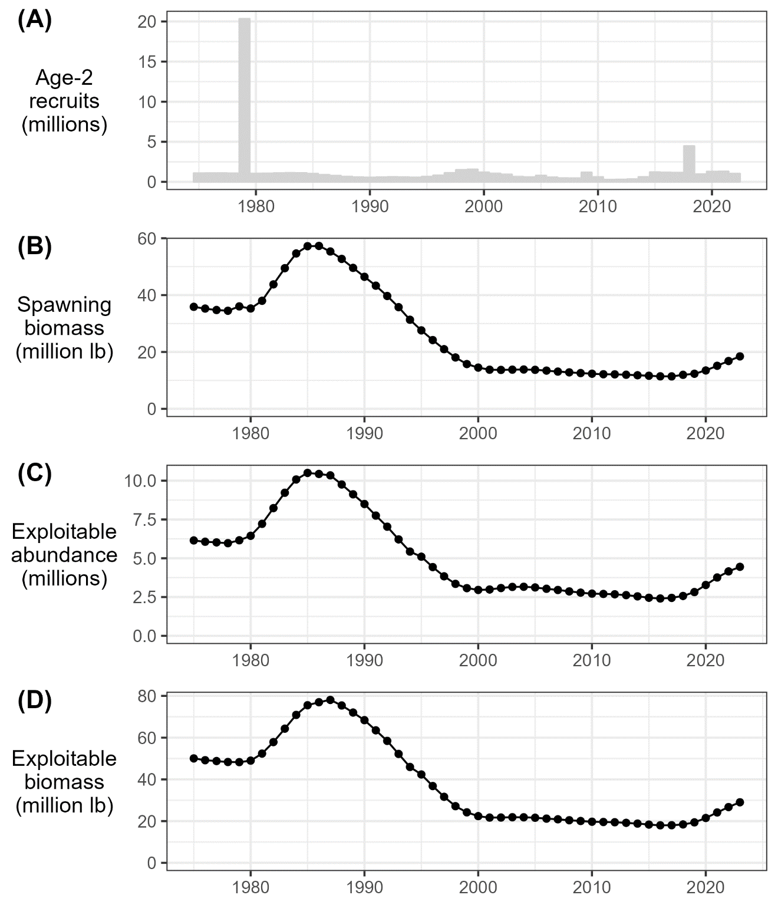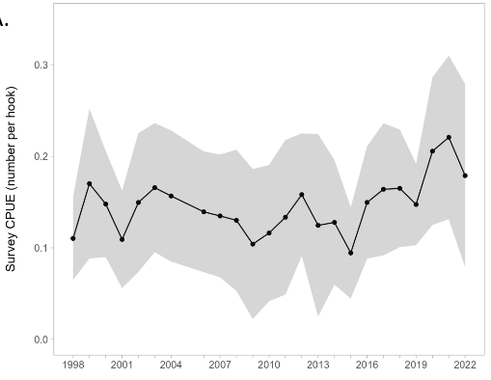

**Figure 3.1a.** Model predictions for the ADFG Northern Southeast Inside (NSEI) sablefish stock assessment (left panels; reproduced here with permission from Phil Joy, pers. comm., https://github.com/commfish/seak_sablefish) of age-2 recruitment (millions; top) and female spawning stock biomass (million pounds; bottom). Southern Southeast Inside (SSEI) sablefish longline survey catch-per-unit-effort (CPUE) in individuals per hook (right panel) from 1998 to 2022 (except 2005; reproduced here with permission from Ehresmann and Olson, 2022).

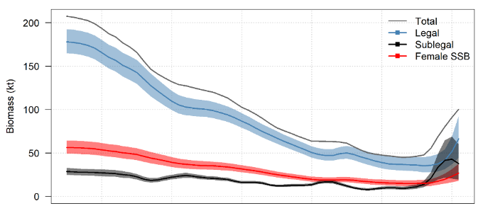

**Figure 3.1b.** Time series of total biomass, legal-sized biomass, sub-legal-sized biomass, and female spawning biomass (SSB) estimates for the British Columbia stock of sablefish based on weighted averages over the five OM scenarios used in 2022. Note that total, legal, and sub-legal biomass estimates include both female and male fish, while SSB is shown for only female Sablefish (reproduced here with permission from Kendra Holt, DFO Canada, pers. comm.).

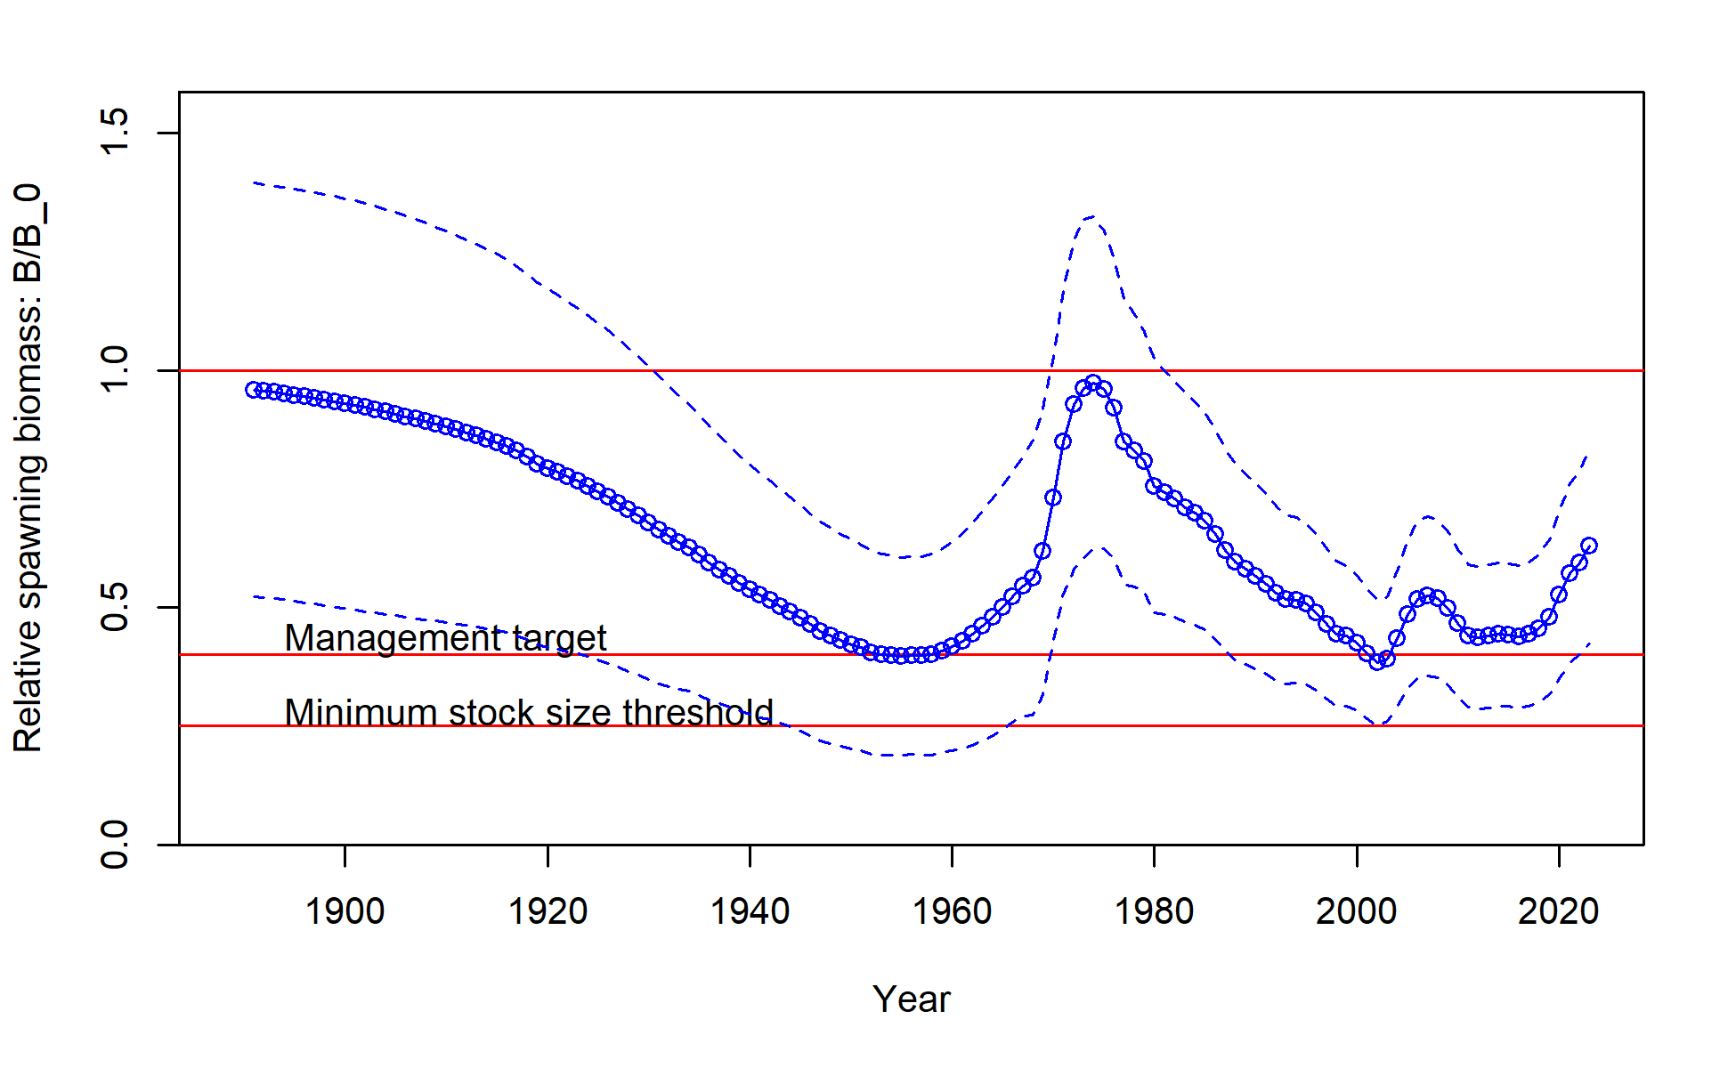

**Figure 3.1c.** Time series of total biomass relative to the unfished biomass for west coast USA sablefish (reproduced here with permission from Johnson et al. 2023).

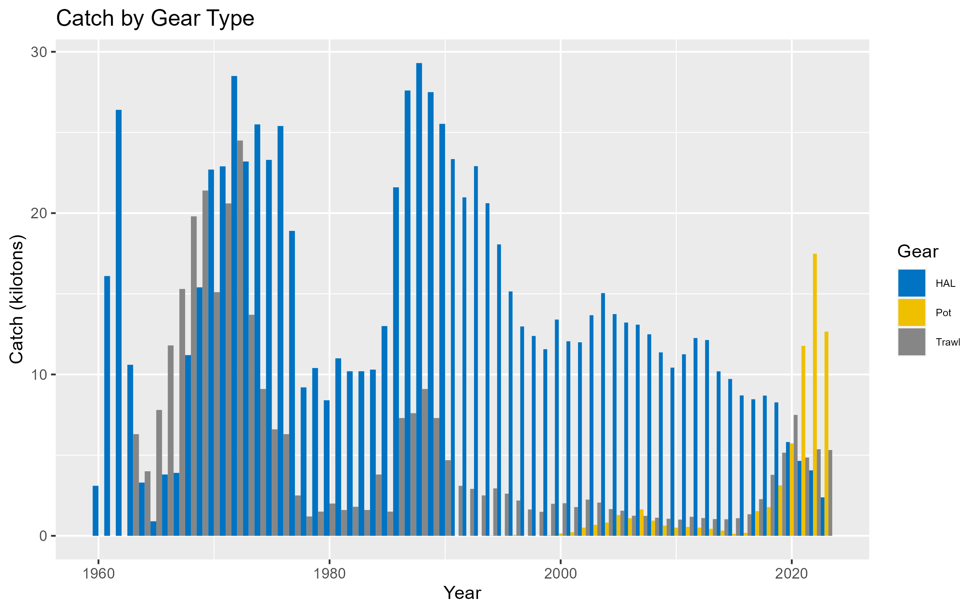

**Figure 3.2**. Sablefish catch (kt) by gear type. Note that hook and line (HAL) and pot gear catch are combined into a single ‘fixed gear’ fleet in the model.

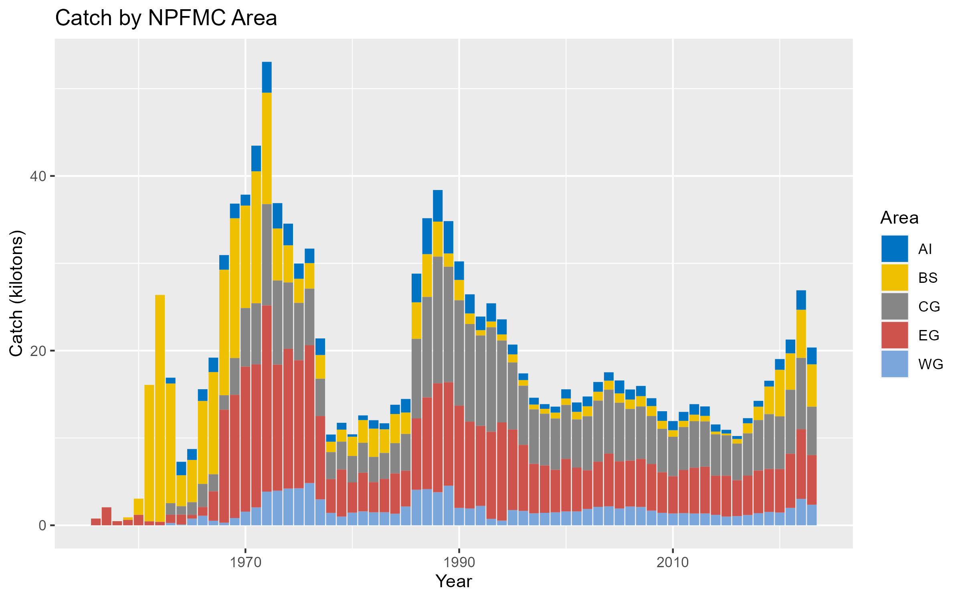

**Figure 3.3.** Sablefish total catch (kt) summed across all fleets by North Pacific Fishery Management Council area.

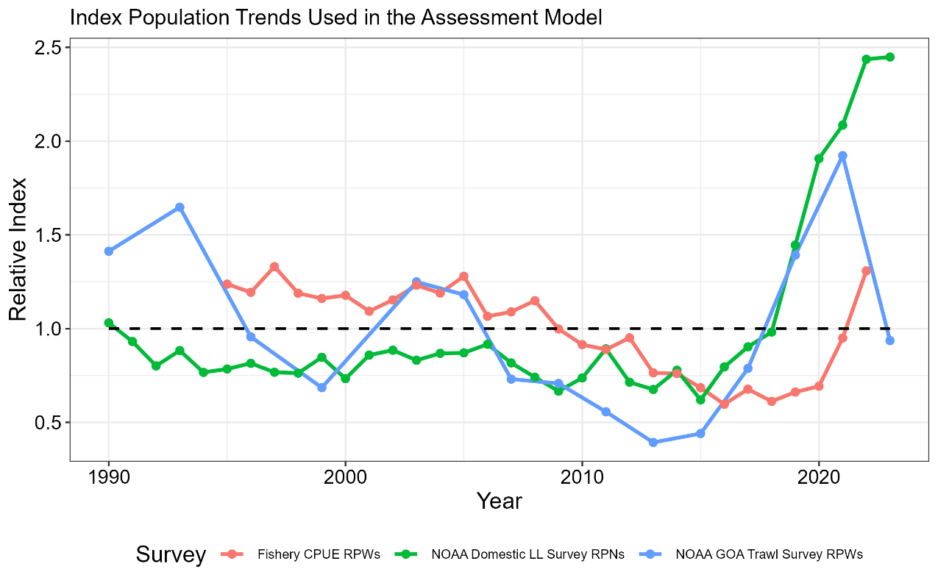

**Figure 3.4.** Comparison of the three indices used in the stock assessment model, including the NOAA domestic longline survey relative population numbers (RPNs), the fixed gear fishery standardized CPUE (in weight), and the NOAA Gulf of Alaska (stations < 500m depth) trawl survey relative population weights (RPWs). Each index is relativized to the associated mean value for the time series.

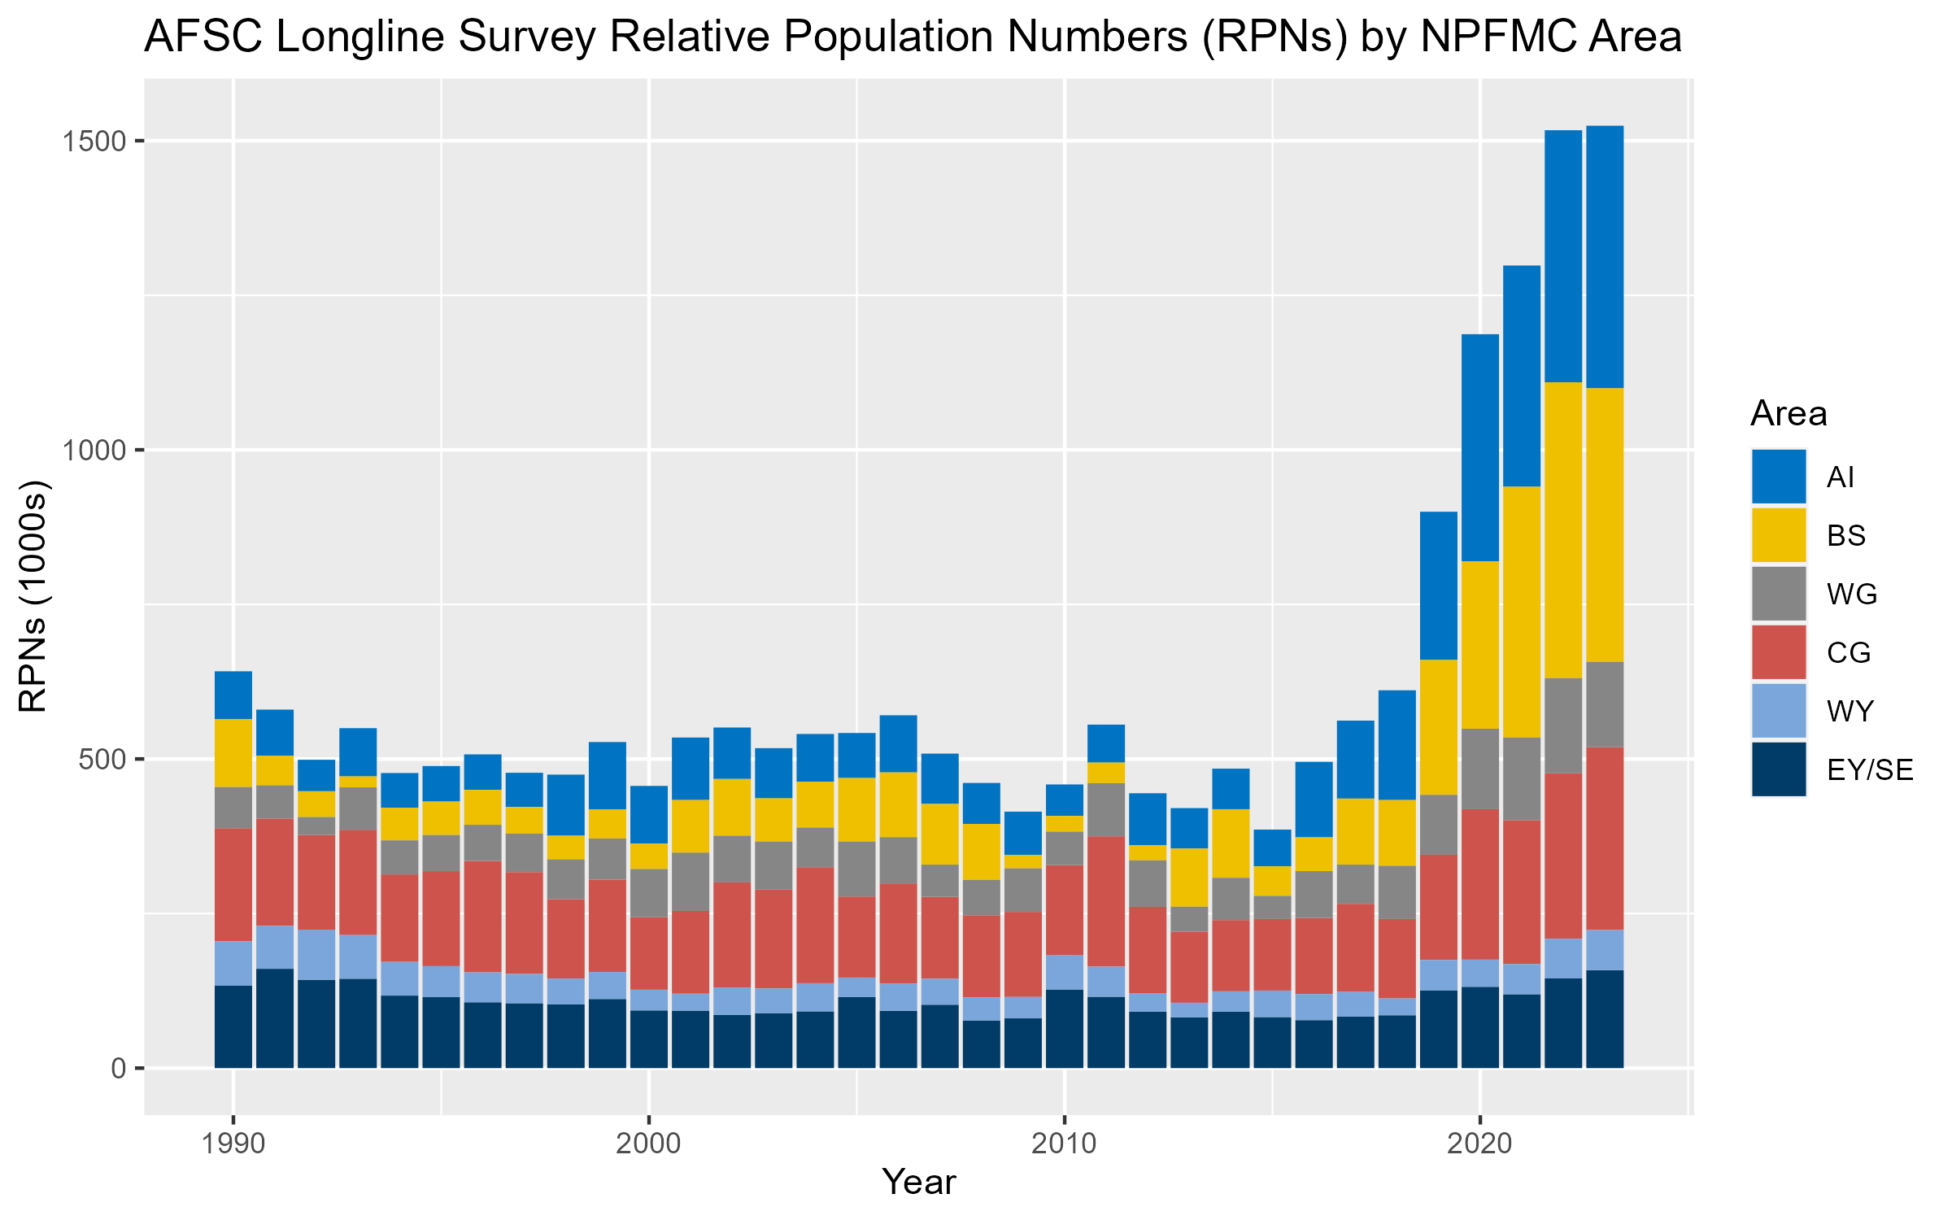

**Figure 3.5.** Relative abundance (relative population number in thousands) by region from the NOAA domestic longline survey. Note that the Bering Sea is surveyed in odd years and the Aleutian Islands are surveyed in even years (i.e., sampling occurs every other year in these regions), and that regional trends for these regions are extrapolated based on the overall trend from the Gulf of Alaska in off years.

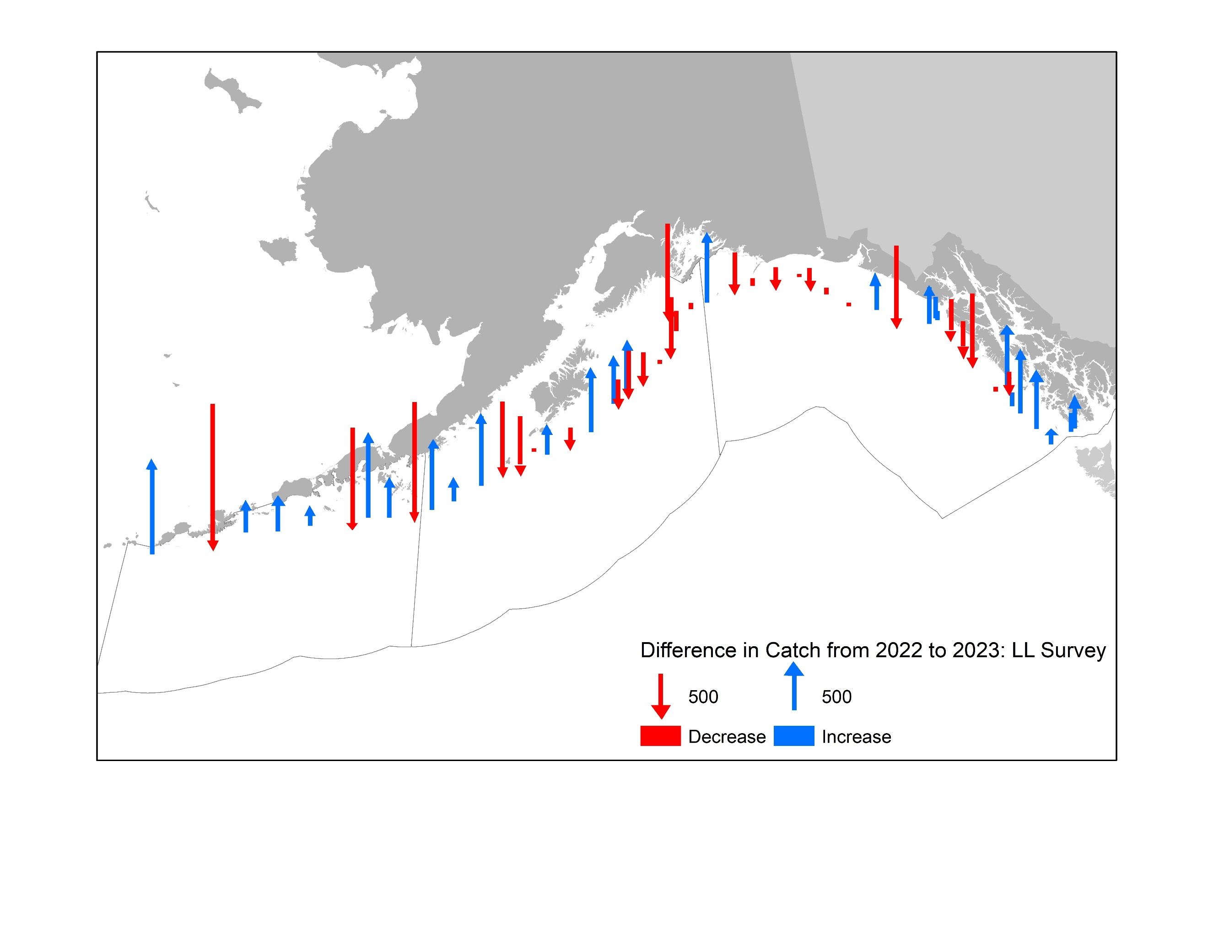

**Figure 3.6.** Comparison of the 2022 and 2023 longline survey in the Gulf of Alaska in terms of the difference in numbers of fish caught per station from 2022 in the 2023 survey. Numbers are not corrected for sperm whale depredation.

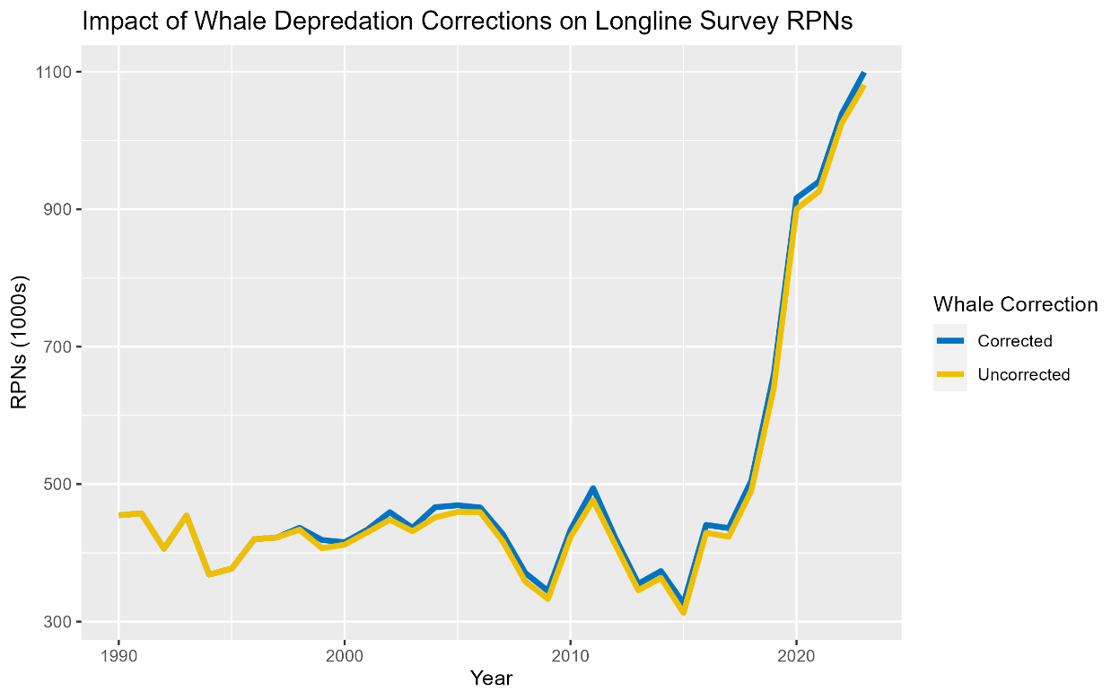

**Figure 3.7.** Longline survey relative population numbers (1000s of fish) with (blue line) and without (yellow line) corrections for sperm whale depredation. Note that these values do not include interpolations for areas not surveyed in the given year (i.e., RPNs are less than the final index by the associated RPN in either the BS or AI, depending on which area was not surveyed).

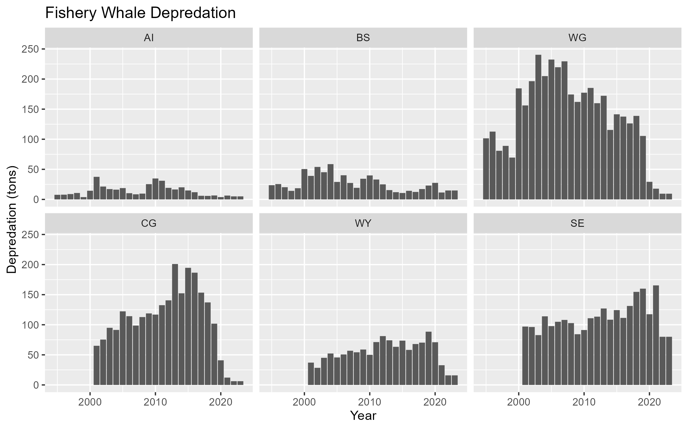

**Figure 3.8.** Estimated whale depredation in the sablefish fixed gear fishery. Depredation estimates reflect catch removals (tons) by region (panel) due to orcas (top row) and sperm whales (bottom row). Starting in 2023, estimates are held constant at 2022 values.

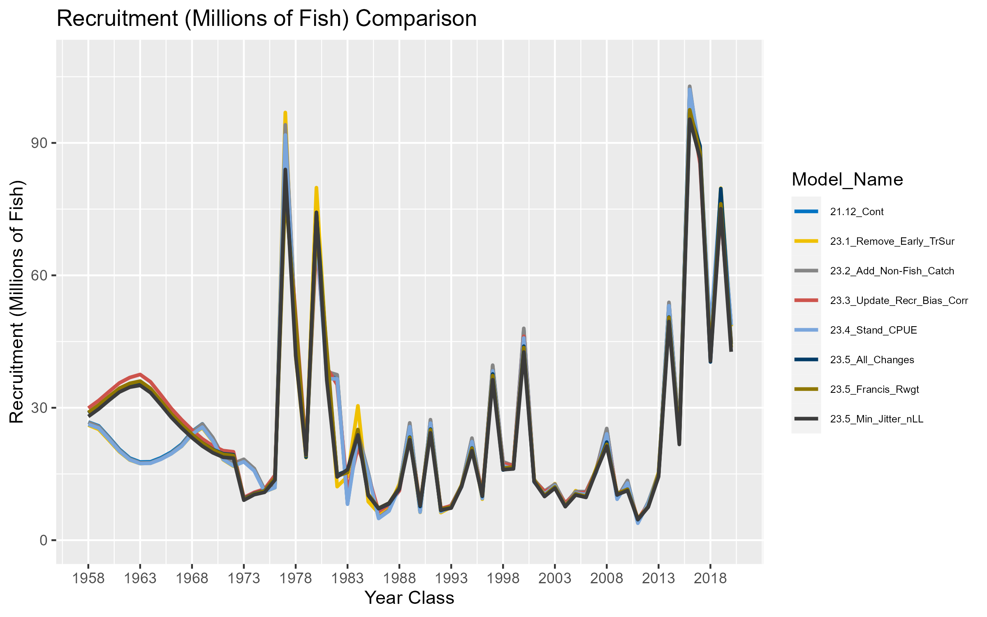

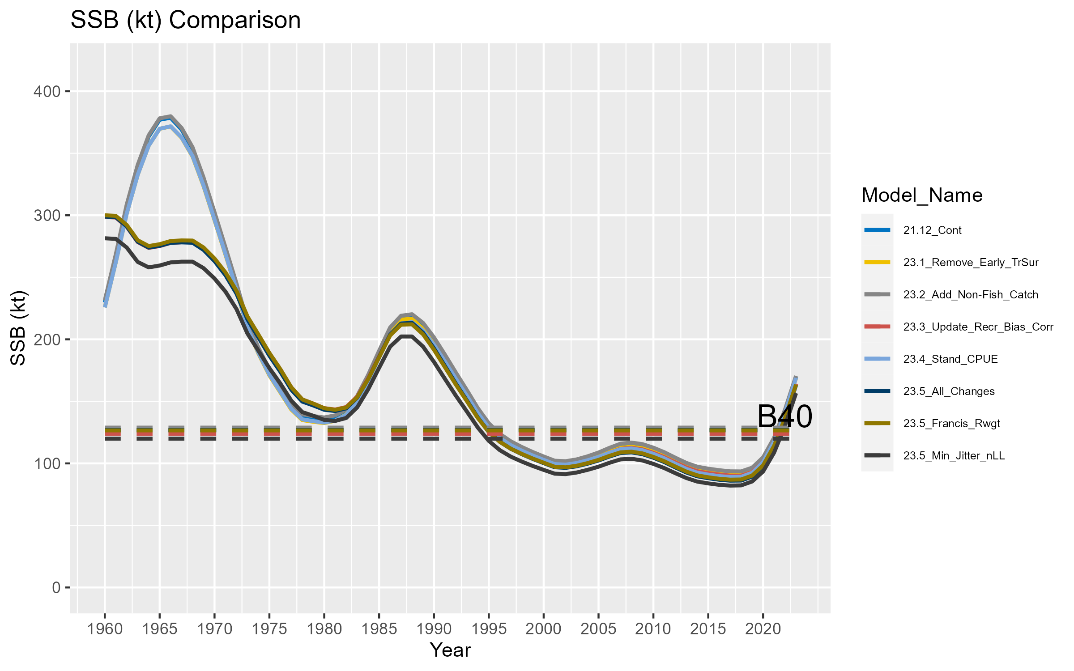

**Figure 3.9.** Results of the model bridging exercise in terms of recruitment (top panel; millions of fish) and spawning stock biomass (bottom panel; kt). See the main text for a description of each model run.

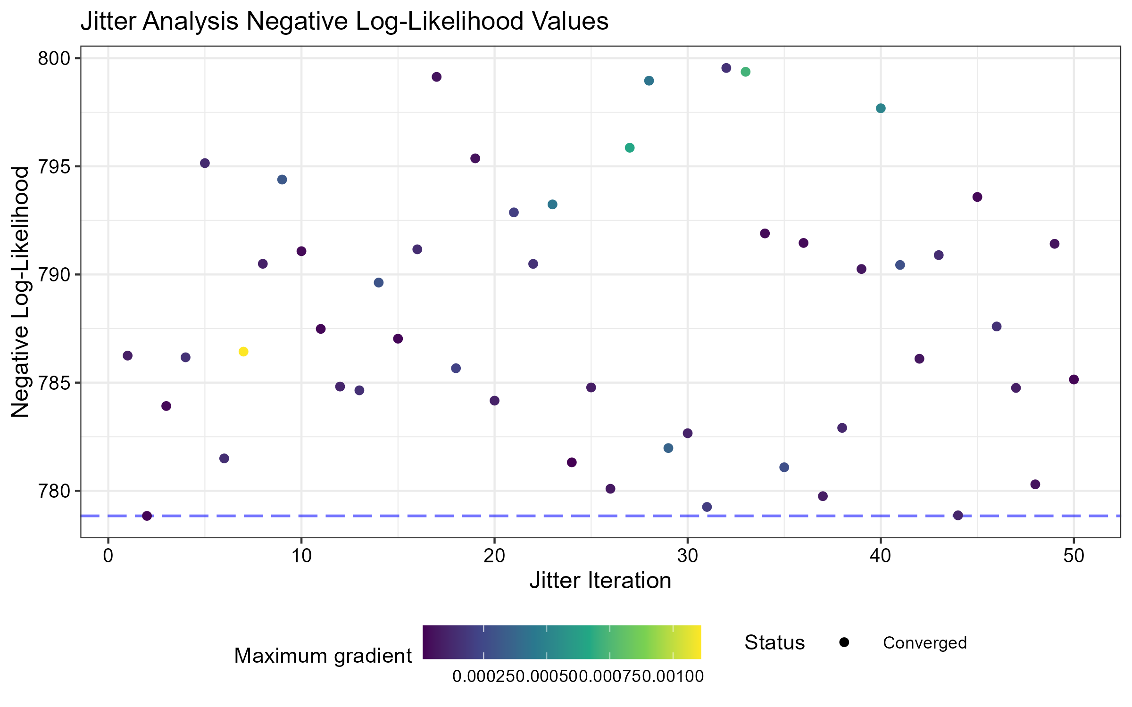

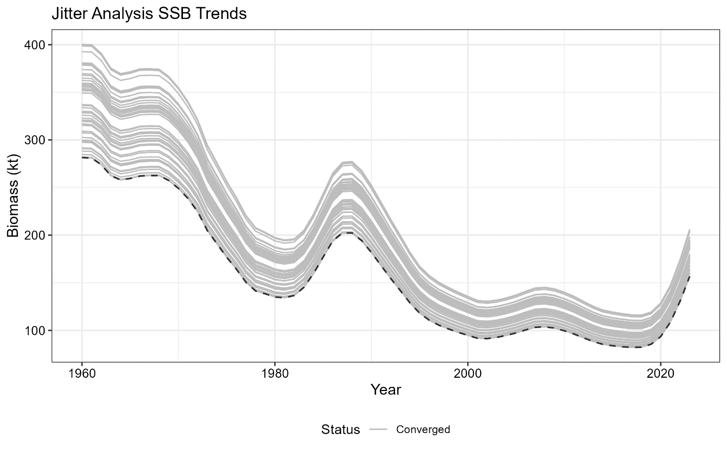

**Figure 3.10.** Results of the jitter analysis in terms of total negative log-likelihood values (top panel) and SSB estimates (kt; bottom panel). All 50 model runs are shown, and the model run demonstrating the lowest negative log-likelihood is emphasized with the dashed line in both panels.

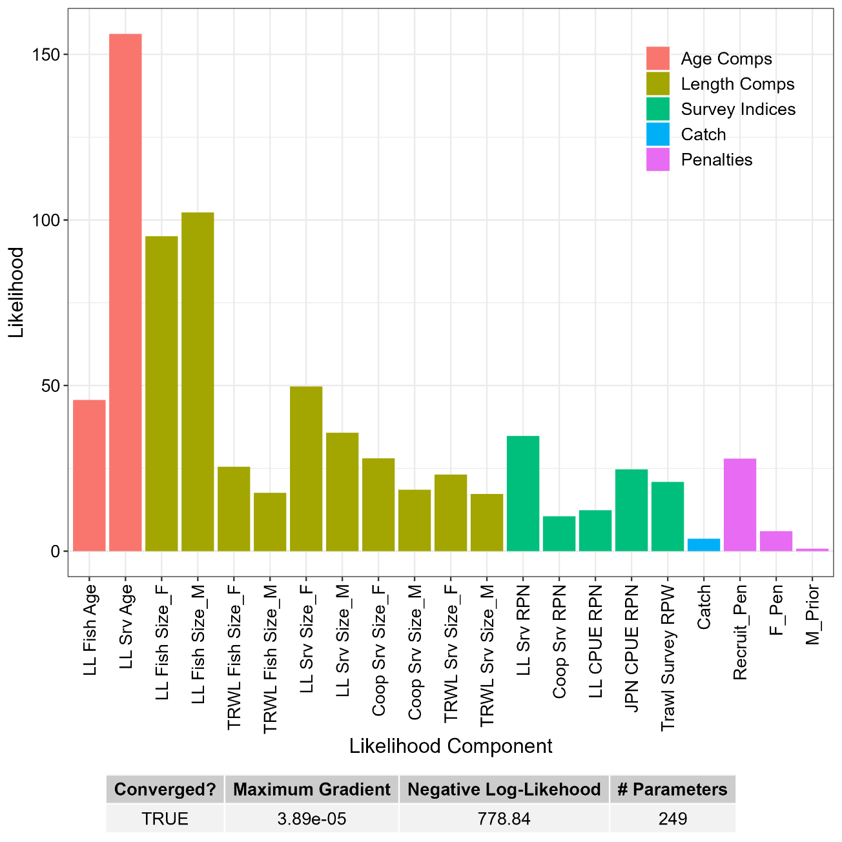

**Figure 3.11.** Contributions to the total negative log-likelihood by data component.

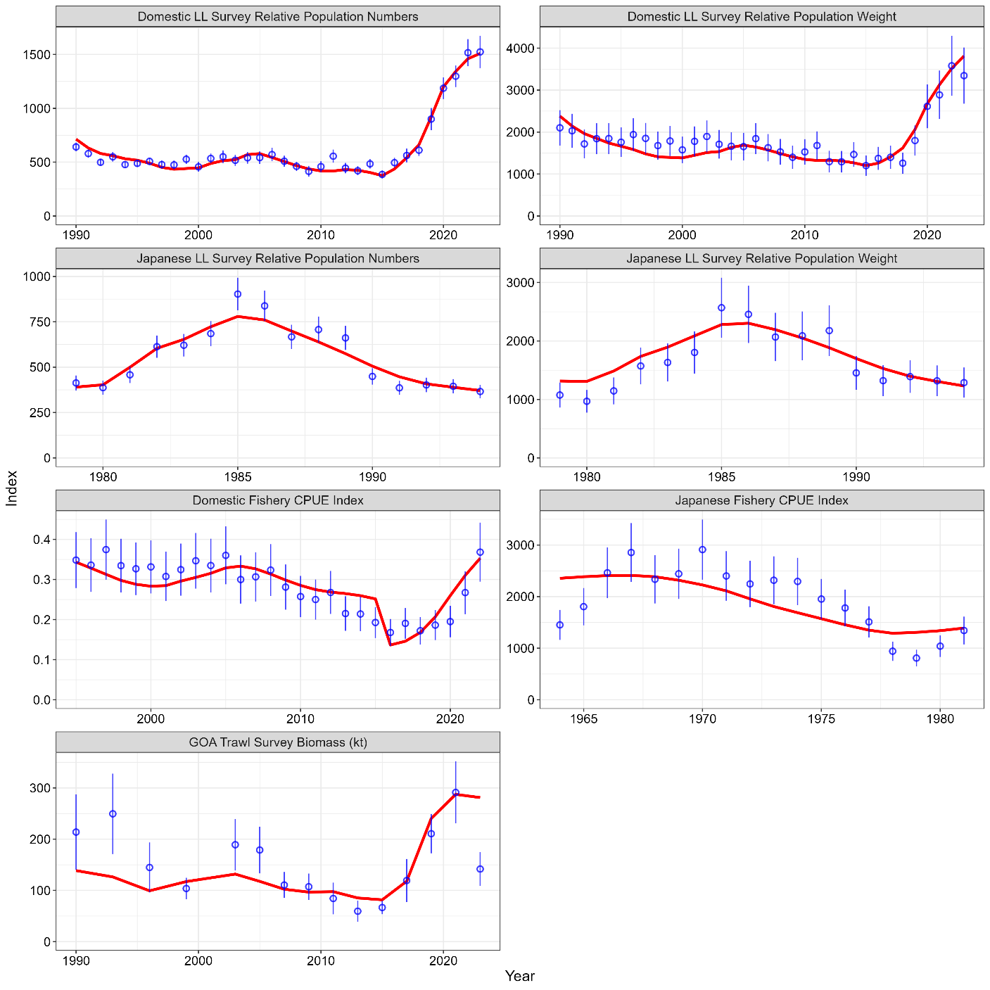

**Figure 3.12.** Observed (blue dots with approximate 95% confidence intervals) and predicted (red lines) sablefish indices of abundance and biomass. By row, these indices are: the NOAA domestic longline survey (top panels) relative population numbers (1,000s of fish; left) and weight (kt; right); the Japanese cooperative survey (second row) relative population numbers (1,000s of fish; left) and weight (kt; right); fishery CPUE indices (in weight; third row) for the domestic fishery (standardized; left) and historic Japanese fishery (kt; right); and the NOAA Gulf of Alaska (stations < 500m depth) trawl survey (kt; bottom panel) relative population weight. For the NOAA and Japanese longline surveys, only the relative population numbers are fit in the model, but the associated weights are presented for comparison.

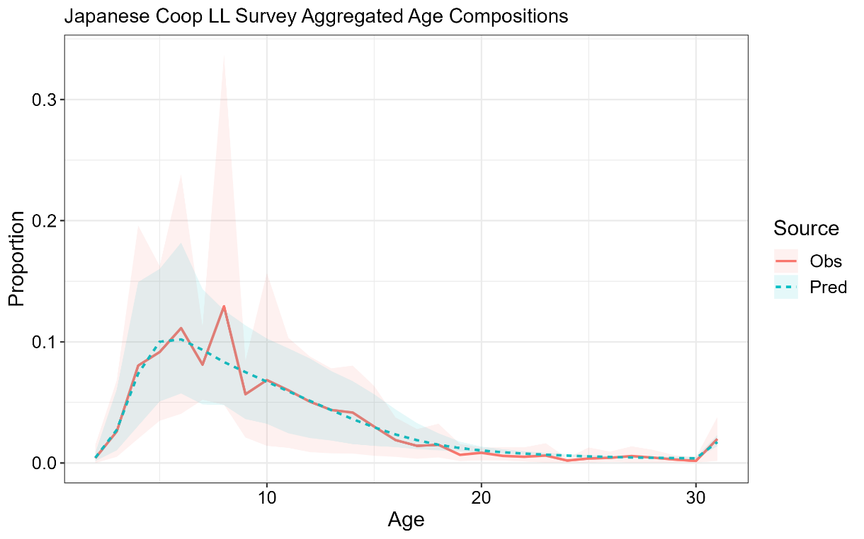

**Figure 3.13.** Mean observed (red line) Japanese cooperative longline survey age compositions aggregated across years and sexes along with the average fit of the model (blue line). The red fill is the 90% empirical confidence intervals, while the blue fill is the model estimated 90% confidence intervals.

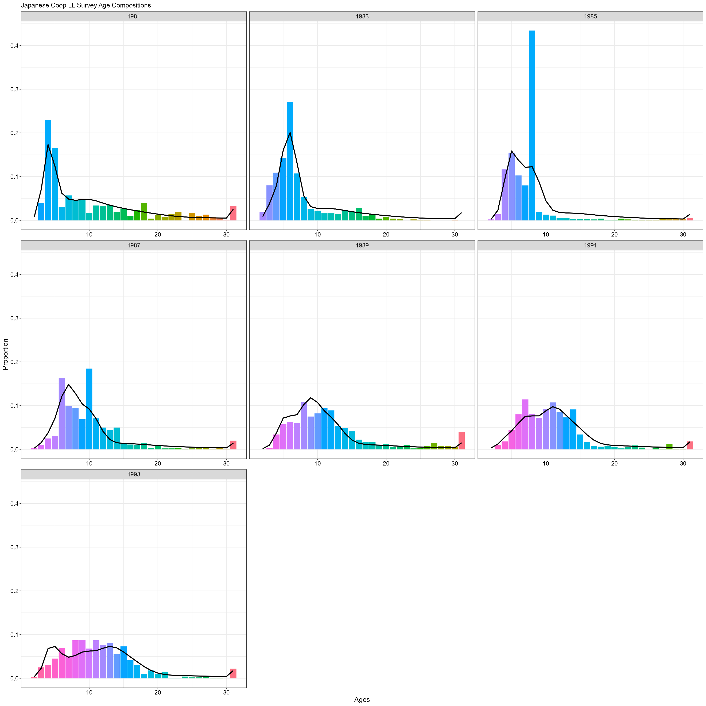

**Figure 3.14.** Japanese cooperative longline survey age compositions. Bars are observed frequencies and the line is predicted frequencies.

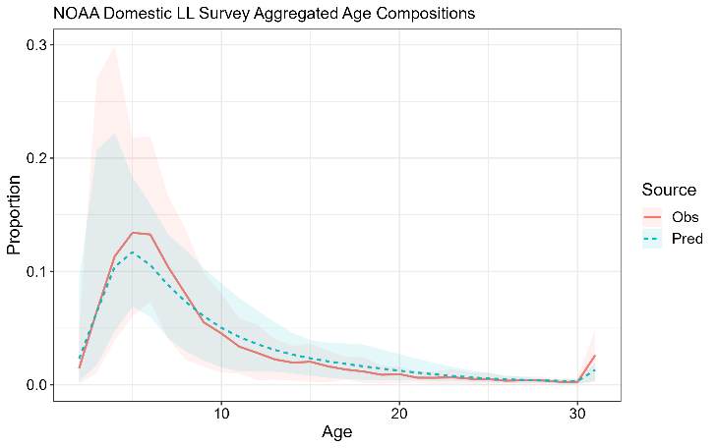

**Figure 3.15.** Mean observed (red line) NOAA domestic longline survey age compositions aggregated across years and sexes along with the average fit of the model (blue line). The red fill is the 90% empirical confidence intervals, while the blue fill is the model estimated 90% confidence intervals.

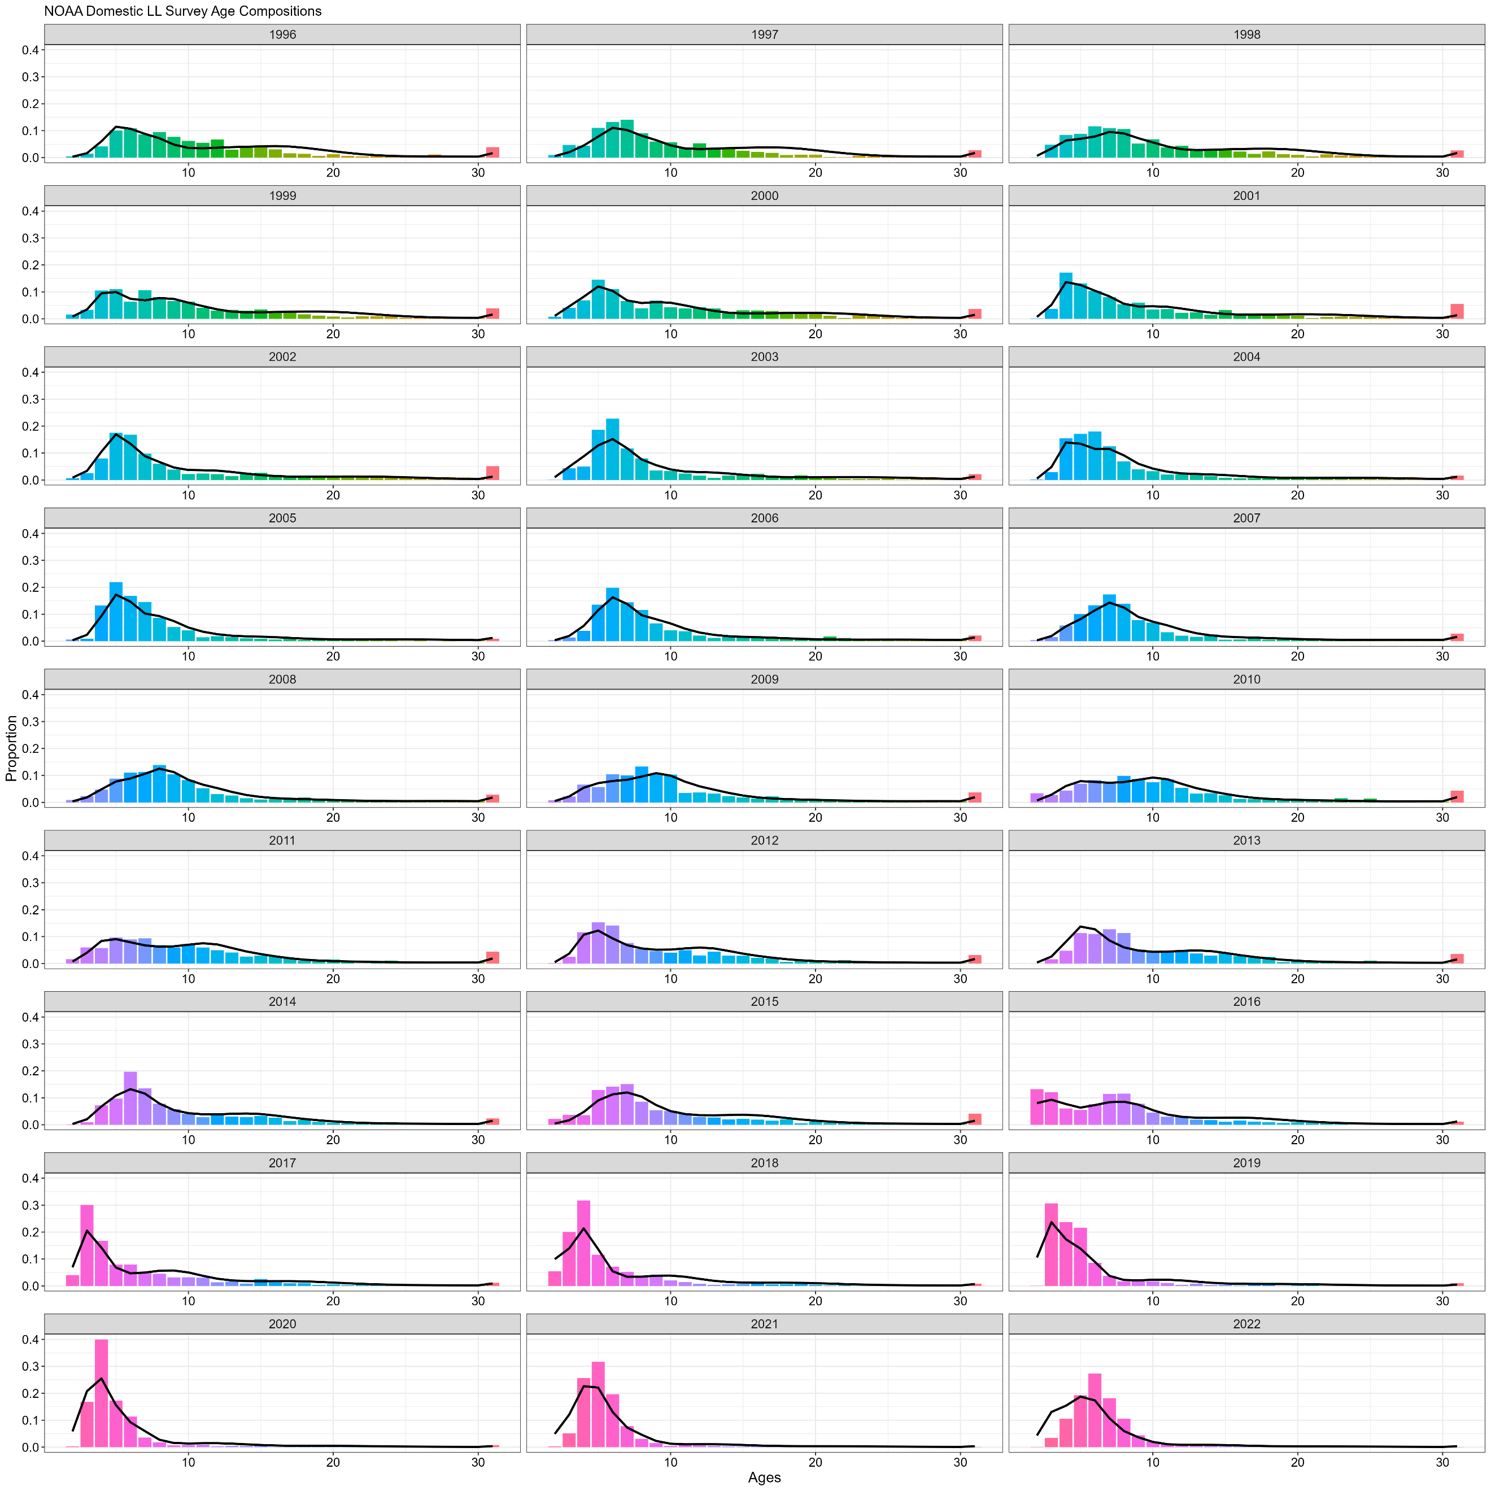

**Figure 3.16.** NOAA domestic longline survey age compositions. Bars are observed frequencies and lines are predicted frequencies.

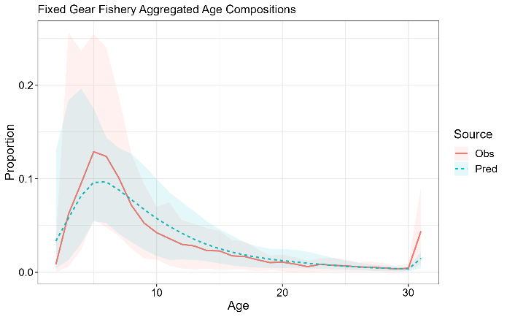

**Figure 3.17.** Mean observed (red line) fixed gear fishery age compositions aggregated across years and sexes along with the average fit of the model (blue line). The red fill is the 90% empirical confidence intervals, while the blue fill is the model estimated 90% confidence intervals.

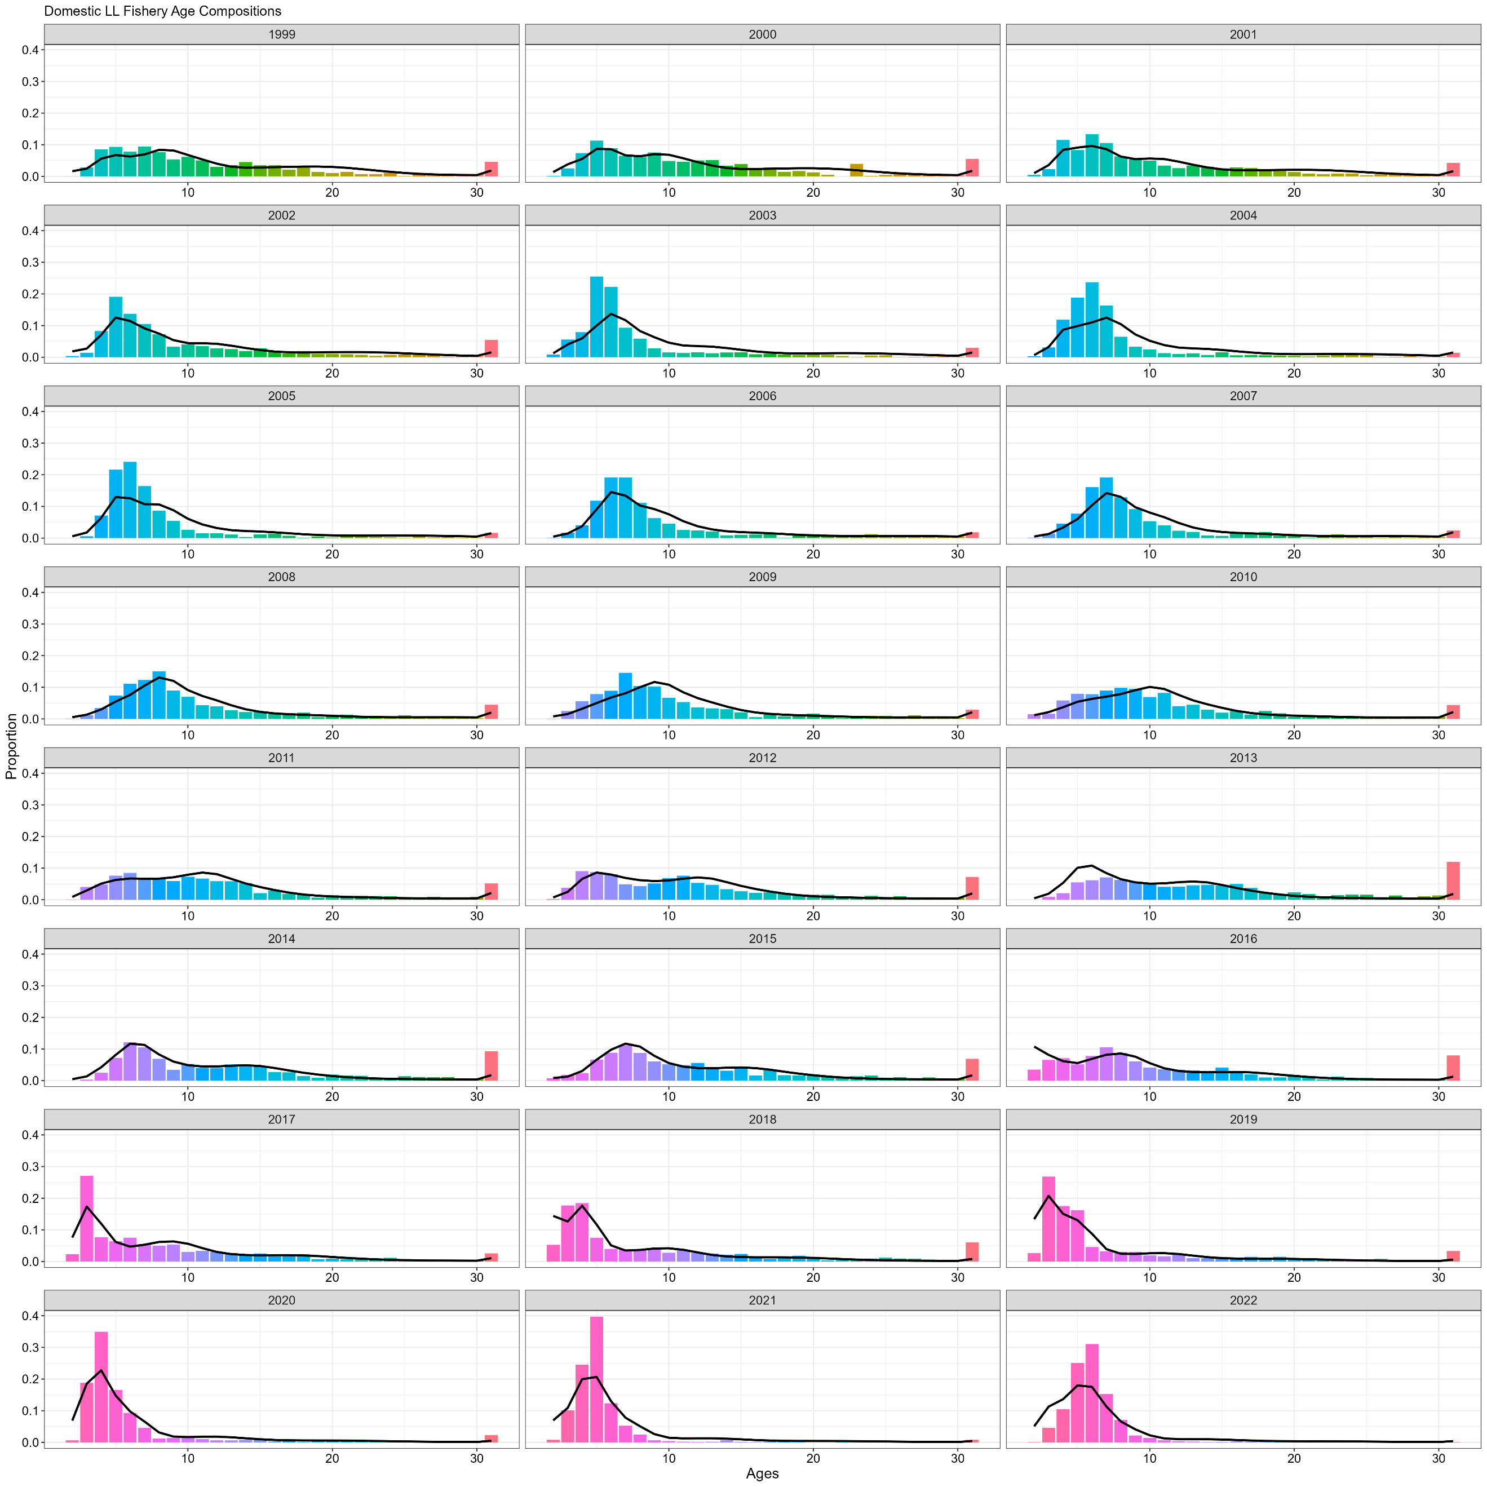

**Figure 3.18.** Domestic fixed gear fishery age compositions. Bars are observed frequencies and lines are predicted frequencies.

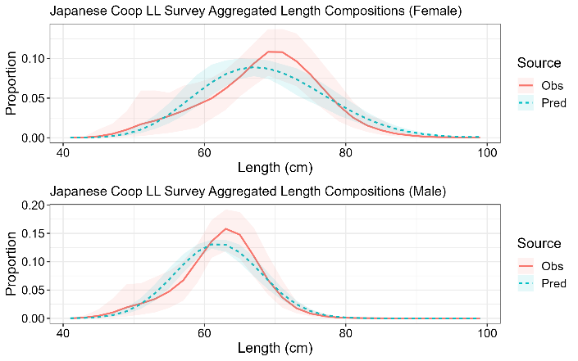

**Figure 3.19.** Mean observed (red line) Japanese cooperative longline survey length compositions aggregated across years along with the average fit of the model (blue line). The red fill is the 90% empirical confidence intervals, while the blue fill is the model estimated 90% confidence intervals. Fit to female length compositions are in the top panel and fit to male length compositions are in the bottom panel.

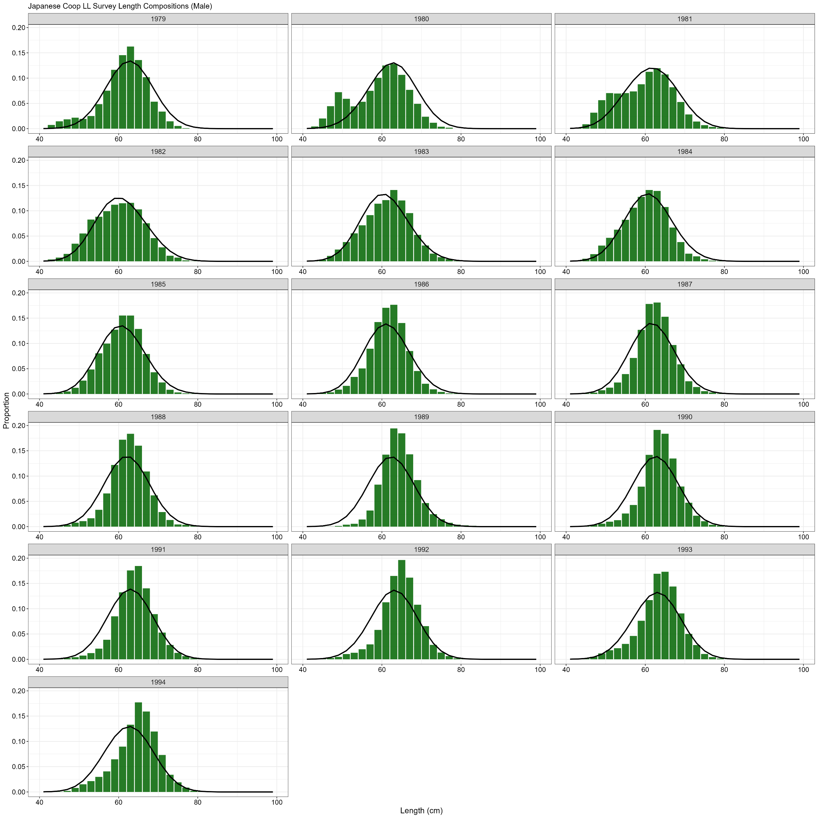

**Figure 3.20.** Japanese cooperative longline survey male length compositions. Bars are observed frequencies and lines are predicted frequencies.

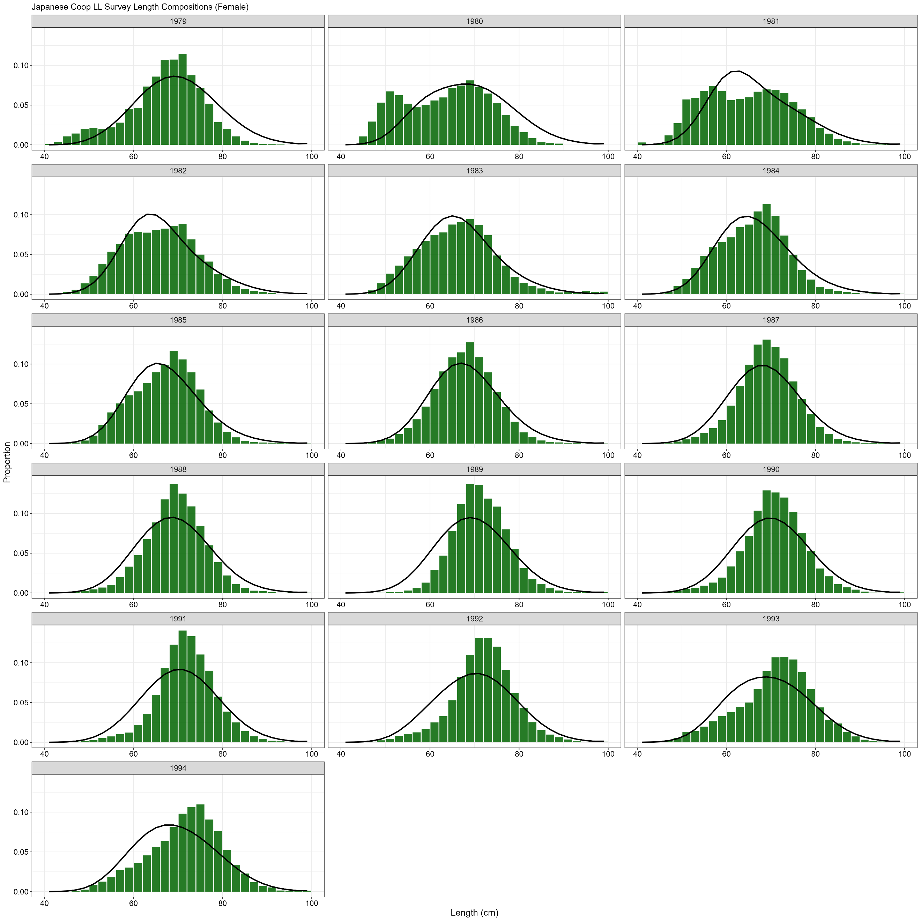

**Figure 3.21.** Japanese cooperative longline survey female length compositions. Bars are observed frequencies and lines are predicted frequencies.

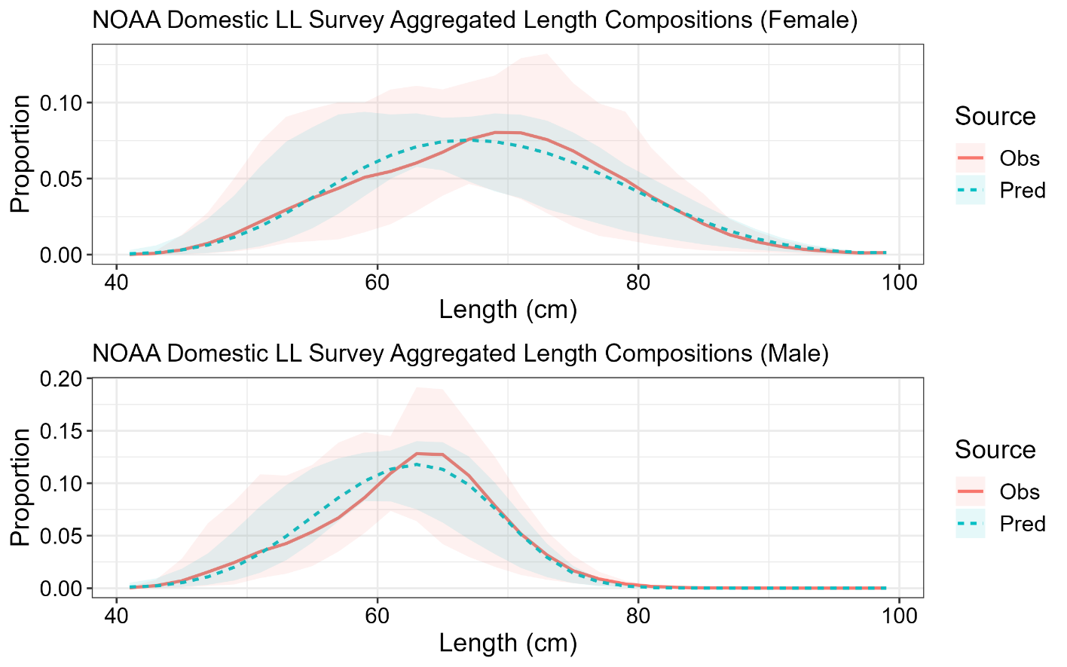

**Figure 3.22.** Mean observed (red line) NOAA domestic longline survey length compositions aggregated across years along with the average fit of the model (blue line). The red fill is the 90% empirical confidence intervals, while the blue fill is the model estimated 90% confidence intervals. Fit to female length compositions are in the top panel and fit to male length compositions are in the bottom panel.

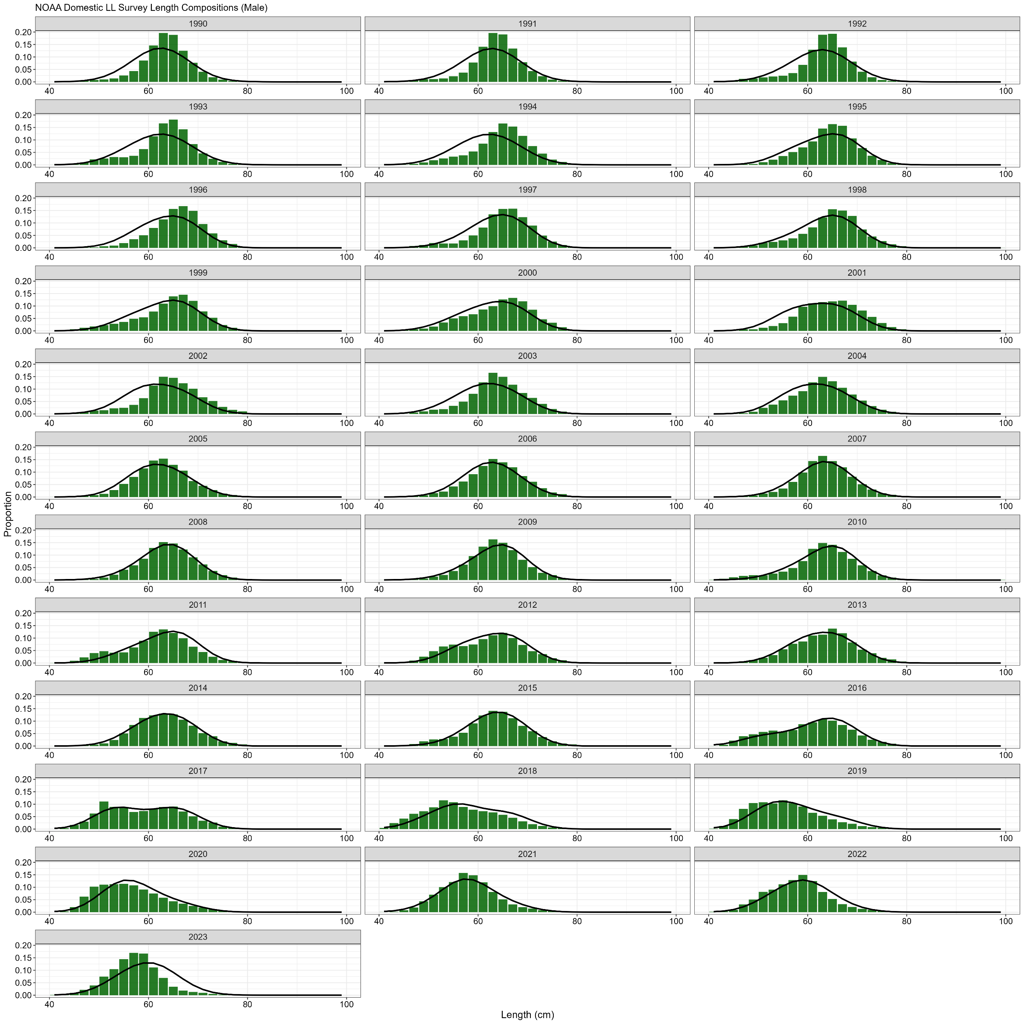

**Figure 3.23.** NOAA domestic longline survey length (cm) compositions for males. Bars are observed frequencies and lines are predicted frequencies.

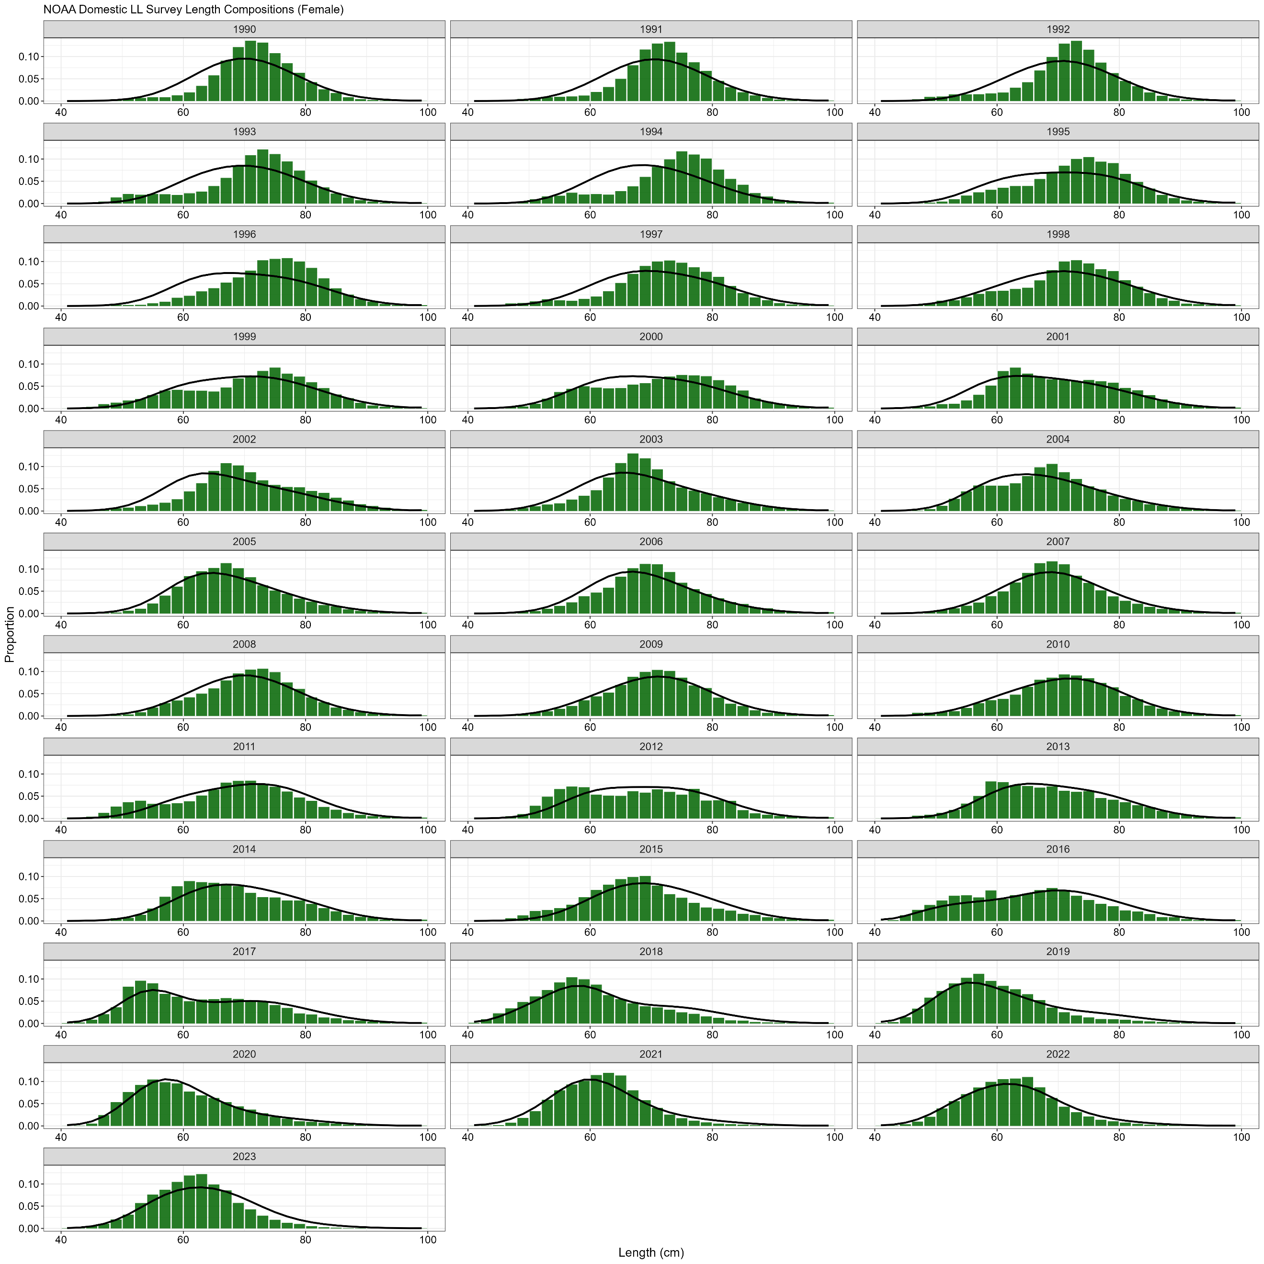

**Figure 3.24.** NOAA domestic longline survey length (cm) compositions for females. Bars are observed frequencies and lines are predicted frequencies.

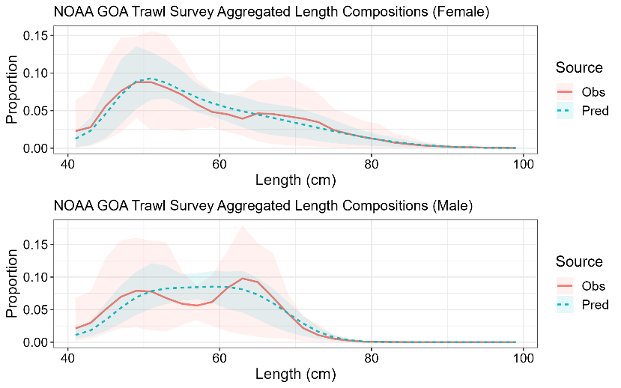

**Figure 3.25.** Mean observed (red line) NOAA Gulf of Alaska trawl survey (stations < 500m depth) length compositions aggregated across years along with the average fit of the model (blue line). The red fill is the 90% empirical confidence intervals, while the blue fill is the model estimated 90% confidence intervals. Fit to female length compositions are in the top panel and fit to male length are in the bottom panel.

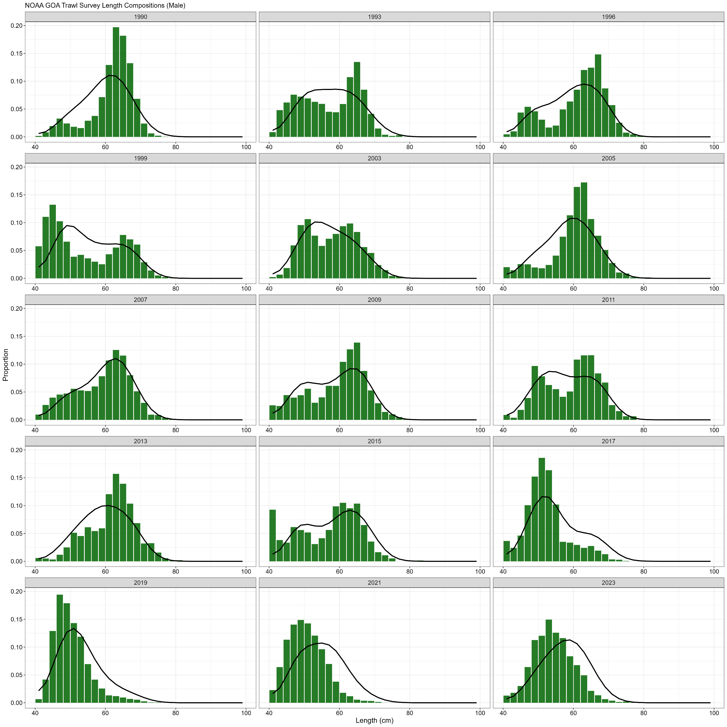

**Figure 3.26.** NOAA Gulf of Alaska (stations < 500m depth) trawl survey length (cm) compositions for males. Bars are observed frequencies and lines are predicted frequencies.

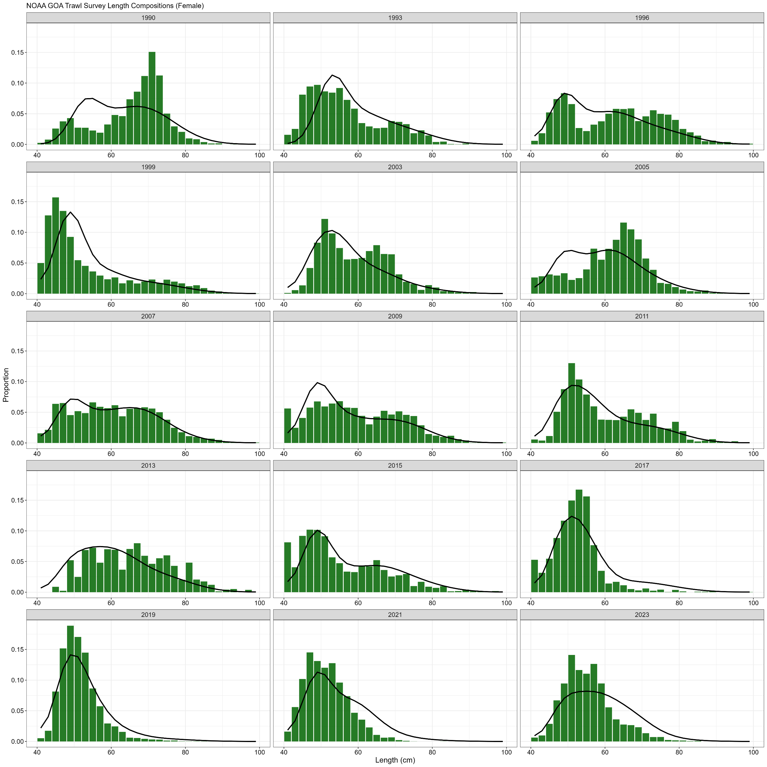

**Figure 3.27.** NOAA Gulf of Alaska (stations < 500m depth) trawl survey length (cm) compositions for females. Bars are observed frequencies and lines are predicted frequencies.

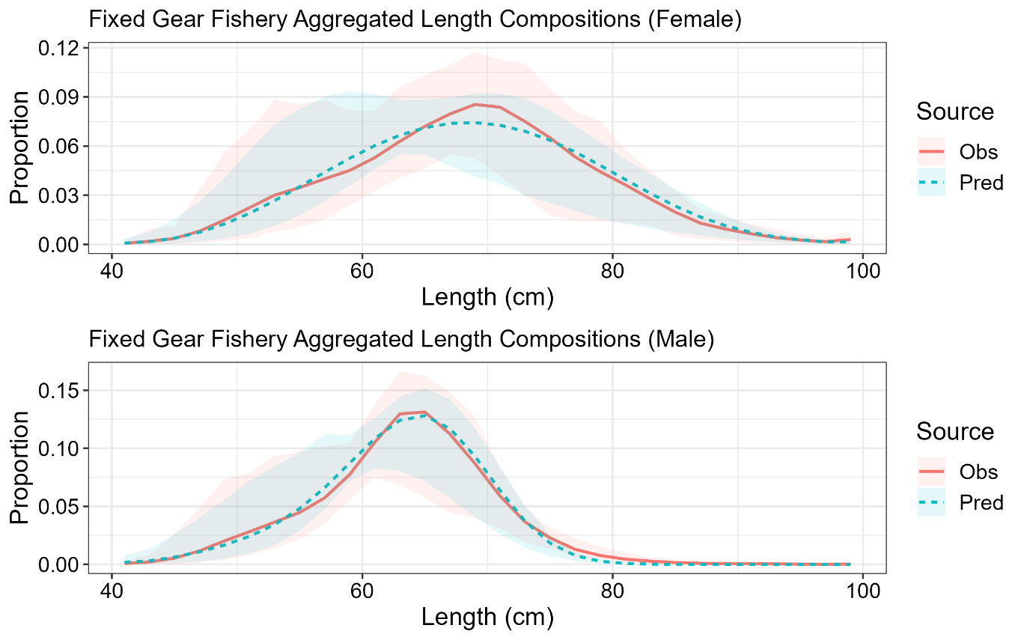

**Figure 3.28.** Mean observed (red line) domestic fixed gear fishery length compositions aggregated across years along with the average fit of the model (blue line). The red fill is the 90% empirical confidence intervals, while the blue fill is the model estimated 90% confidence intervals. Fit to female length compositions are in the top panel and fit to male length compositions are in the bottom panel.

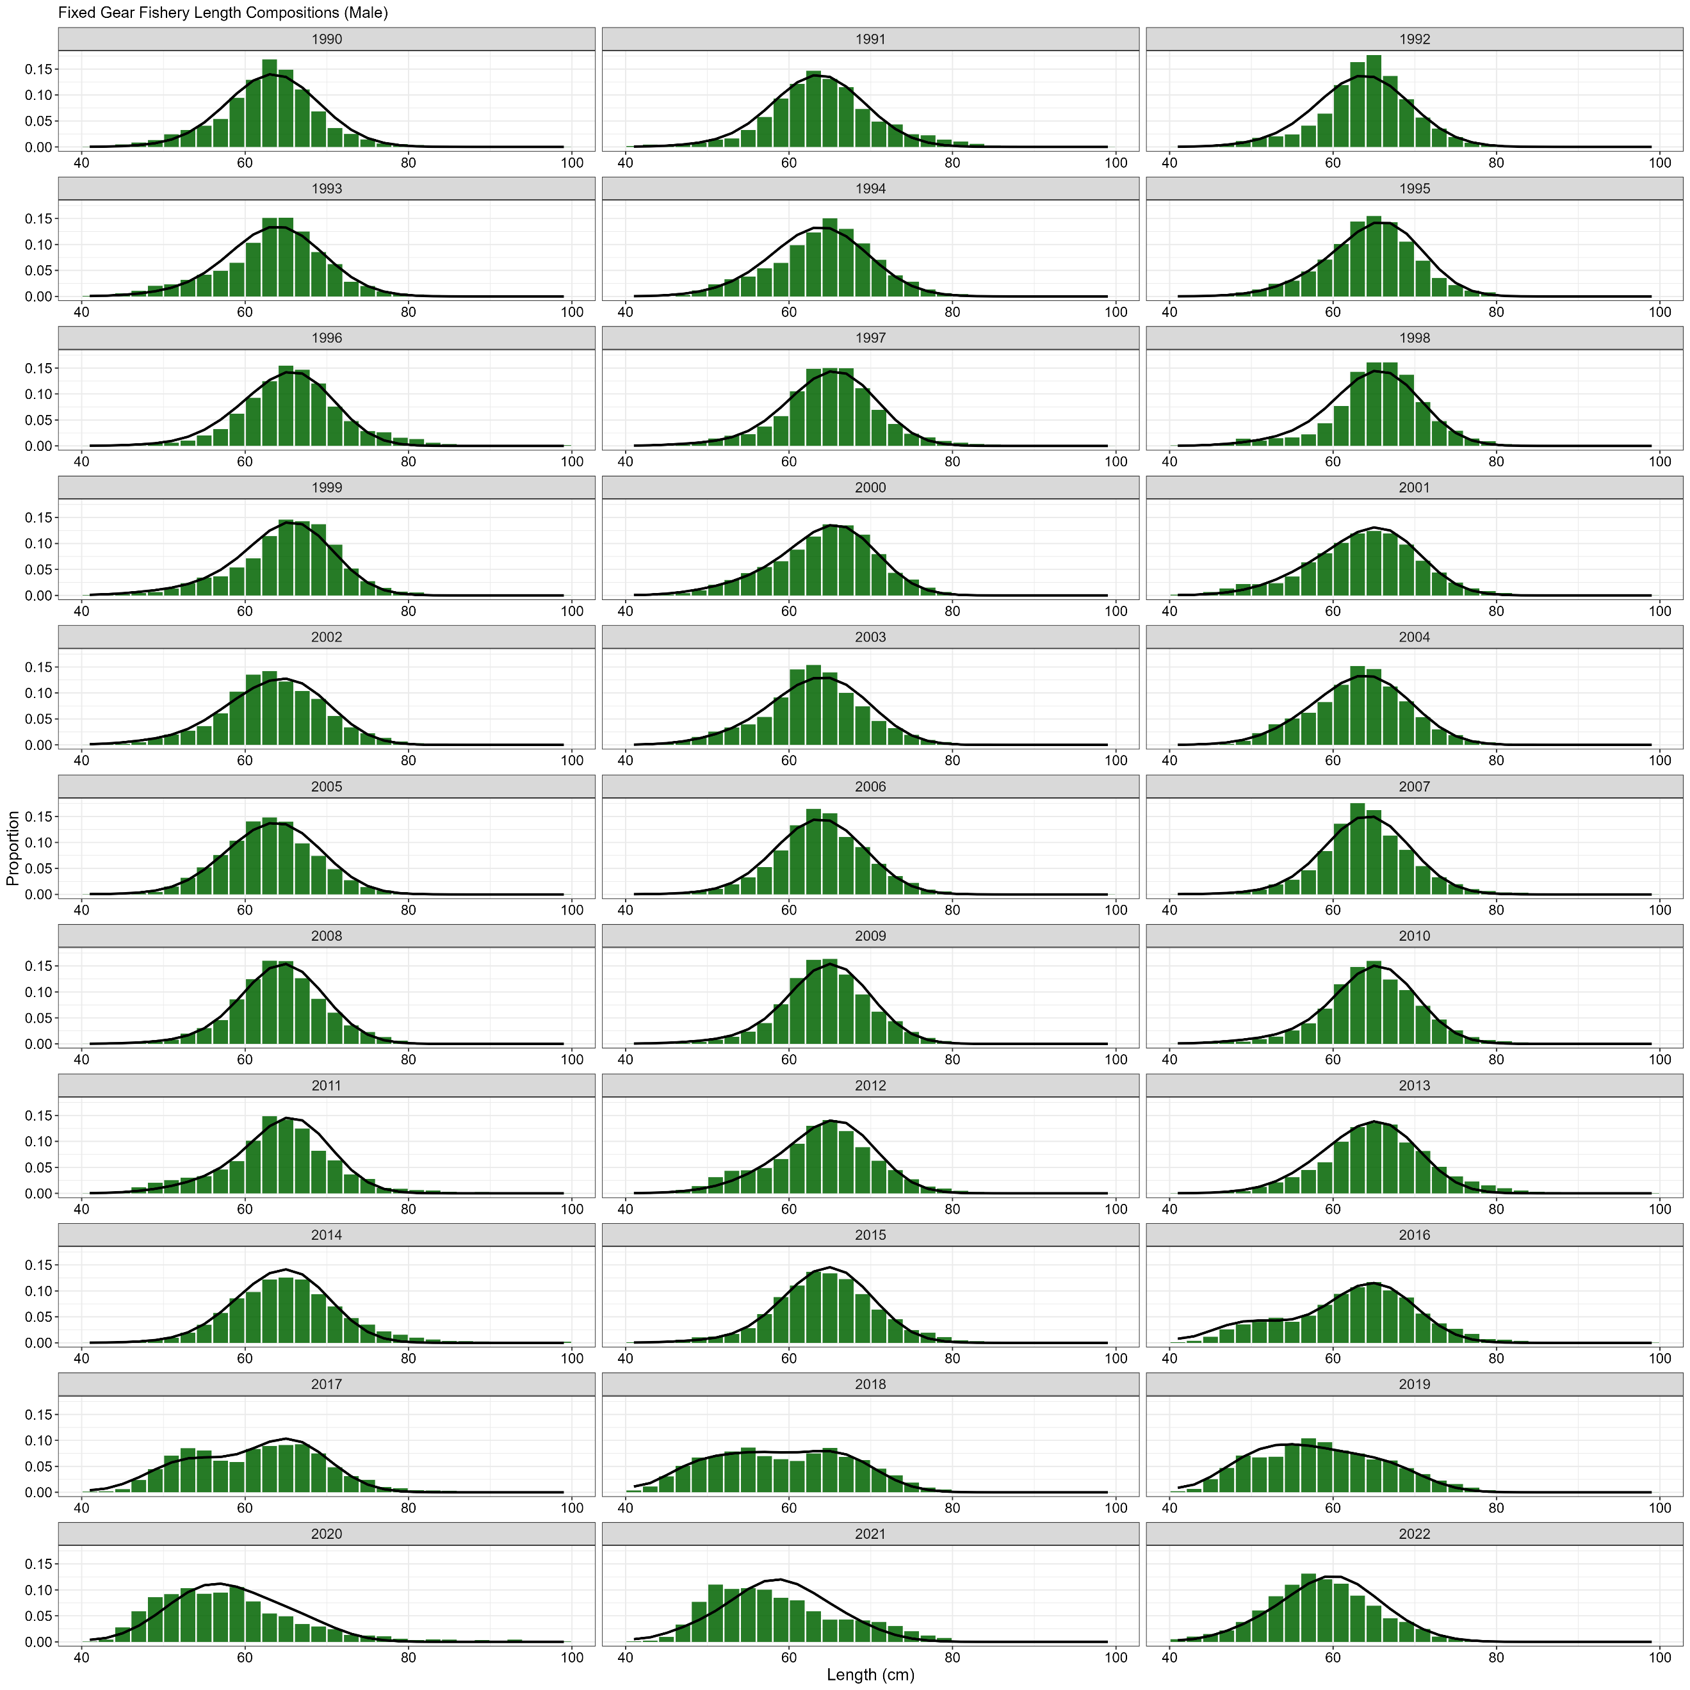

**Figure 3.29.** Domestic fixed gear fishery length (cm) compositions for males. Bars are observed frequencies and lines are predicted frequencies.

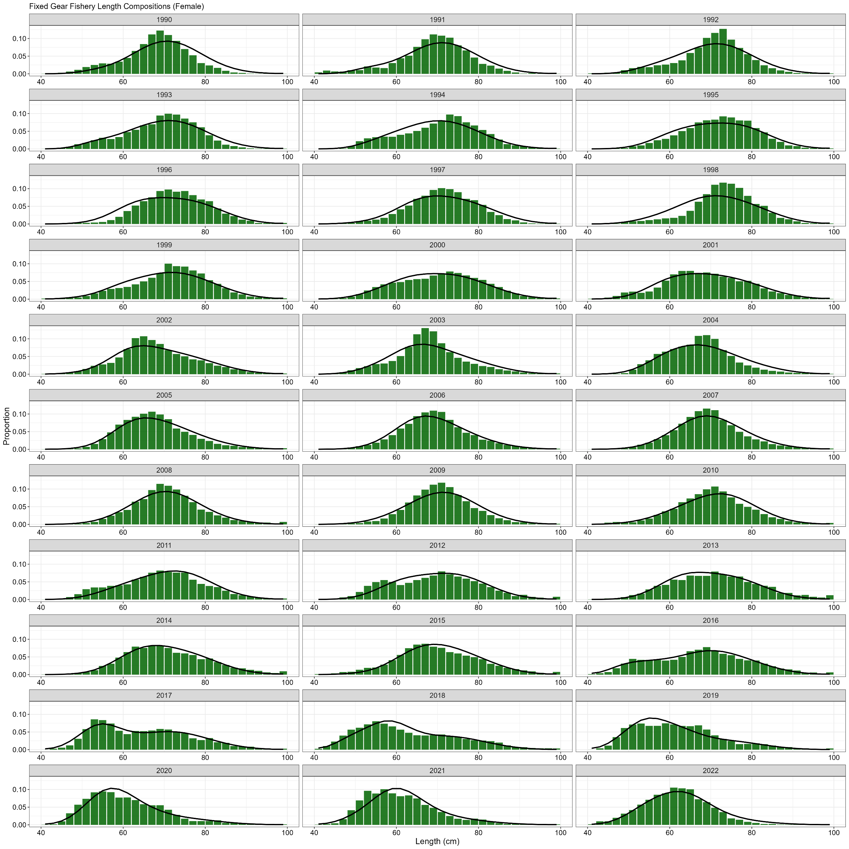

**Figure 3.30.** Domestic fixed gear fishery length (cm) compositions for females. Bars are observed frequencies and lines are predicted frequencies.

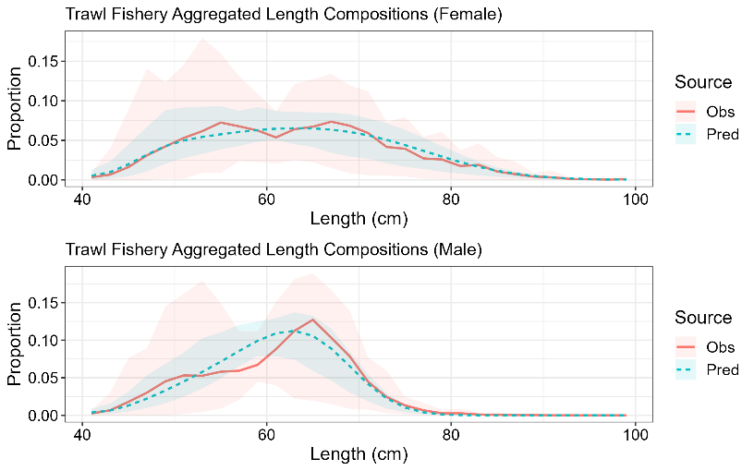

**Figure 3.31.** Mean observed (red line) domestic trawl gear fishery length compositions aggregated across years along with the average fit of the model (blue line). The red fill is the 90% empirical confidence intervals, while the blue fill is the model estimated 90% confidence intervals. Fit to female length compositions are in the top panel and fit to male length compositions are in the bottom panel.

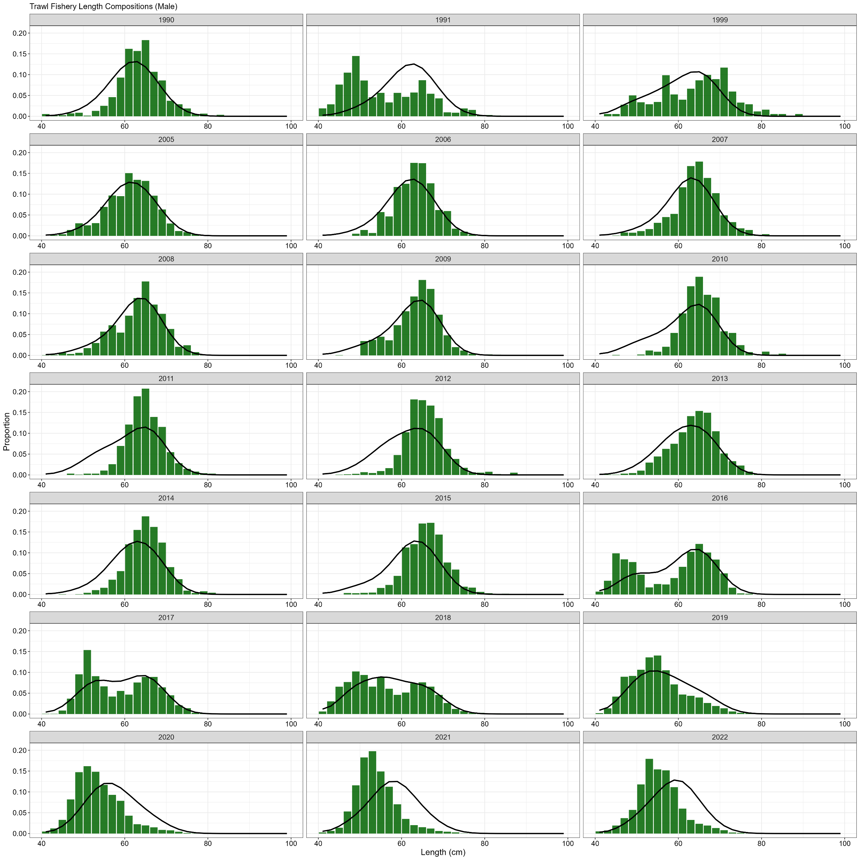

**Figure 3.32.** Domestic trawl gear fishery length (cm) compositions for males. Bars are observed frequencies and lines are predicted frequencies.

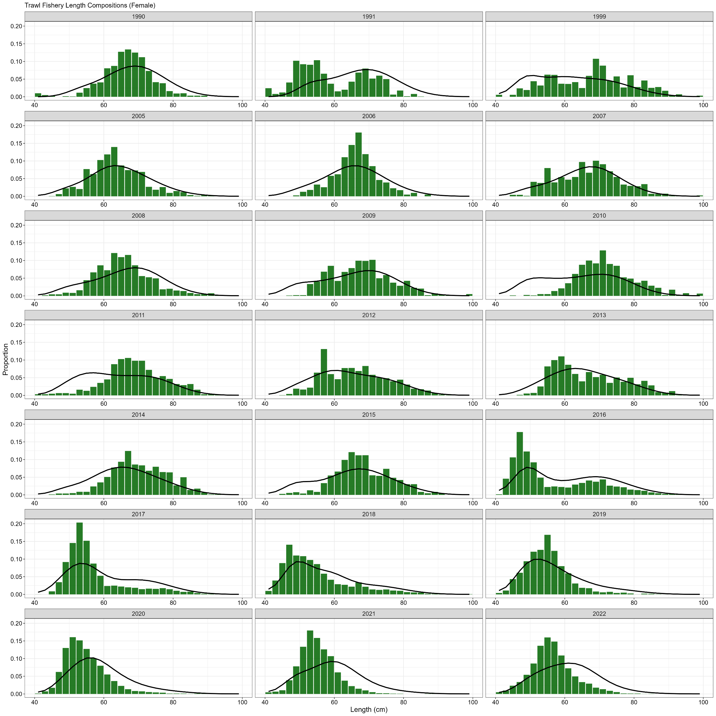

**Figure 3.33.** Domestic trawl gear fishery length (cm) compositions for females. Bars are observed frequencies and lines are predicted frequencies.

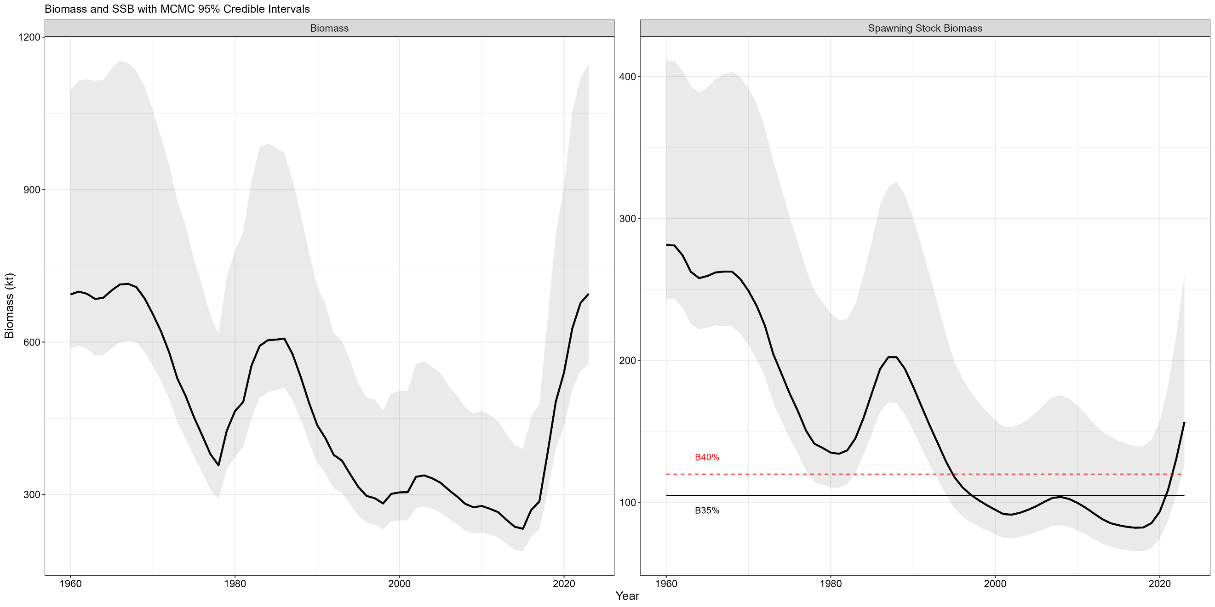

**Figure 3.34.** Estimated sablefish total biomass (top panel) and spawning biomass (bottom panel) with 95% MCMC credible intervals (grey fill). Values are in kilotons. The B35% (black solid line) and B40% (red dashed line) reference points are shown on the SSB panel.

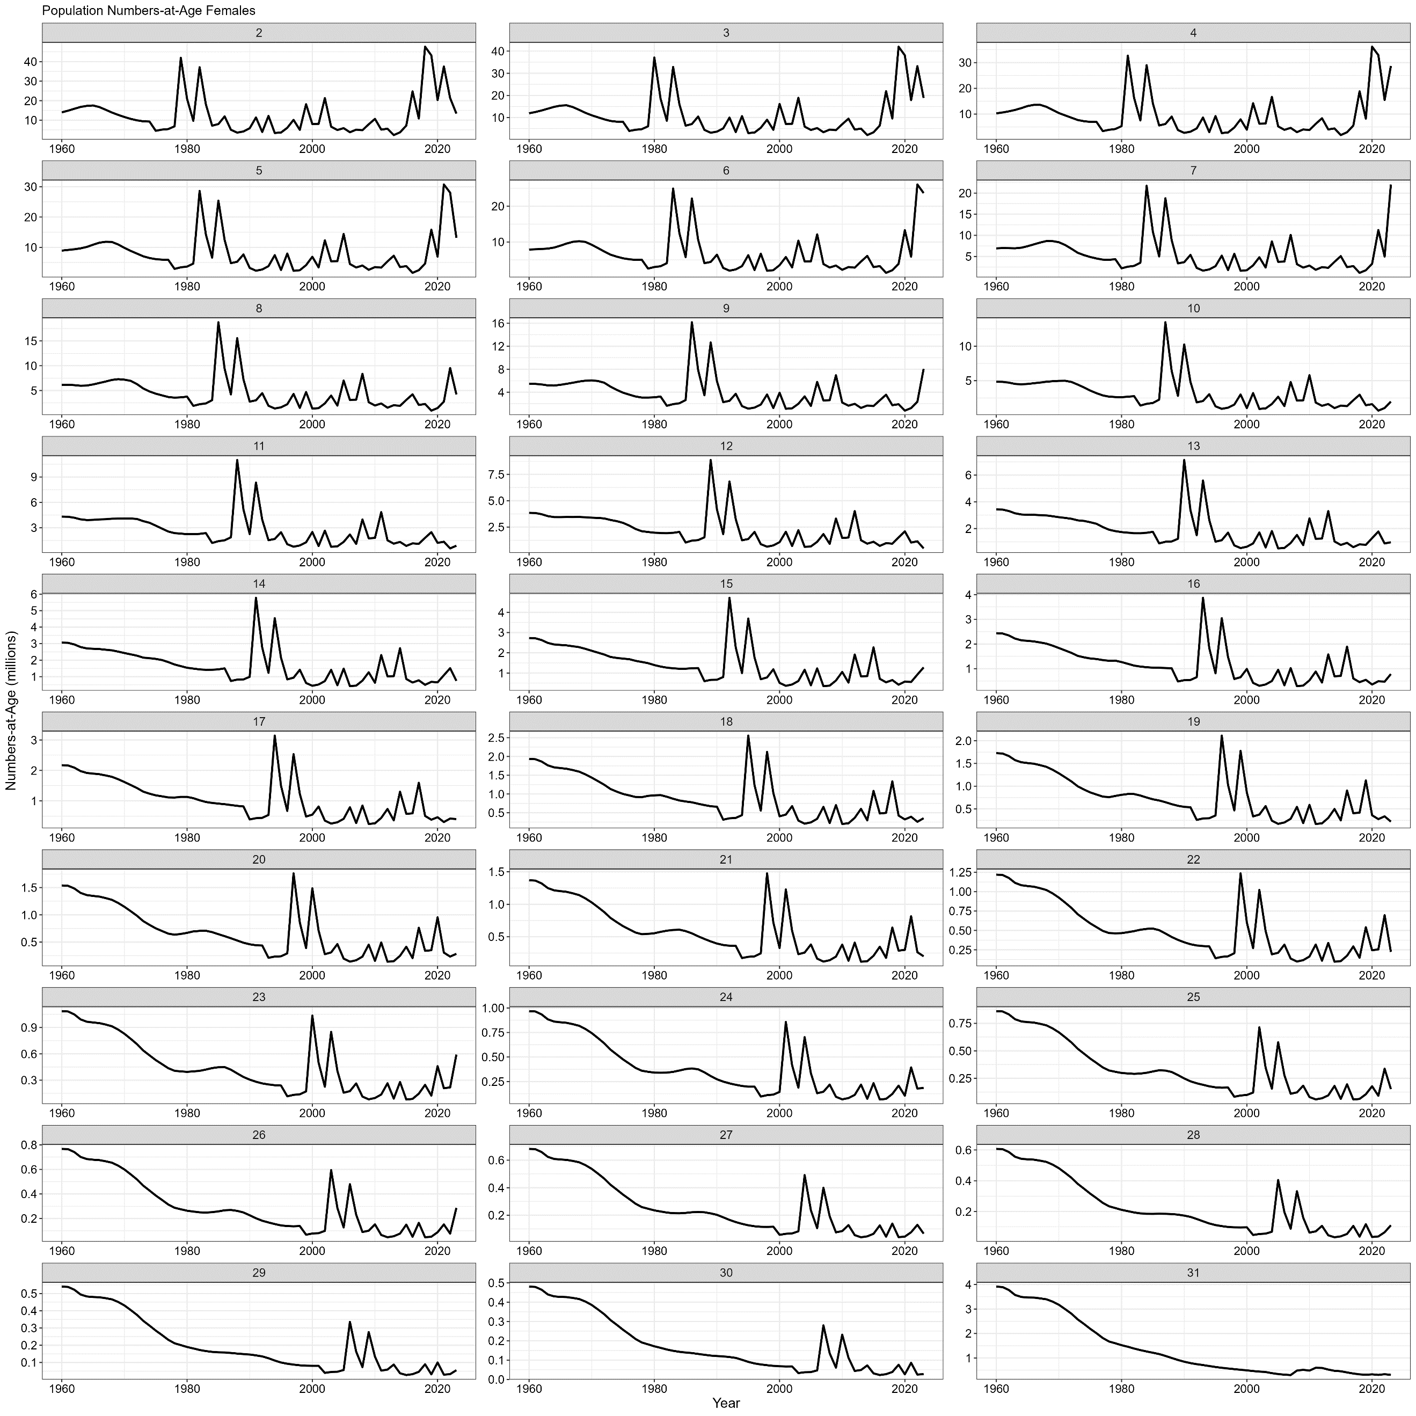

**Figure 3.35.** Model estimated female population numbers by age and year. Abundance is in millions of fish.

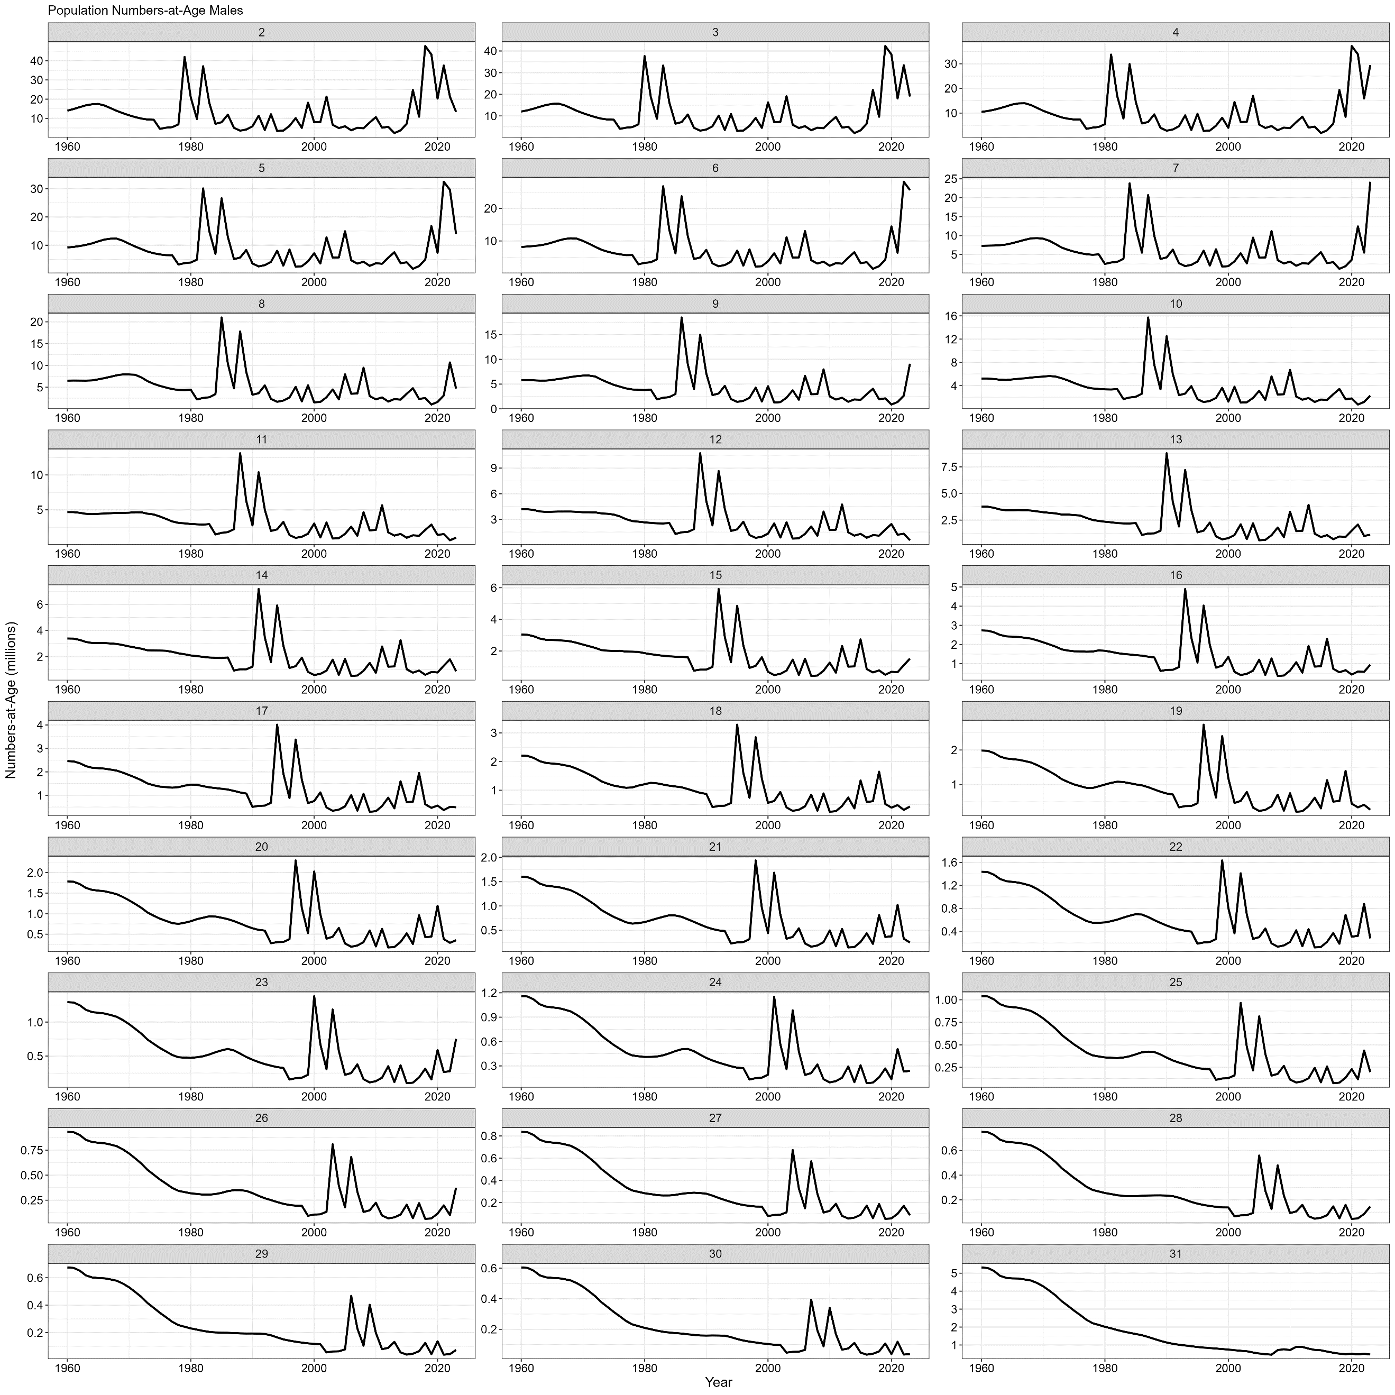

**Figure 3.36.** Model estimated male population numbers by age and year. Abundance is in millions of fish.

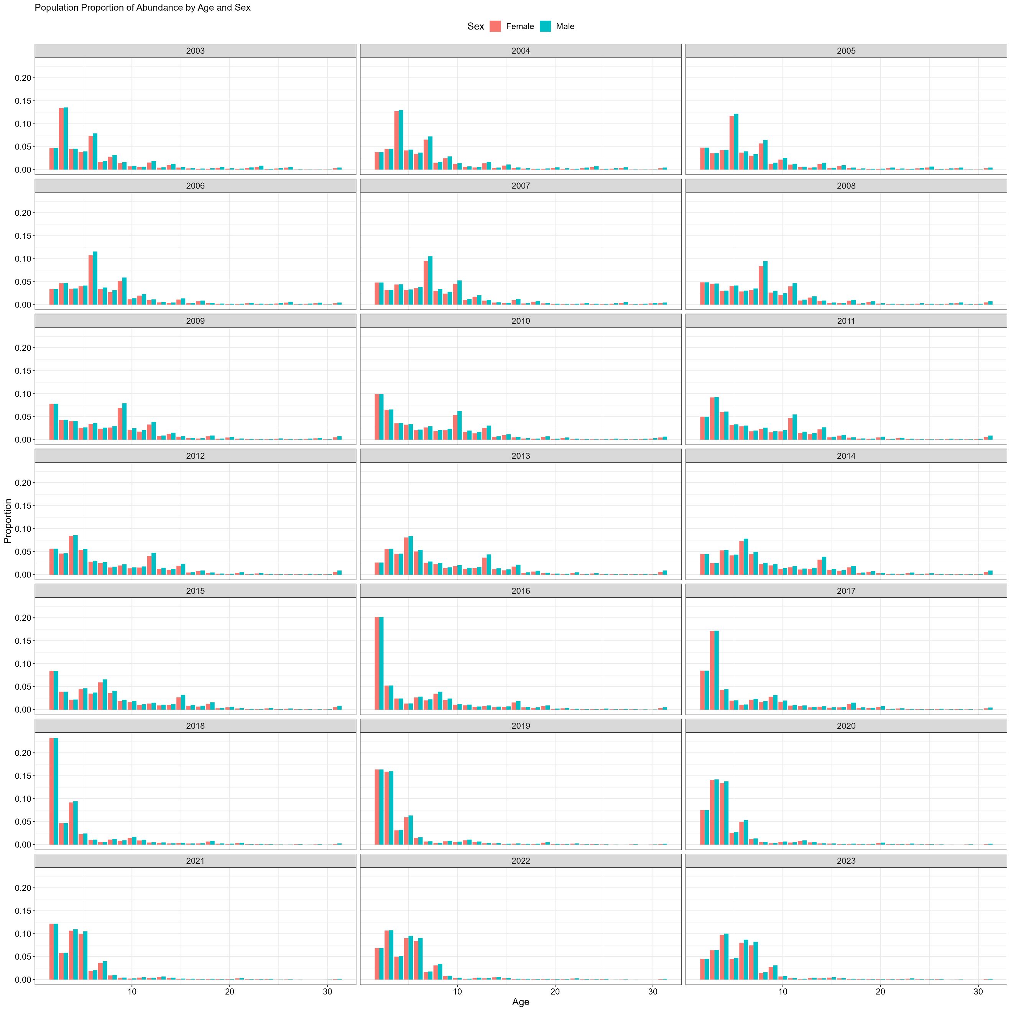

**Figure 3.37.** Model estimated proportions-at-age and sex by year. Female proportions are red bars and male proportions are blue bars.

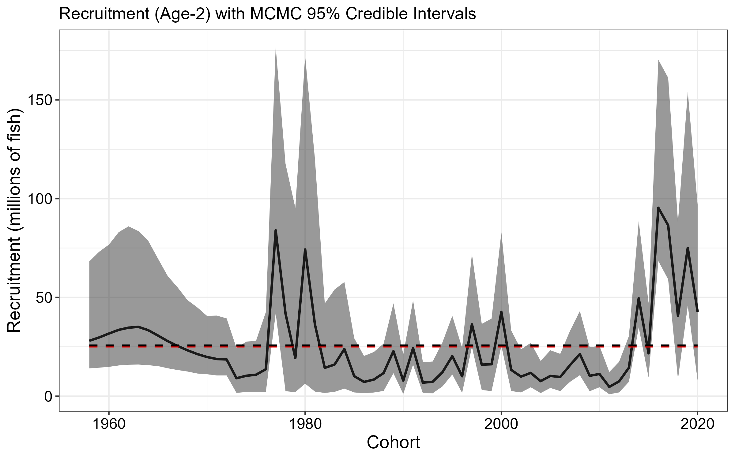

**Figure 3.38.** Estimated recruitment of age-2 sablefish (millions of fish; black line) with 95% credible intervals (grey fill) from MCMC by cohort (recruitment year minus two). Red line is time series mean, while black line is mean from year classes between 1977 and 2020. The estimate for the 2021 year class (terminal year 2023 recruitment event) is omitted, because it is fixed to the estimated mean recruitment value (*μr*) with no deviation parameter estimated.

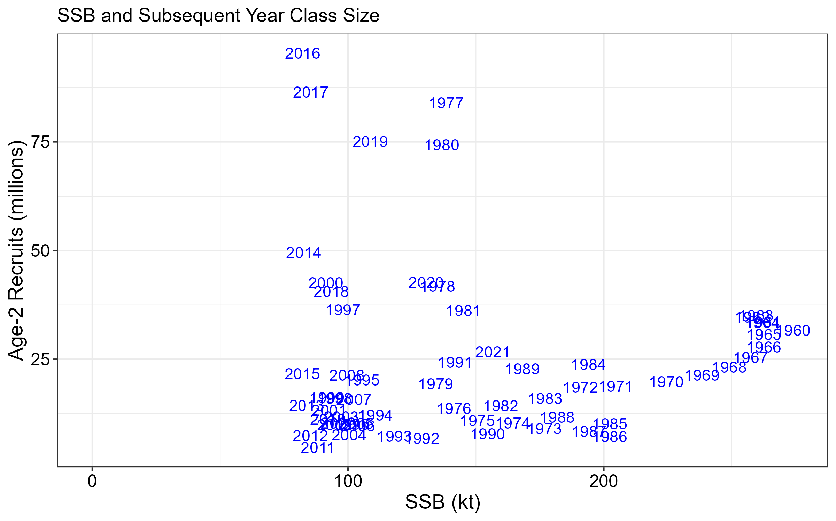

**Figure 3.39.** Age-2 recruits (millions of fish) and corresponding spawning stock biomass (kilotons) for each year class (identified by plotted year text).

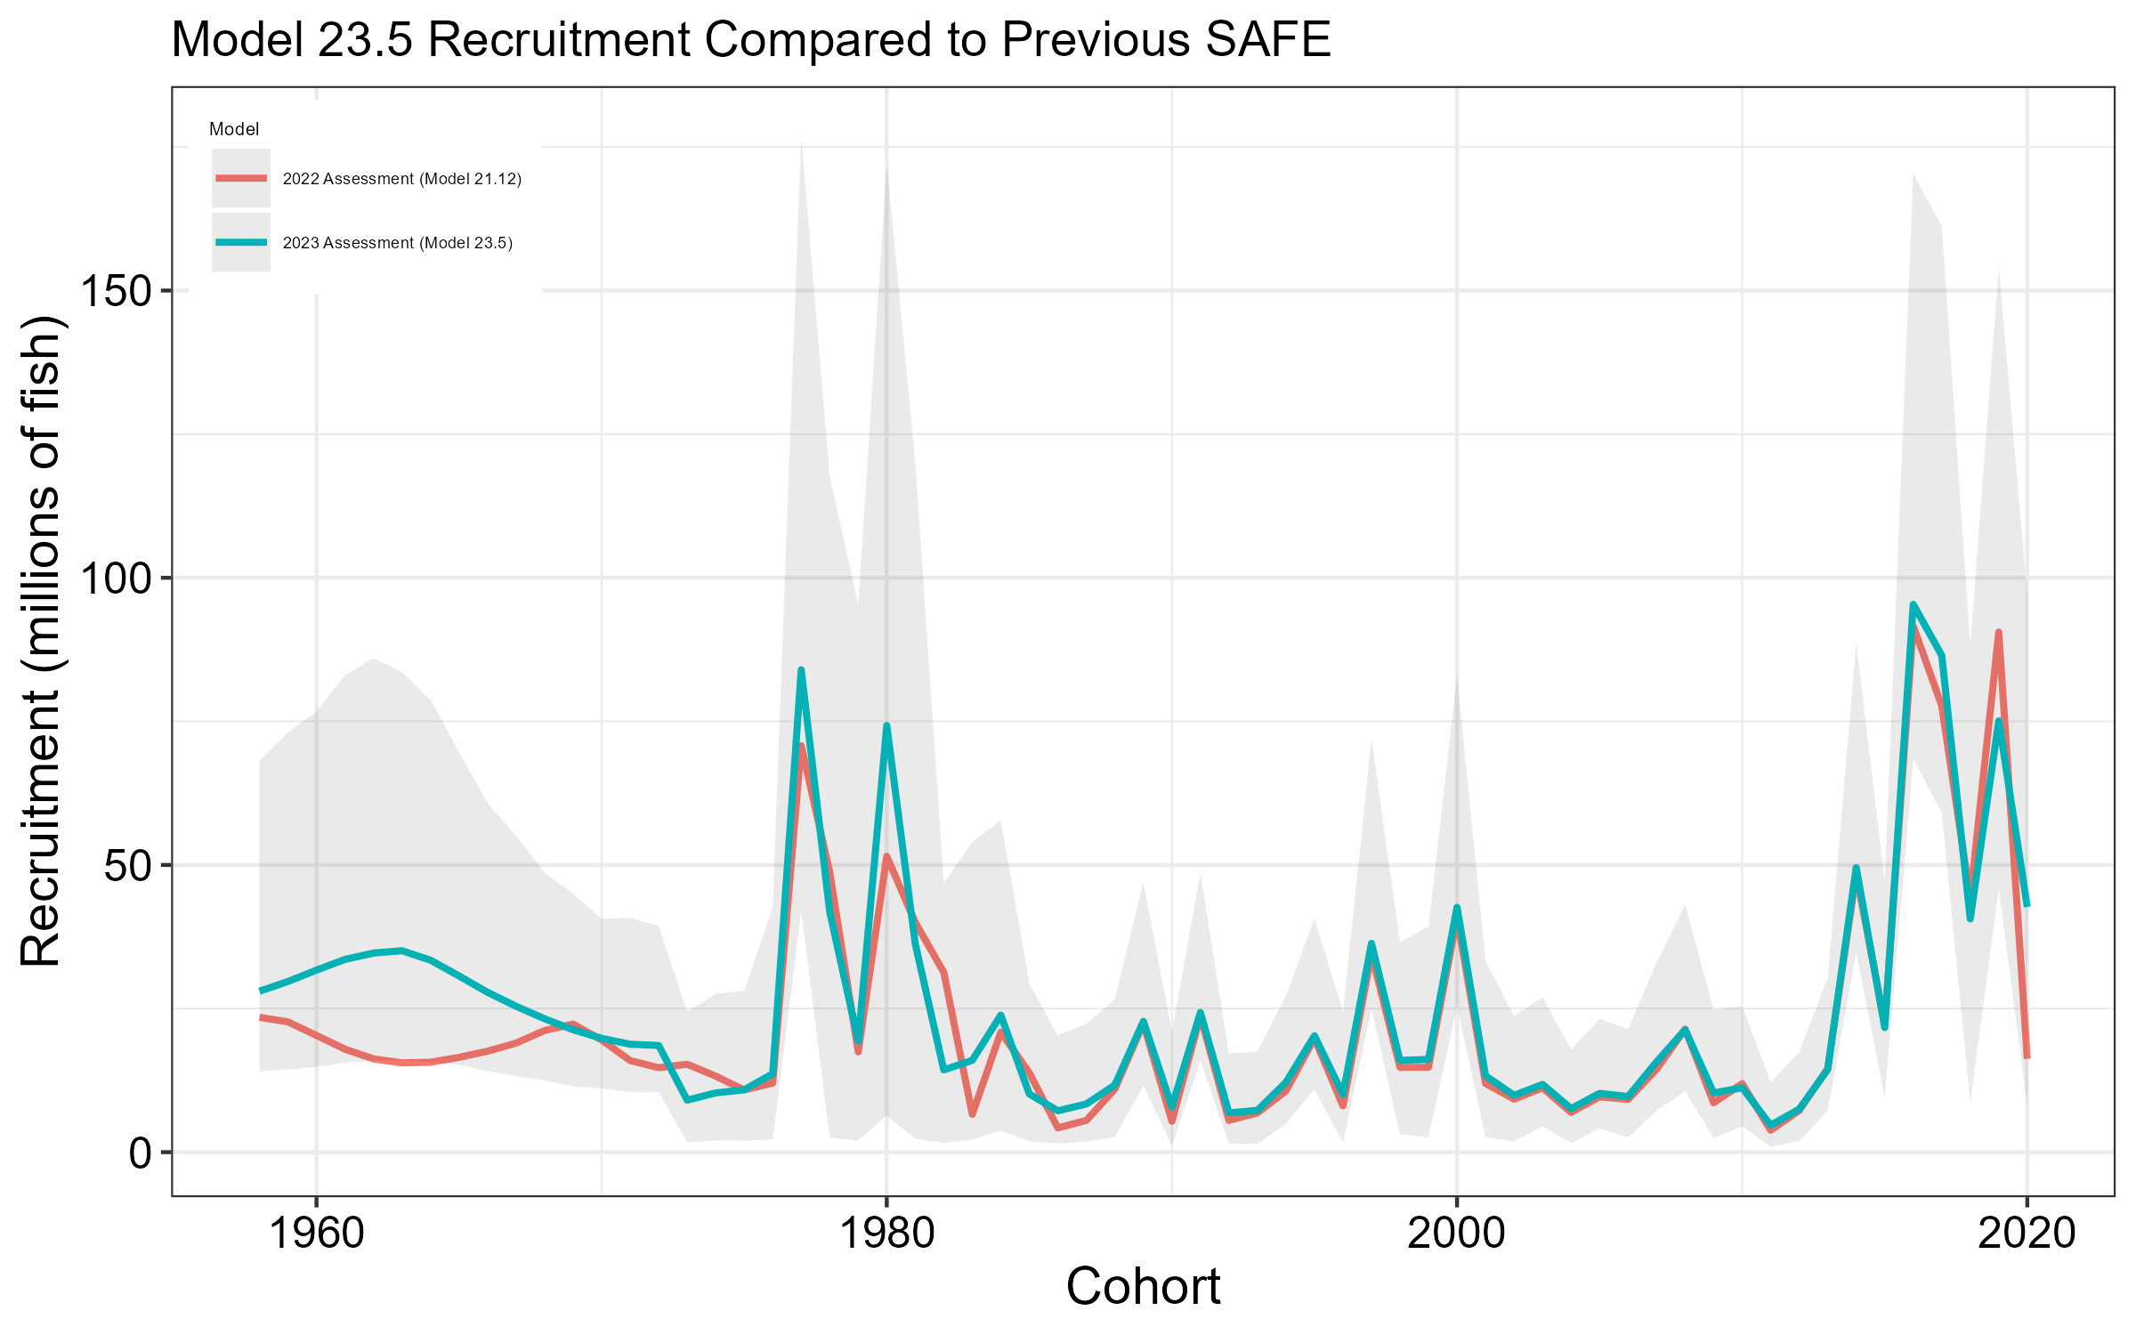

**Figure 3.40.** Estimated recruitment by cohort (recruitment year minus two) in number of age-2 fish (millions of fish) for the 2022 (red line) and 2023 (blue line) final SAFE models with 95% credible intervals (grey fill) from MCMC for the 2023 model. Note that the 2020 yearclass for the 2022 model is equivalent to the estimated mean recruitment value (*μr*).

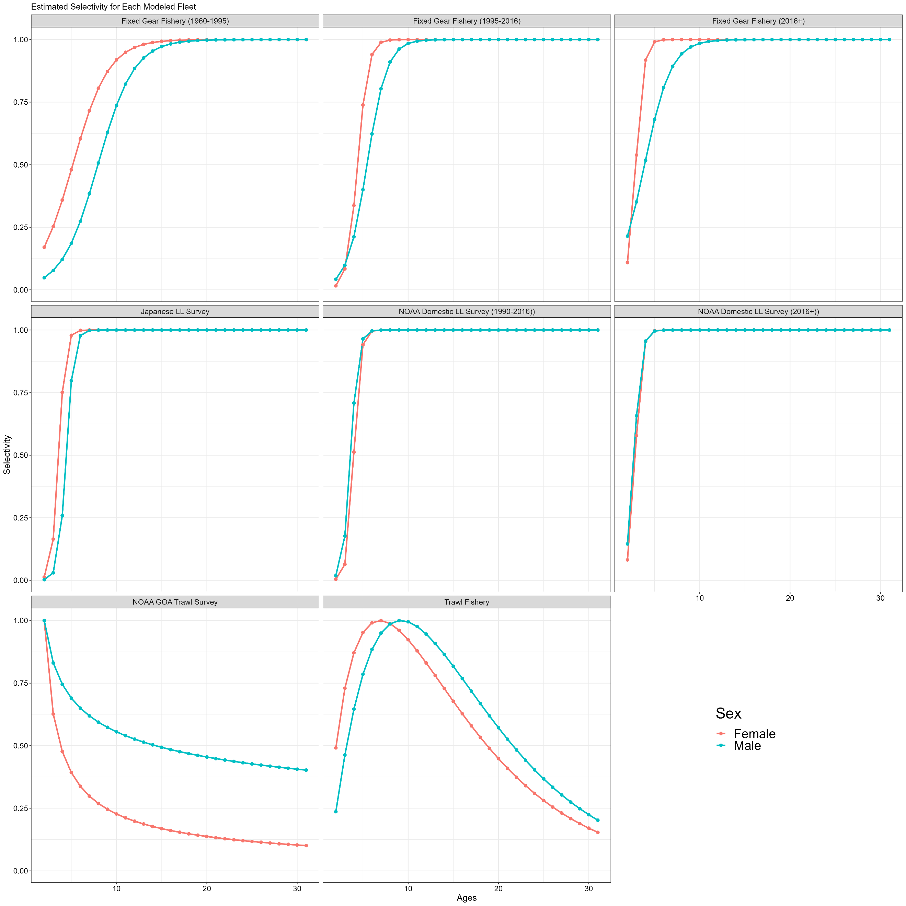

**Figure 3.41.** Estimated fishery and survey selectivity. Fixed gear fishery selectivity is in the top row for the three time blocks (i.e., pre-IFQ, IFQ, and recent), the longline survey selectivities are in the middle row (Japanese cooperative, left, NOAA domestic, center and right), and trawl survey (left) and fishery (right) in the bottom row. Female selectivity is given by the red line and male selectivity by the blue line.

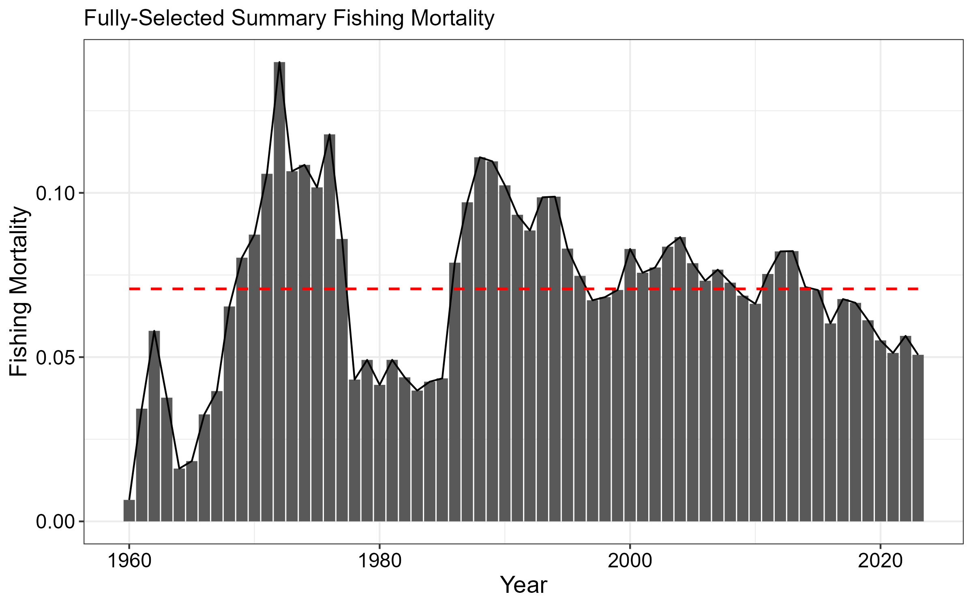

**Figure 3.42.** Time series of fully selected fishing mortality aggregated across the fixed gear and trawl fisheries. Red line is the mean fishing mortality for the entire time series.

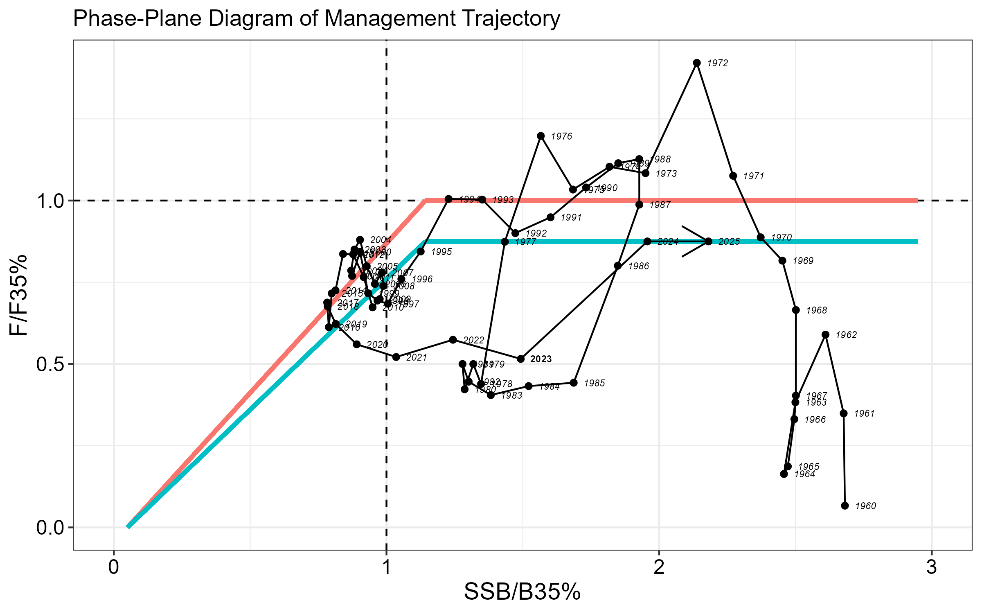

**Figure 3.43.** Phase-plane diagram illustrating the time series of sablefish estimated spawning biomass relative to the level at B35% and fishing mortality relative to F35% (equal to *FOFL*). *FABC* for the max ABC is equivalent to F40%, which is demonstrated by the blue lines. The red line represents fishing at *FOFL*, but with a target of B40% (i.e., the inflection point occurs at a biomass ratio greater than one).

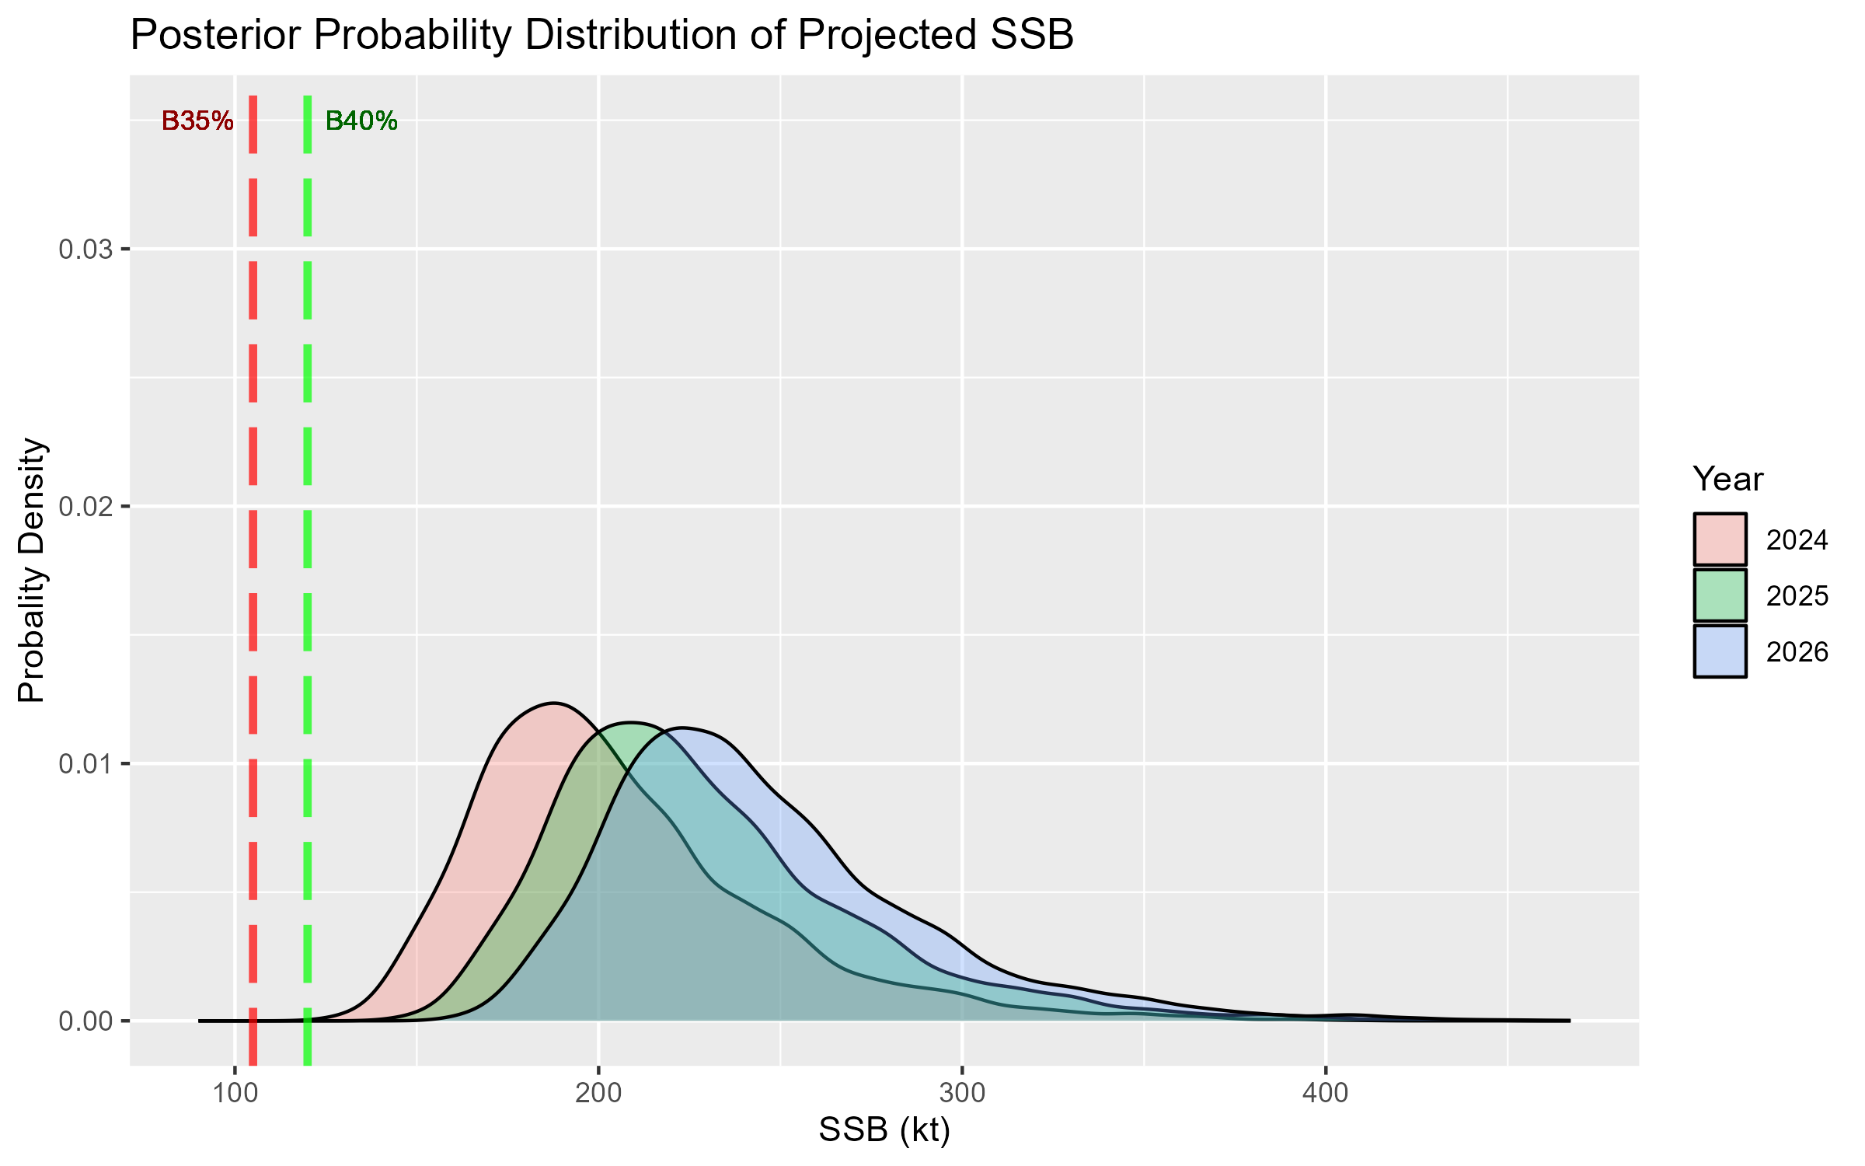

**Figure 3.44.** Posterior probability distribution from MCMC for projected spawning biomass (kilotons) in years 2024 – 2026. The dashed lines are B35% and B40%.

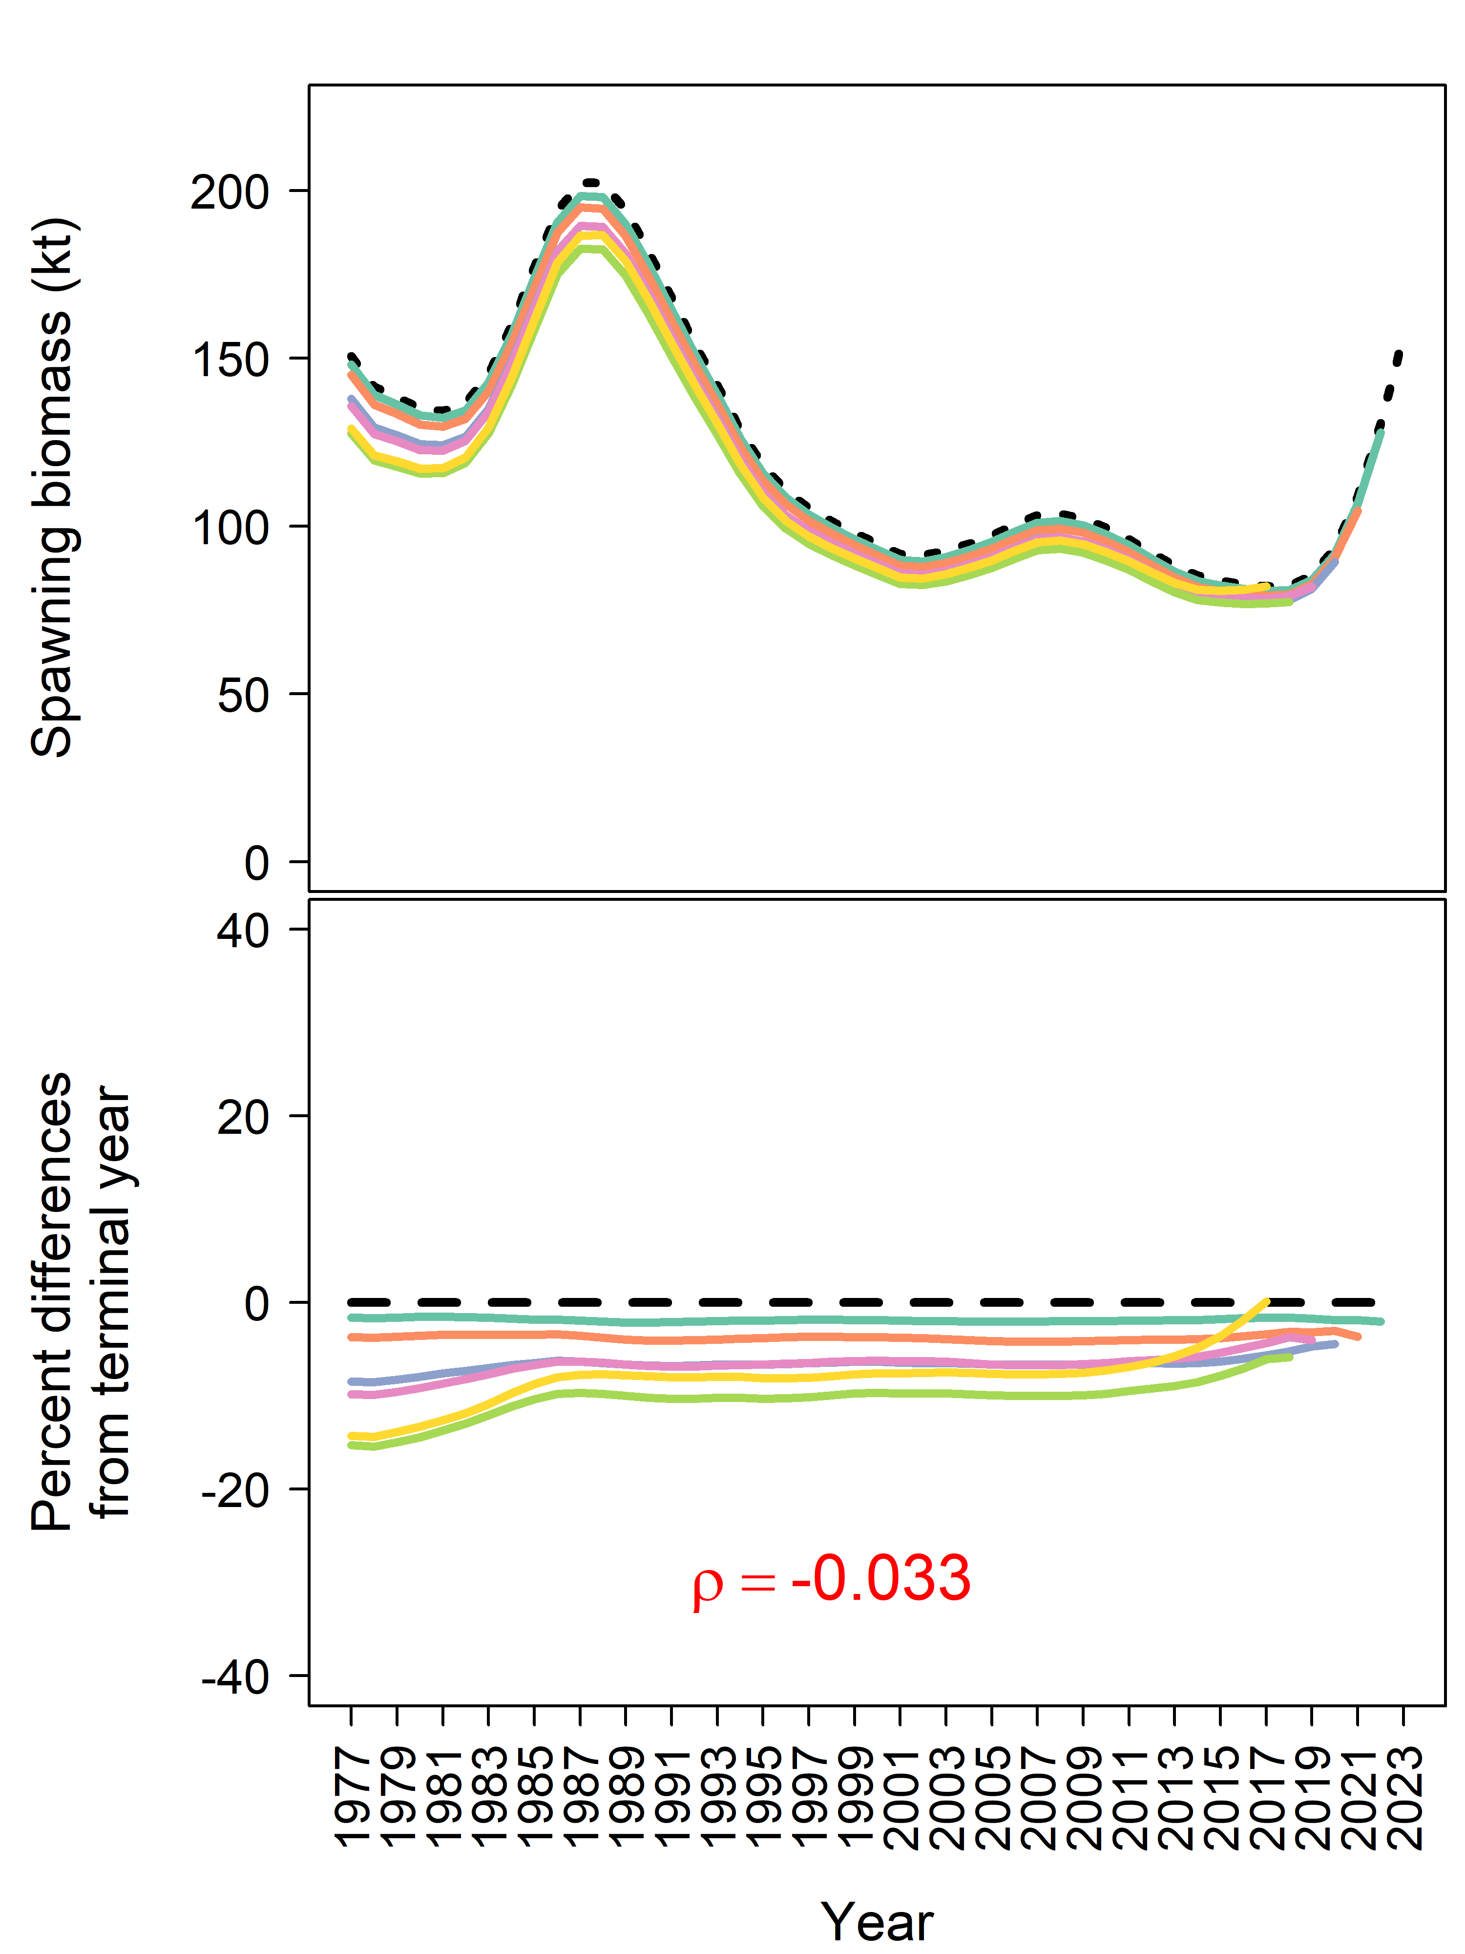

**Figure 3.45.** Retrospective trends for spawning biomass (top) and percent difference from terminal year (bottom). Mohn’s rho (*ρ*) is provided in red (bottom panel).

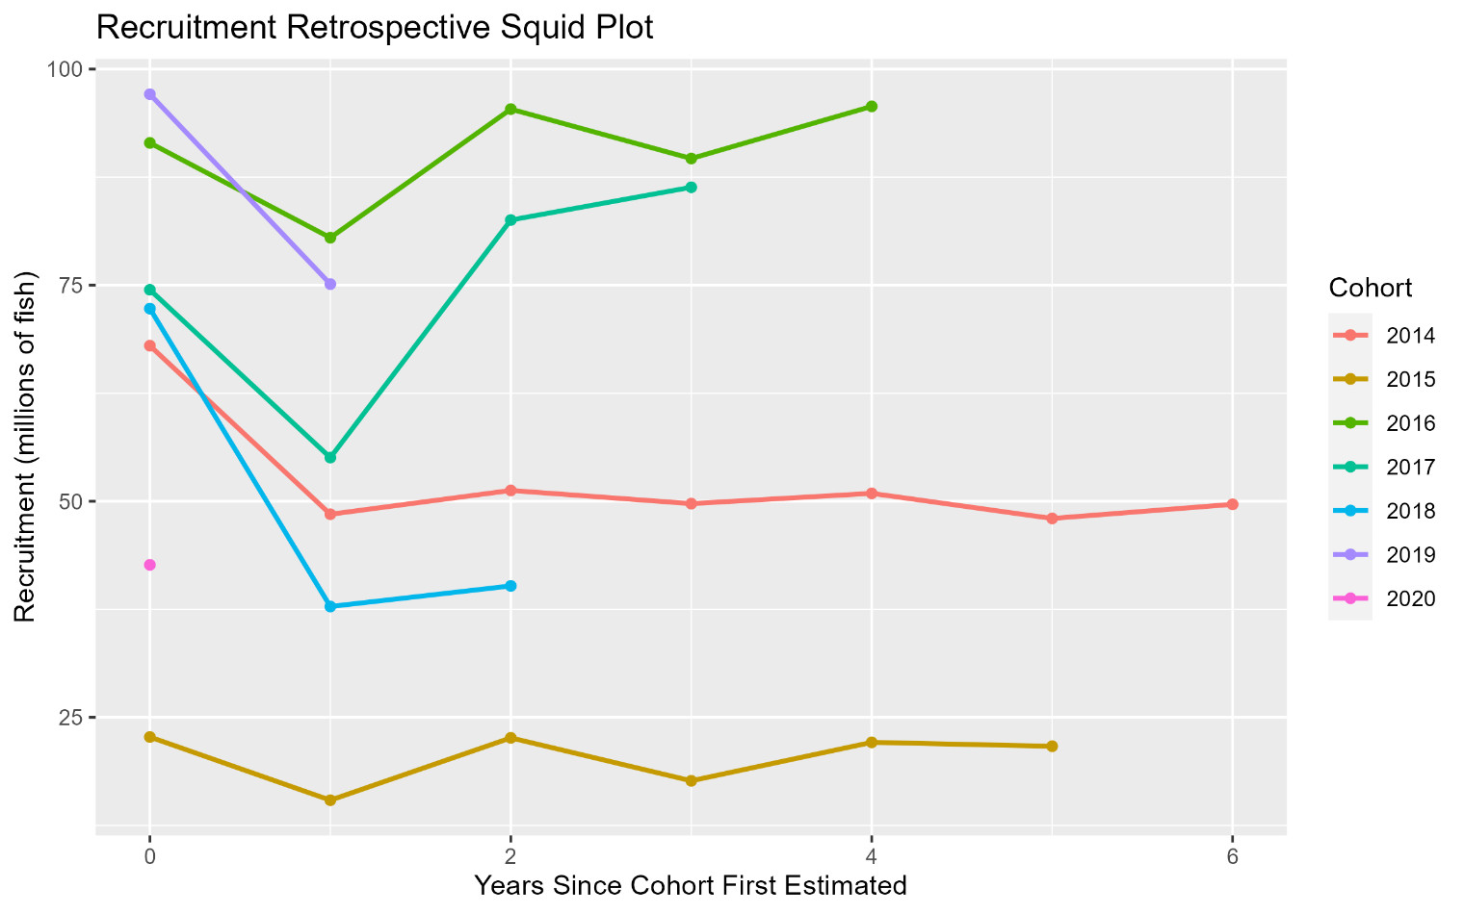

**Figure 3.46.** Squid plot of subsequent estimates of age-2 recruitment for 2014 to 2020 year classes from retrospective analysis.

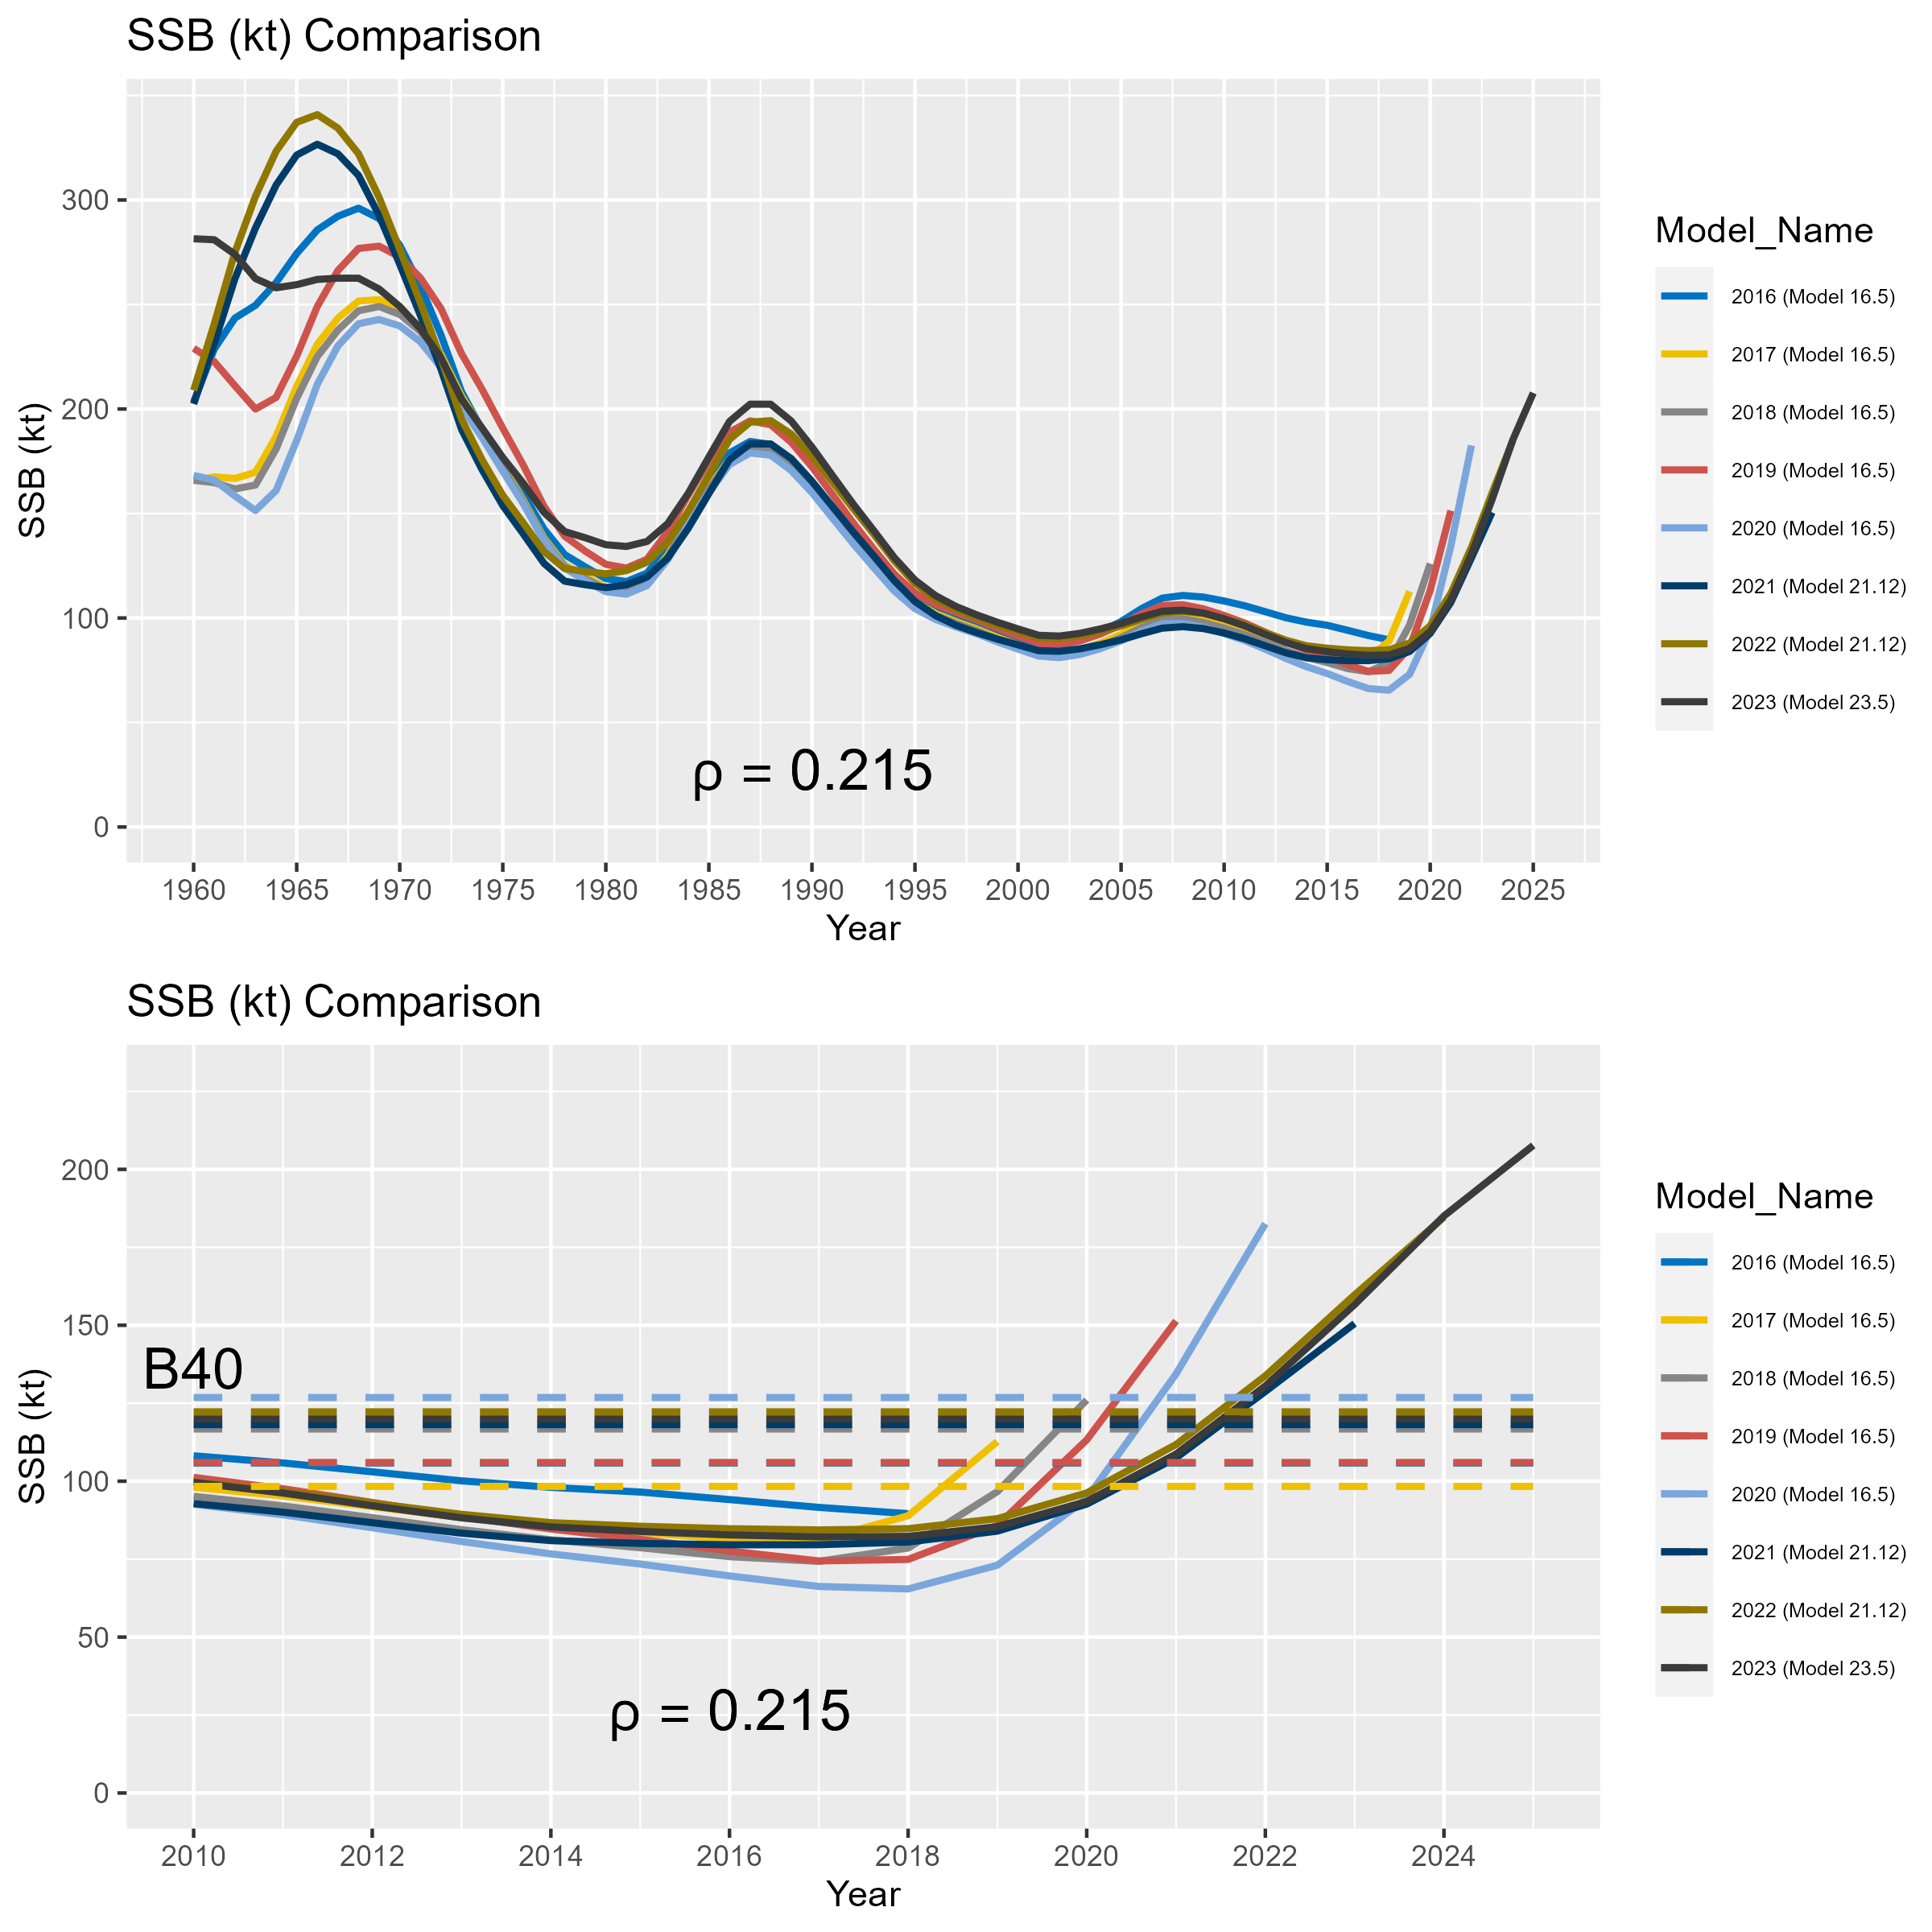

**Figure 3.47.** Results of the ‘all model’ historical retrospective illustrating estimated and projected (terminal year + 2 years) spawning stock biomass (in kilotons). Results are based on the accepted model in each terminal model year, including application of the *23.5* model for 2023, the *21.12* model for the 2021 and 2022 model years, and the *16.5* model for earlier model years. The top panel shows the entire time series of SSB from each assessment model, while the bottom panel shows the same results since 2010 overlaid with corresponding estimates of *B40%*. Mohn’s rho for two year SSB projections is provided below the lines in each plot.

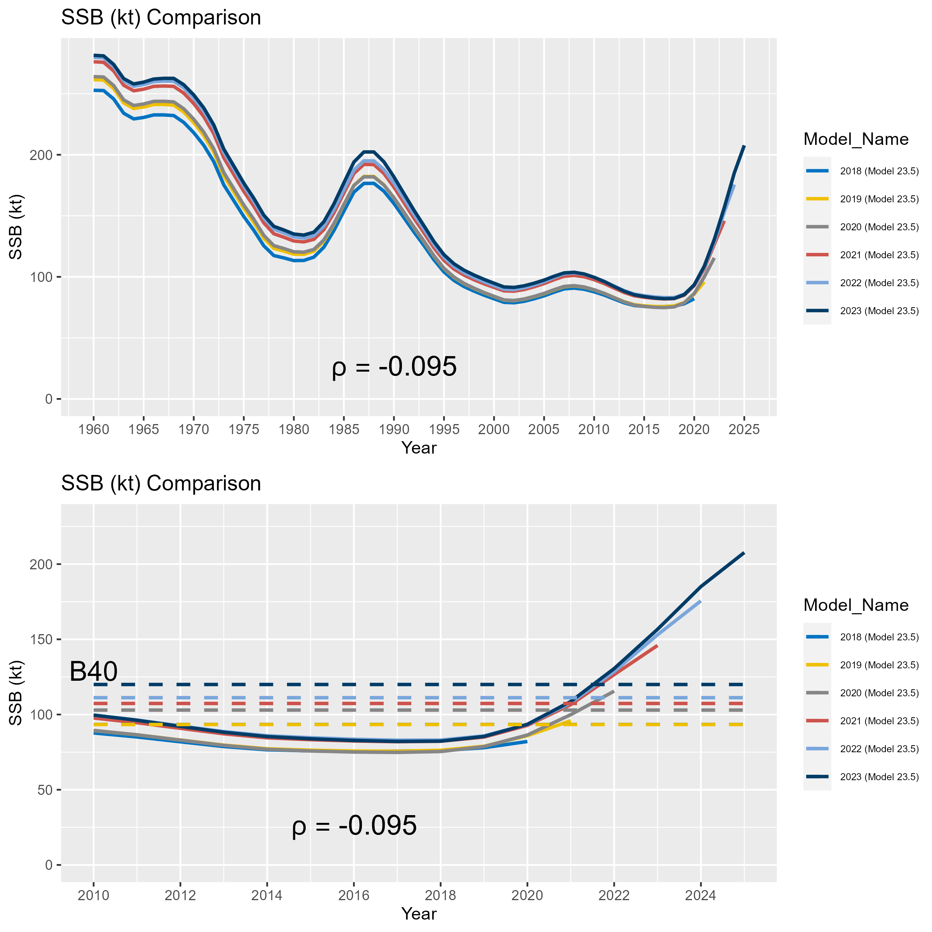

**Figure 3.48.** Results of the ‘current model’ historical retrospective illustrating estimated and projected (terminal year + 2 years) spawning stock biomass (in kilotons). Results are based on application of the *23.5* model to the available data at the time of the last five sablefish assessments (i.e., terminal model years from 2018 to 2023). The top panel shows the entire time series of SSB from each assessment model, while the bottom panel shows the same results since 2010 overlaid with corresponding estimates of *B40%*. Mohn’s rho for two year SSB projections is provided below the lines in each plot.

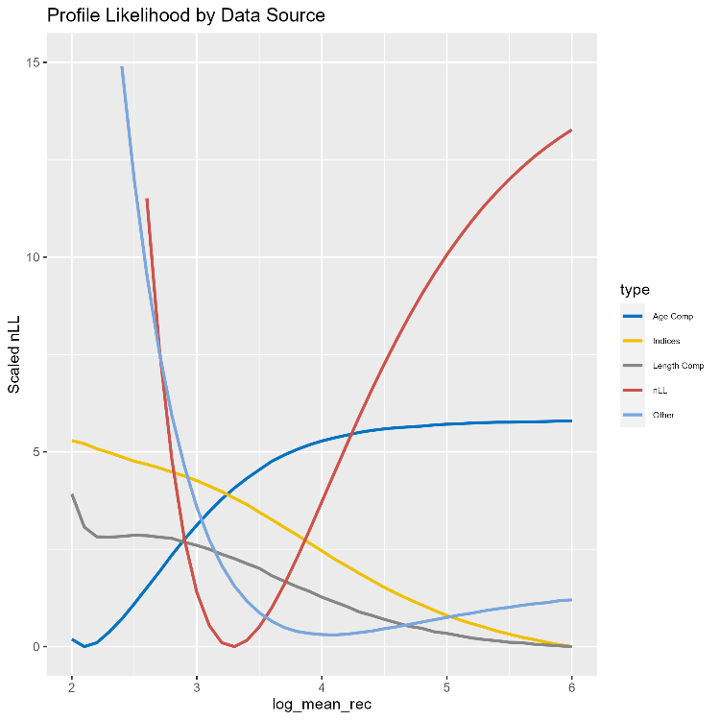

**Figure 3.49.** Likelihood profiles by data type (line color) for the mean recruitment parameter in logarithmic space.

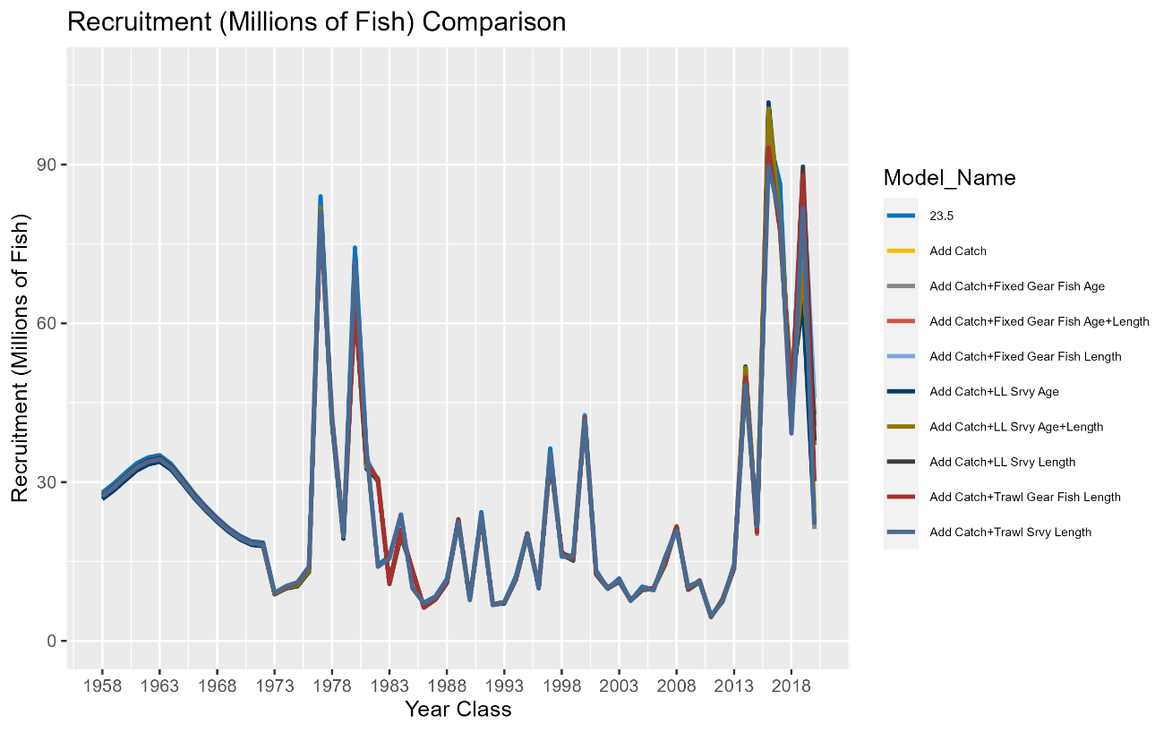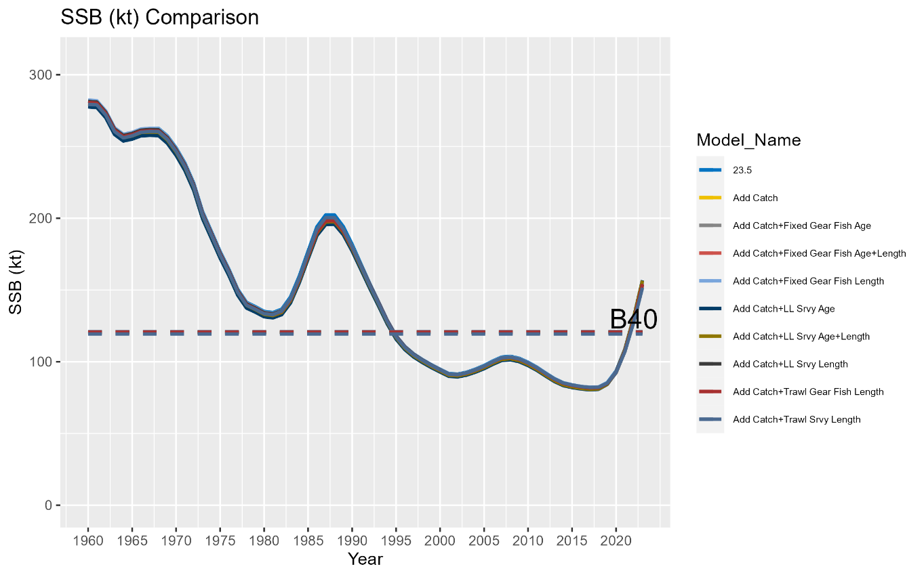

**Figure 3.50.** Results of an incremental data addition exercise where each new year of data for the 2023 model is added in a step-wise fashion. All model runs include the 2023 fishery catch data. For compositional data associated with fishery independent indices, each run also includes the associated survey index. The top panel illustrates the model estimated recruitment (millions of fish). The bottom panel depicts the time series of SSB (kt).

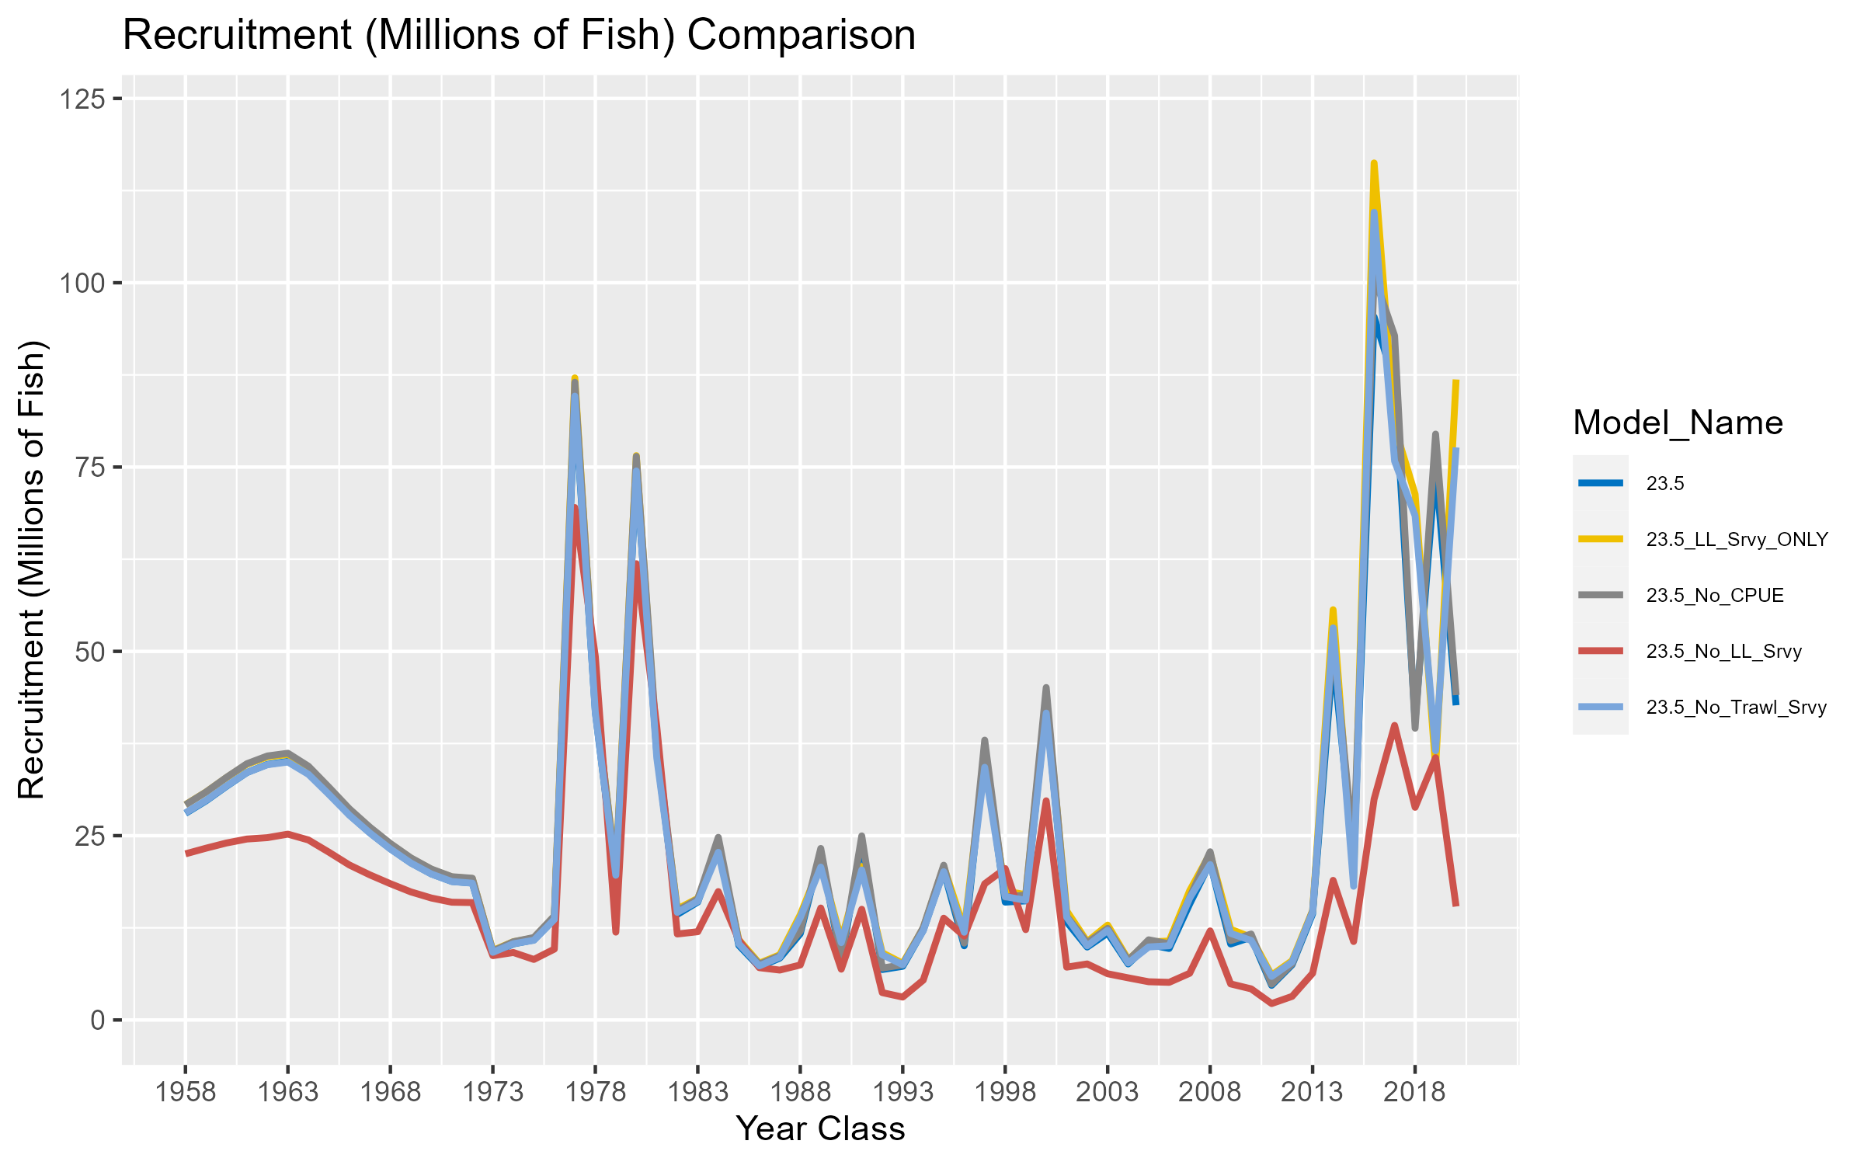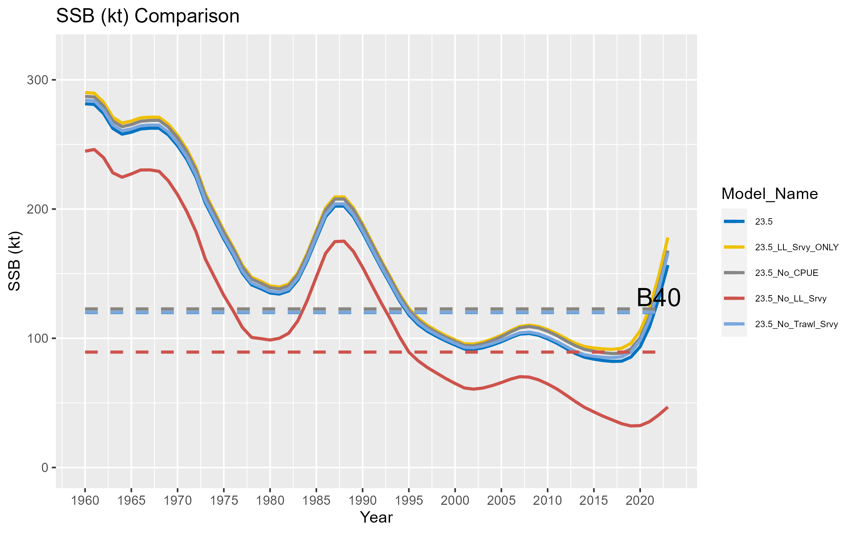

**Figure 3.51.** Results of an index sensitivity analysis where the model is rerun after removing each index (and any associated compositional data in the case of fishery independent surveys) one at a time. The top panel illustrates the model estimated recruitment (millions of fish). The bottom panel depicts the time series of SSB (kt).

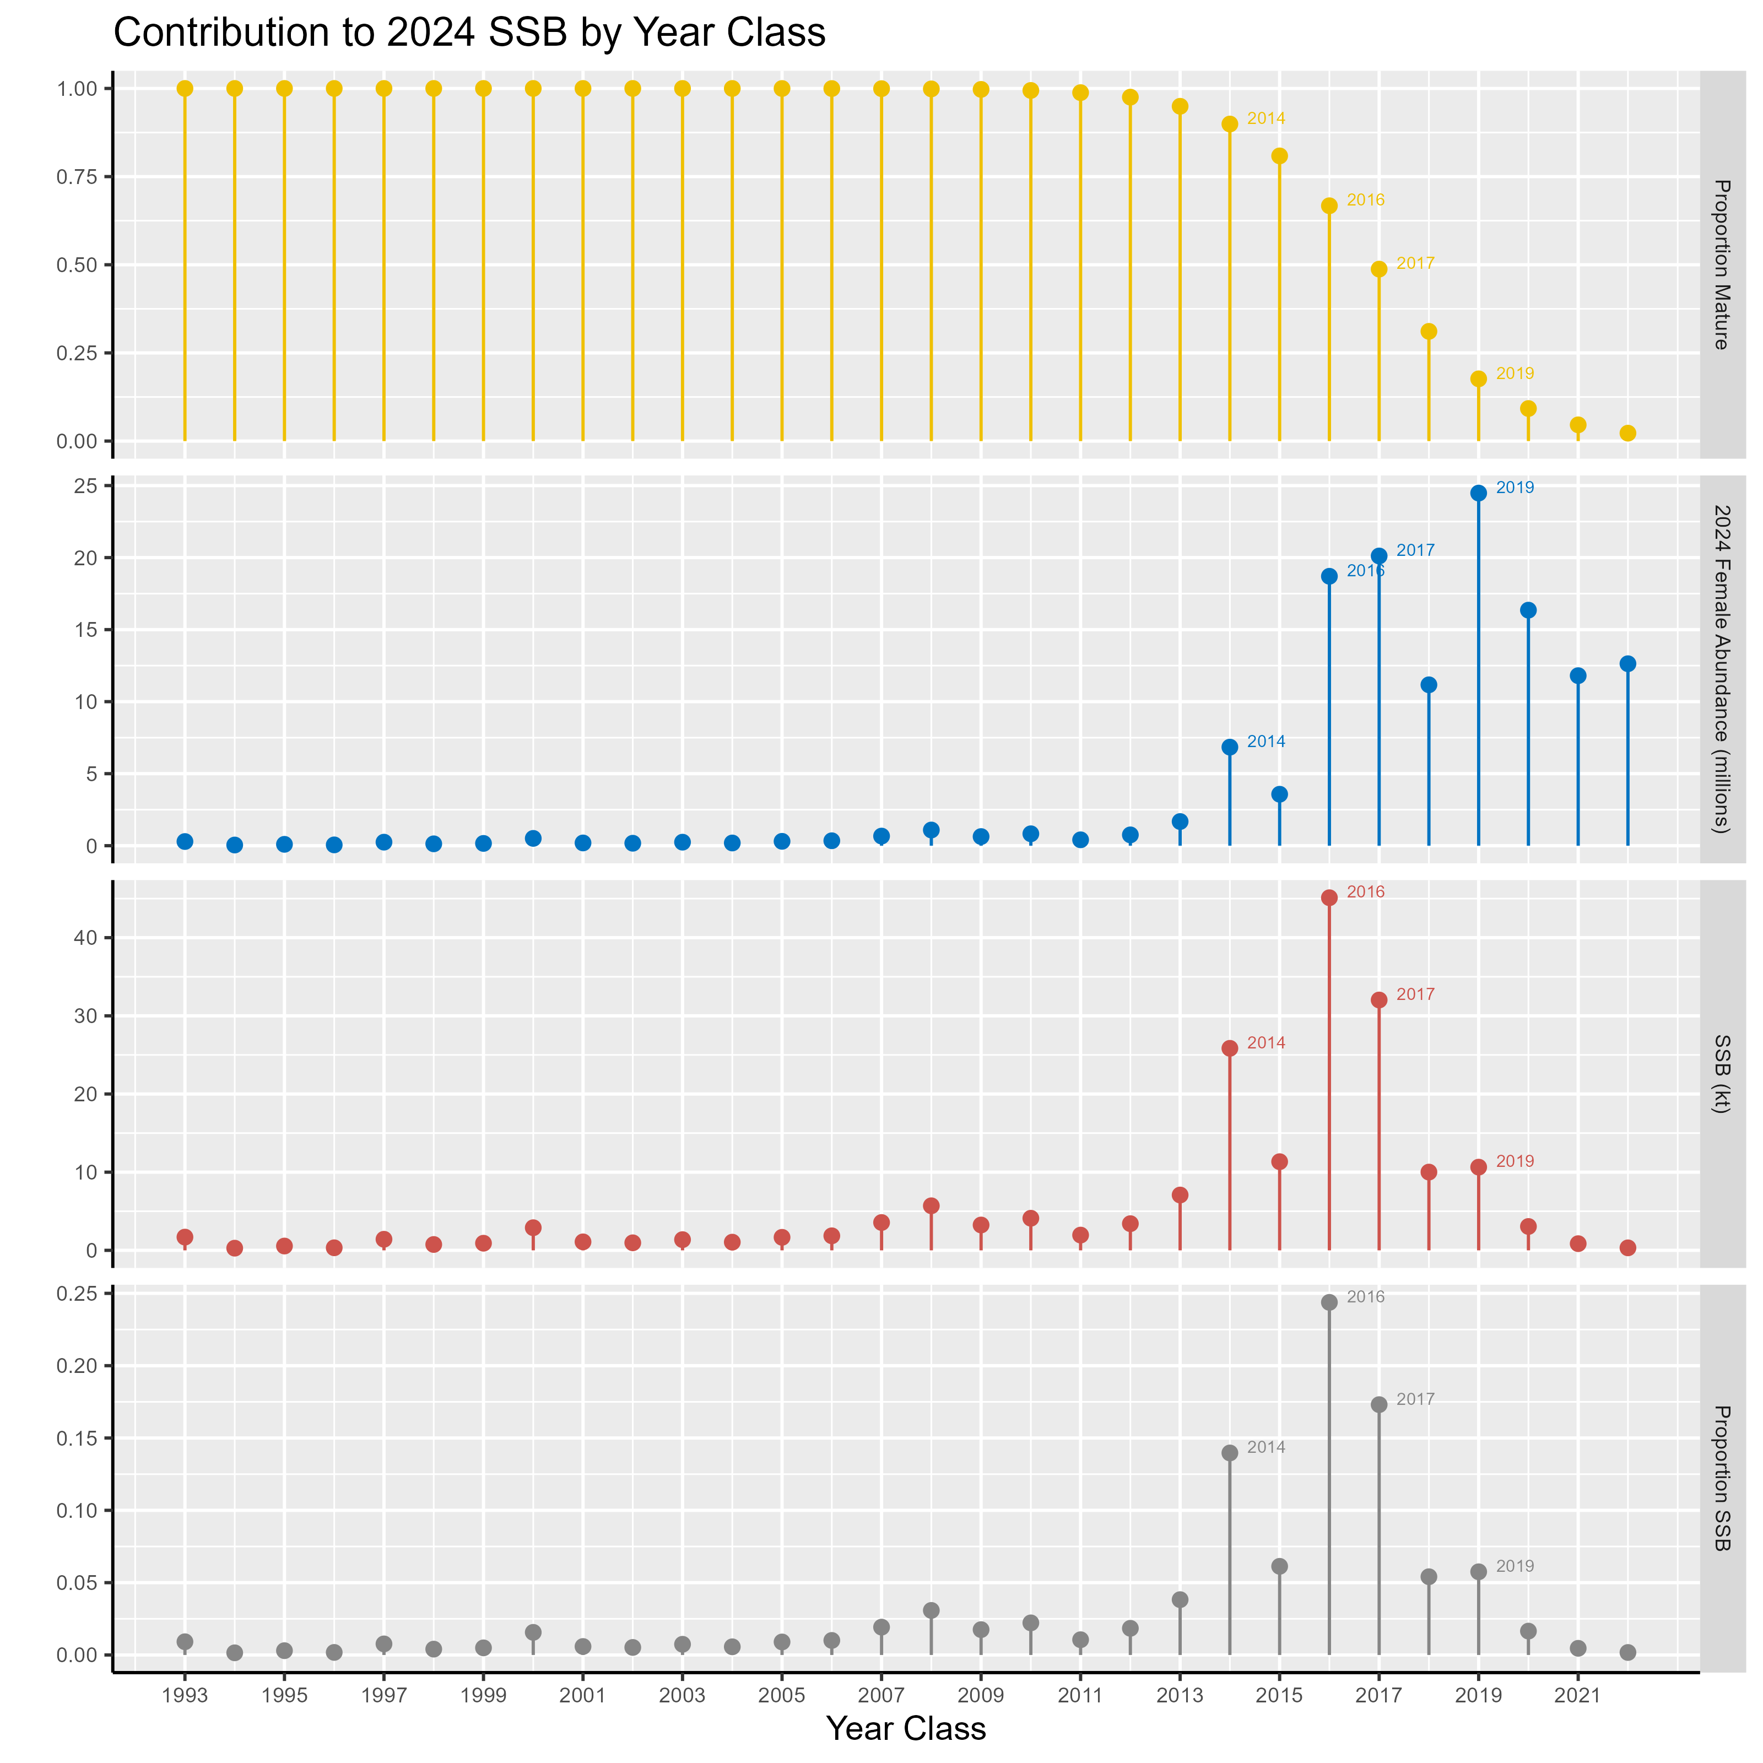

**Figure 3.52.** Proportion mature (top panel), projected 2024 female (assuming a 50:50 sex ratio) abundance (millions of fish; second panel from top), projected 2024 spawning stock biomass (kilotons; third panel from top), and proportional contribution to 2024 SSB (bottom panel) for each of the last 30 year classes. Note that the 1993 year class represents all contributions from all earlier year classes (i.e., fish in the plus group age). Abundance of the 2021 and 2022 year classes are based on mean recruitment, because these year classes have not yet been estimated in the 2023 assessment model.

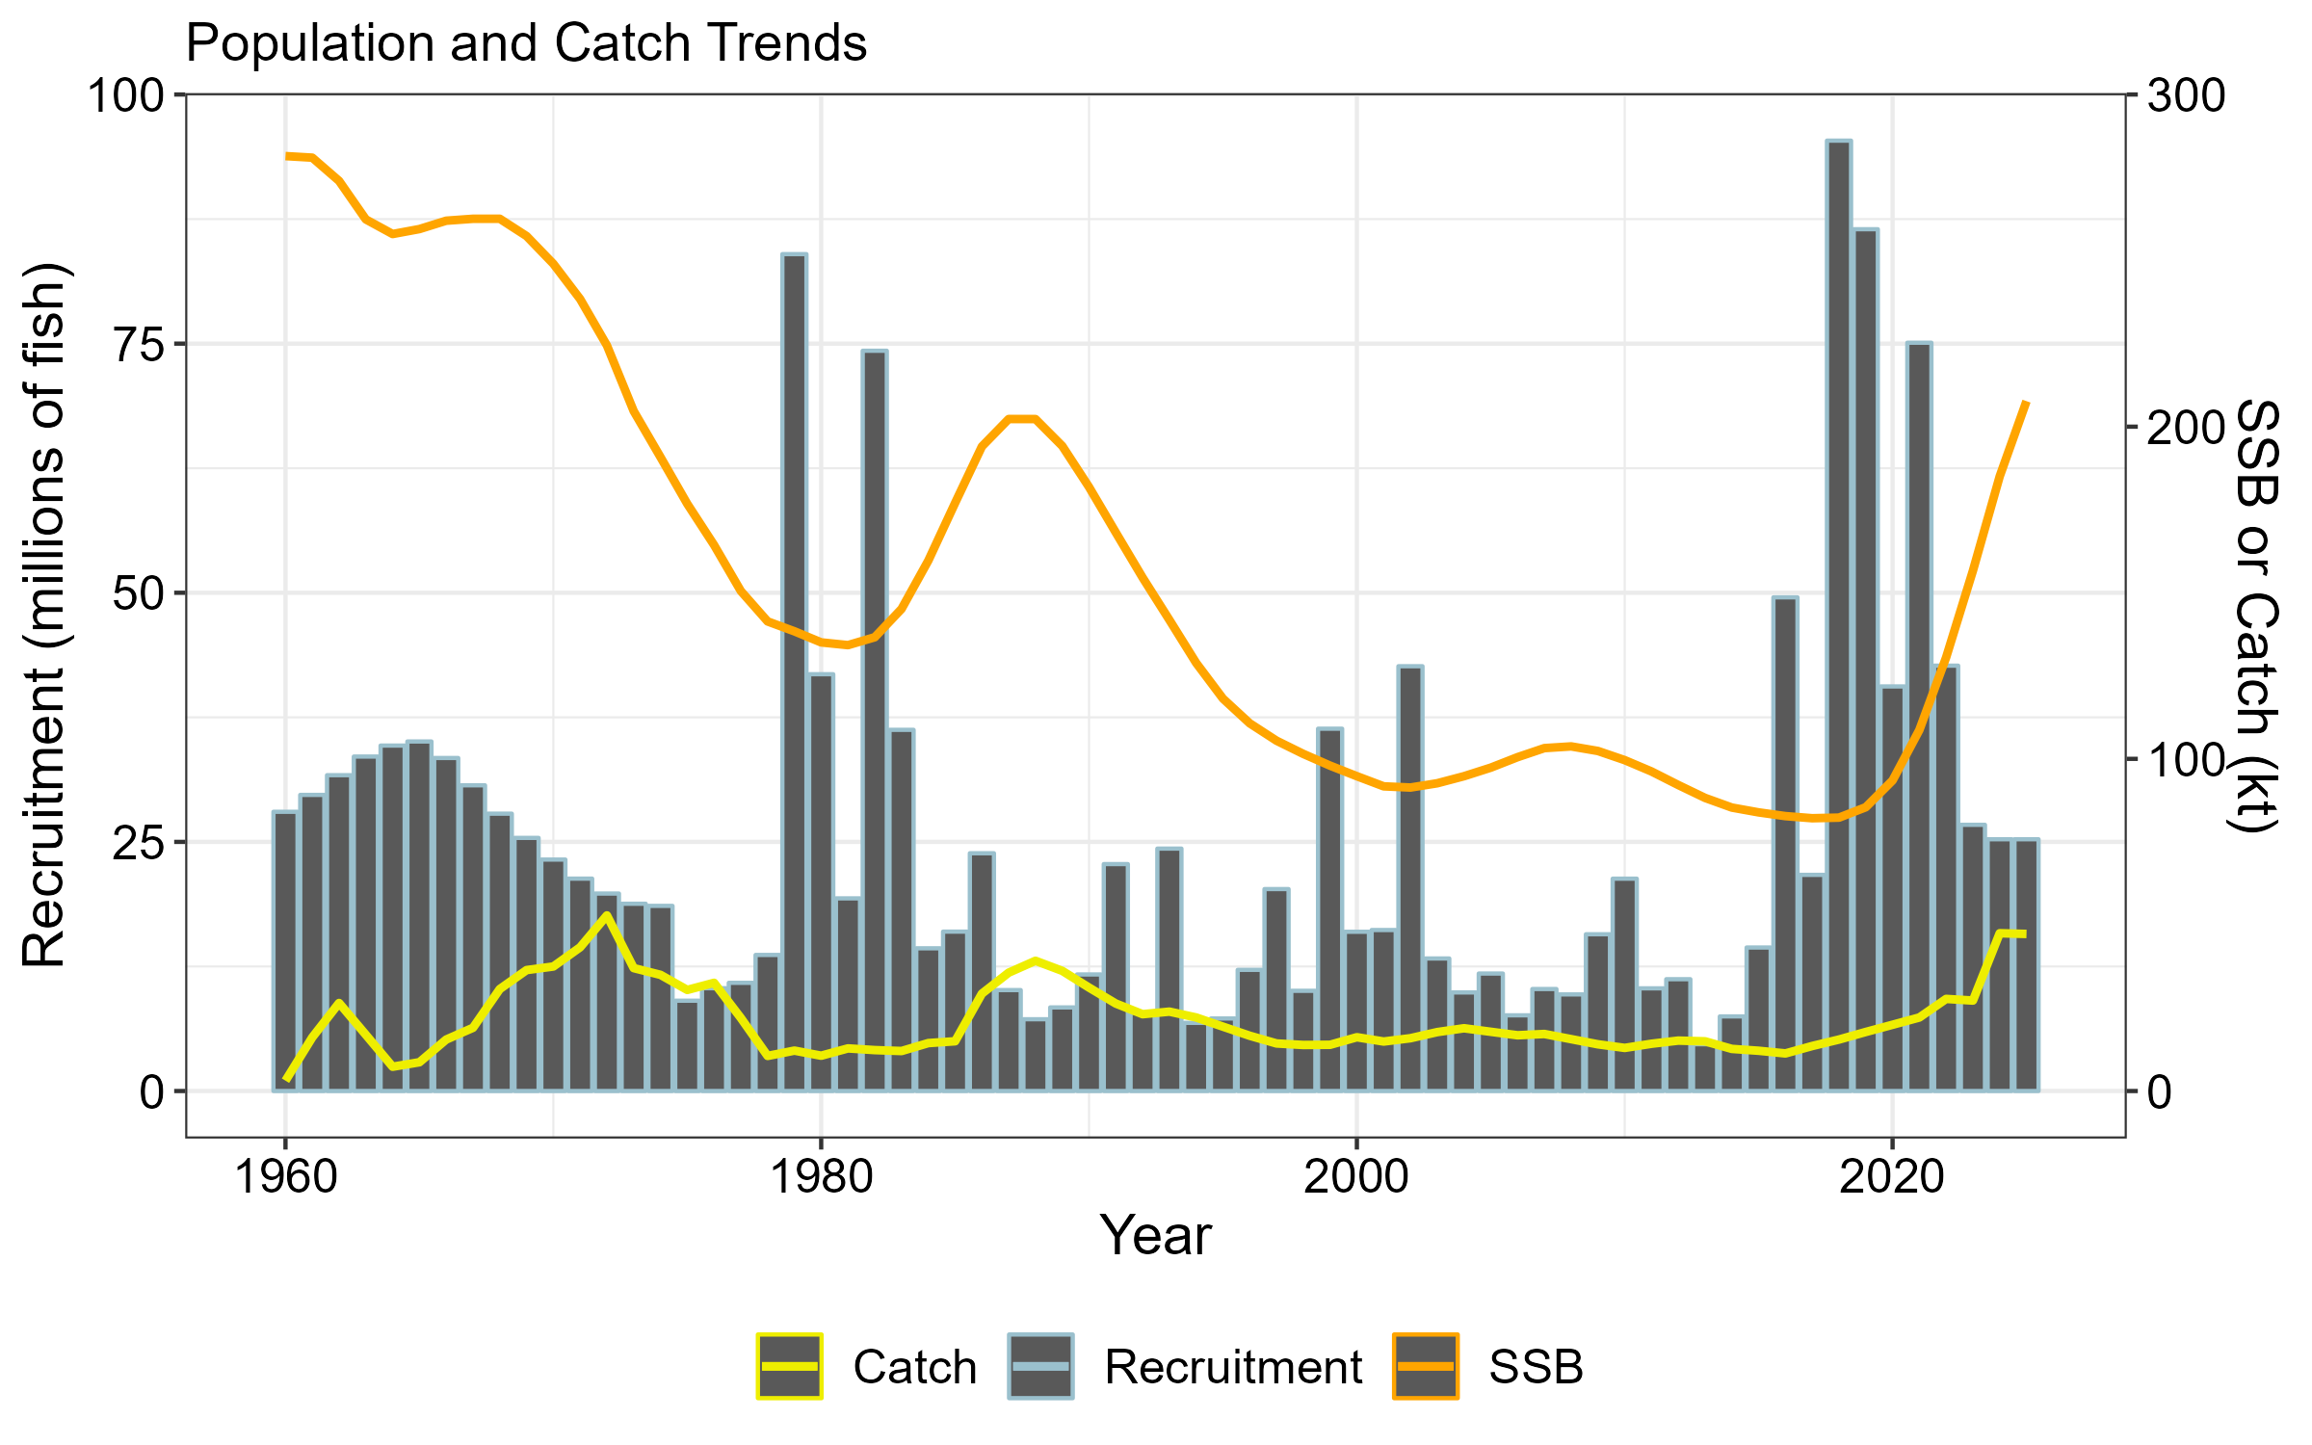

**Figure 3.53**. Time series of sablefish SSB (orange line), catch (yellow line), and recruitment (grey bars). Projected dynamics for 2024 and 2025 are included based on the maximum permissible ABC and average recruitment. Note the cyclical dynamics associated with spasmodic recruitment. Transitory increases in SSB subsequent to periods of strong recruitment are often followed by a persistent downward time series trend. Catches often rapidly increase following high recruitment periods, while recruitment reverts back towards average levels.

Appendix 3A. Sablefish Longline Survey: Fishery and Whale Interactions

NMFS has requested the assistance of the fishing fleet to avoid the annual longline survey stations since the inception of sablefish IFQ management in 1995. We request that fishermen stay at least five nm away from each survey station for 7 days before and 3 days after the planned sampling date (3 days allows for survey delays). Since 2021, survey calendars have been made available online (https://www.fisheries.noaa.gov/resource/document/alaska-sablefish-longline-survey-station-schedule). While the survey is being conducted, the skipper of the vessel makes announcements on the radio detailing the planned set locations for the upcoming days. Vessels encountered near survey stations are contacted by the survey vessel captain and interviewed to determine potential effects on survey catches. Typically, vessels have been aware of the survey and have not been fishing close to survey locations. Even with communication, there are some instances where survey gear was fished nearby commercial fishing gear or where commercial fishing had recently occurred. There are generally few interactions during the 90-day survey (Table 3A.1). In 2023 there were eight instances of vessel interactions that may have impacted survey catch or required the survey vessel to move the day’s sets from their originally intended locations. In the GOA, there were 5 interactions with pot boats (3 in East Yakutat/Southeast, 1 in West Yakutat, and 1 in the Central GOA) and 3 interactions with longline vessels (1 in the western GOA and 2 in the central GOA). There were no vessel interactions in the Bering Sea. The number of sets impacted by whales is also tallied (Table 3A.2) and those sets are dropped (for orca interaction; 16 stations, mostly in the BS) or catch rates inflated using the survey whale inflation factor (for sperm whales; 12 stations, mostly in the eastern GOA; see ‘Whale Depredation Estimation’ section).

## Tables

**Table 3A.1.** Count of longline survey and fishery vessel interactions by area, fishery gear type, and year.

|  |  |  |  |  |  |  |  |  |  |  |
| --- | --- | --- | --- | --- | --- | --- | --- | --- | --- | --- |
|  | **Longline** | | **Trawl** | | **Pot** | | | **Total** | | |
| **Year** | **Stations** | **Vessels** | **Stations** | **Vessels** | | **Stations** | **Vessels** | | **Stations** | **Vessels** | |
| 1995 | 8 | 7 | 9 | 15 | | 0 | 0 | | 17 | 22 | |
| 1996 | 11 | 18 | 15 | 17 | | 0 | 0 | | 26 | 35 | |
| 1997 | 8 | 8 | 8 | 7 | | 0 | 0 | | 16 | 15 | |
| 1998 | 10 | 9 | 0 | 0 | | 0 | 0 | | 10 | 9 | |
| 1999 | 4 | 4 | 2 | 6 | | 0 | 0 | | 6 | 10 | |
| 2000 | 10 | 10 | 0 | 0 | | 0 | 0 | | 10 | 10 | |
| 2001 | 1 | 1 | 1 | 1 | | 0 | 0 | | 2 | 2 | |
| 2002 | 3 | 3 | 0 | 0 | | 0 | 0 | | 3 | 3 | |
| 2003 | 4 | 4 | 2 | 2 | | 0 | 0 | | 6 | 6 | |
| 2004 | 5 | 5 | 0 | 0 | | 1 | 1 | | 6 | 6 | |
| 2005 | 1 | 1 | 1 | 1 | | 0 | 0 | | 2 | 2 | |
| 2006 | 6 | 6 | 1 | 2 | | 0 | 0 | | 7 | 8 | |
| 2007 | 8 | 6 | 2 | 2 | | 0 | 0 | | 10 | 8 | |
| 2008 | 2 | 2 | 2 | 2 | | 0 | 0 | | 4 | 4 | |
| 2009 | 3 | 3 | 0 | 0 | | 0 | 0 | | 3 | 3 | |
| 2010 | 2 | 2 | 1 | 1 | | 0 | 0 | | 3 | 3 | |
| 2011 | 3 | 3 | 0 | 0 | | 0 | 0 | | 3 | 3 | |
| 2012 | 5 | 5 | 0 | 0 | | 0 | 0 | | 5 | 5 | |
| 2013 | 5 | 5 | 0 | 0 | | 0 | 0 | | 5 | 5 | |
| 2014 | 2 | 2 | 0 | 0 | | 0 | 0 | | 2 | 2 | |
| 2015 | 3 | 3 | 1 | 1 | | 0 | 0 | | 6 | 6 | |
| 2016 | 5 | 5 | 1 | 1 | | 0 | 0 | | 6 | 6 | |
| 2017 | 8 | 10 | 3 | 3 | | 3 | 3 | | 13 | 16 | |
| 2018 | 9 | 9 | 3 | 3 | | 0 | 0 | | 12 | 12 | |
| 2019 | 4 | 4 | 1 | 1 | | 4 | 4 | | 9 | 9 | |
| 2020 | 1 | 1 | 1 | 1 | | 3 | 3 | | 5 | 5 | |
| 2021 | 0 | 0 | 0 | 0 | | 4 | 4 | | 4 | 4 | |
| 2022 | 1 | 1 | 0 | 0 | | 7 | 7 | | 8 | 8 | |
| 2023 | 2 | 3 | 0 | 0 | | 4 | 5 | | 6 | 8 | |

**Table 3.A2.** Count of stations where sperm (S) or killer whale (K) depredation occurred and the number of stations sampled (in parentheses) by management area. Only stations used for RPN calculations are included. Areas not surveyed in a given year are left blank. If there were no whale depredation data taken, it is denoted with an “n/a”. Killer whale depredation did not always occur on all skates of gear, and only those skates with depredation were removed from calculations of RPNs and RPWs.

|  |  |  |  |  |  |  |  |  |  |  |  |  |
| --- | --- | --- | --- | --- | --- | --- | --- | --- | --- | --- | --- | --- |
|  | **BS (16)** | | **AI (14)** | | **WG (10)** | | **CG (16)** | | **WY (8)** | | **EY/SE (17)** | |
| **Year** | **S** | **K** | **S** | **K** | **S** | **K** | **S** | **K** | **S** | **K** | **S** | **K** |
| 1996 |  |  | n/a | 1 | n/a | 0 | n/a | 0 | n/a | 0 | n/a | 0 |
| 1997 | n/a | 2 |  |  | n/a | 0 | n/a | 0 | n/a | 0 | n/a | 0 |
| 1998 |  |  | 0 | 1 | 0 | 0 | 0 | 0 | 4 | 0 | 0 | 0 |
| 1999 | 0 | 7 |  |  | 0 | 0 | 3 | 0 | 6 | 0 | 4 | 0 |
| 2000 |  |  | 0 | 1 | 0 | 1 | 0 | 0 | 4 | 0 | 2 | 0 |
| 2001 | 0 | 5 |  |  | 0 | 0 | 3 | 0 | 0 | 0 | 2 | 0 |
| 2002 |  |  | 0 | 1 | 0 | 4 | 3 | 0 | 4 | 0 | 2 | 0 |
| 2003 | 0 | 7 |  |  | 0 | 3 | 2 | 0 | 1 | 0 | 2 | 0 |
| 2004 |  |  | 0 | 0 | 0 | 4 | 3 | 0 | 4 | 0 | 6 | 0 |
| 2005 | 0 | 2 |  |  | 0 | 4 | 0 | 0 | 2 | 0 | 8 | 0 |
| 2006 |  |  | 0 | 1 | 0 | 3 | 2 | 1 | 4 | 0 | 2 | 0 |
| 2007 | 0 | 7 |  |  | 0 | 5 | 1 | 1 | 5 | 0 | 6 | 0 |
| 2008 |  |  | 0 | 3 | 0 | 2 | 2 | 0 | 8 | 0 | 9 | 0 |
| 2009 | 0 | 10 |  |  | 0 | 2 | 5 | 1 | 3 | 0 | 2 | 0 |
| 2010 |  |  | 0 | 3 | 0 | 1 | 2 | 1 | 2 | 0 | 6 | 0 |
| 2011 | 0 | 7 |  |  | 0 | 5 | 1 | 1 | 4 | 0 | 9 | 0 |
| 2012 |  |  | 1 | 5 | 1 | 5 | 2 | 0 | 4 | 0 | 3 | 0 |
| 2013 | 0 | 11 |  |  | 0 | 2 | 2 | 2 | 3 | 0 | 7 | 0 |
| 2014 |  |  | 1 | 3 | 0 | 4 | 4 | 0 | 6 | 0 | 4 | 0 |
| 2015 | 0 | 9 |  |  | 0 | 5 | 4 | 0 | 6 | 0 | 7 | 0 |
| 2016 |  |  | 1 | 0 | 0 | 3 | 3 | 2 | 5 | 0 | 6 | 0 |
| 2017 | 0 | 11 |  |  | 1 | 2 | 4 | 0 | 3 | 0 | 9 | 0 |
| 2018 |  |  | 0 | 2 | 0 | 3 | 3 | 0 | 7 | 0 | 9 | 0 |
| 2019 | 0 | 10 |  |  | 1 | 4 | 6 | 3 | 6 | 0 | 4 | 0 |
| 2020 |  |  | 0 | 7 | 1 | 5 | 3 | 1 | 4 | 0 | 6 | 0 |
| 2021 | 0 | 10 |  |  | 0 | 1 | 5 | 0 | 1 | 0 | 2 | 0 |
| 2022 |  |  | 0 | 1 | 0 | 4 | 2 | 0 | 1 | 0 | 5 | 0 |
| 2023 | 0 | 12 |  |  | 0 | 3 | 2 | 1 | 2 | 0 | 8 | 0 |

Appendix 3B. Supplemental Catch Data

In order to address NS1 total accounting requirements, discards (Table 3B.1), FMP bycatch (Table 3B.2), nontarget bycatch (Table 3B.3), and prohibited species catch (PSC; Table 3B.4) are reported in this appendix. Note that all non-commercial catch is now accounted for in the assessment model catch, so no additional table is provided for these sources of removal.

Tables

**Table 3.B1.** Retained and discarded catch of sablefish (t) by year, fleet, and management (FMP) region. Abbreviations are: HAL = hook-and-line; POT = pot; and TRW = trawl. Source: NMFS Alaskan Regional Office Catch Accounting System via AKFIN (www.akfin.org), accessed on October 24, 2023. Discards are included in the assessment model catch assuming 100% mortality.

|  |  |  |  |  |  |  |  |
| --- | --- | --- | --- | --- | --- | --- | --- |
|  |  |  |  |  |  |  |  |
|  |  |  | **Gulf of Alaska** | | **Bering Sea/ Aleutian Islands** | |  |
|  | **Year** | **Gear Type** | **Retained** | **Discarded** | **Retained** | **Discarded** |  |
|  | 2019 | HAL | 7,187 | 626 | 274 | 181 |  |
|  | POT | 1,876 | 632 | 595 | 28 |  |
|  | TRW | 1,139 | 1,268 | 1,319 | 1,428 |  |
|  | 2020 | HAL | 4,954 | 440 | 188 | 231 |  |
|  | POT | 4,614 | 136 | 948 | 32 |  |
|  | TRW | 1,088 | 1,243 | 2,239 | 2,924 |  |
|  | 2021 | HAL | 3,723 | 354 | 252 | 315 |  |
|  | POT | 9,647 | 193 | 1,881 | 50 |  |
|  | TRW | 1,142 | 460 | 1,374 | 1,876 |  |
|  | 2022 | HAL | 3,234 | 400 | 200 | 222 |  |
|  | POT | 13,493 | 155 | 3,781 | 56 |  |
|  | TRW | 1,354 | 527 | 2,209 | 1,276 |  |
|  | 2023 | HAL | 2,288 | 267 | 164 | 116 |  |
|  | POT | 10,995 | 53 | 3,322 | 7 |  |
|  | TRW | 1,106 | 302 | 3,537 | 482 |  |
|  |  |  |  |  |  |  |  |

**Table 3.B2.** Bycatch (t) of FMP groundfish species by year in the targeted sablefish fishery. Source: NMFS Alaskan Regional Office Catch Accounting System via AKFIN (www.akfin.org), accessed on October 24, 2023.

|  |  |  |  |  |  |  |  |  |  |  |
| --- | --- | --- | --- | --- | --- | --- | --- | --- | --- | --- |
|  | **2019** | | **2020** | | **2021** | | **2022** | | **2023** | |
| **Species** | **R** | **D** | **R** | **D** | **R** | **D** | **R** | **D** | **R** | **D** |
| Arrowtooth Flounder | 239.4 | 18.3 | 410.6 | 24.1 | 504.1 | 34.4 | 437.3 | 38.5 | 227.9 | 170.5 |
| BSAI Kamchatka Flounder | 1.3 | 15.0 | 7.4 | 9.0 | 3.9 | 9.7 | 18.9 | 60.3 | 20.9 | 235.6 |
| BSAI Other Flatfish | 0.2 | 5.7 | 0.2 | 0.7 | 0.7 | 5.0 | 14.6 | 22.4 | 6.3 | 133.8 |
| BSAI Shortraker Rockfish | 0.4 | 8.0 | 0.3 | 1.1 | 0.1 | 1.6 | 2.3 | 6.4 | 2.1 | 16.9 |
| BSAI and GOA Skate | 203.0 | 0.3 | 174.3 | 0.5 | 68.3 | 3.9 | 71.2 | 0.6 | 66.8 | 4.4 |
| Flathead Sole | 4.2 | 7.0 | 5.3 | 6.5 | 1.4 | 3.0 | 5.3 | 31.4 | 3.2 | 79.8 |
| GOA Deep Water Flatfish | 21.3 | 1.3 | 14.3 | 0.2 | 13.6 | 0.6 | 19.9 | 2.0 | 11.6 | 0.1 |
| GOA Demersal Shelf Rockfish | 2.7 | 11.5 | 1.0 | 9.8 | 2.1 | 17.5 | 2.1 | 20.7 | 0.4 | 18.1 |
| GOA Dusky Rockfish | 0.5 | 0.3 | 0.3 | 0.6 | 0.0 | 0.2 | 0.0 | 1.1 | 0.0 | 5.6 |
| GOA Rex Sole | 15.6 | 1.2 | 6.8 | 1.5 | 2.2 | 0.3 | 3.3 | 0.7 | 1.0 | 2.1 |
| GOA Skate, Big | 28.4 | 0.4 | 28.0 | 0.7 | 31.0 | 2.4 | 28.5 | 1.5 | 27.0 | 1.6 |
| GOA Skate, Longnose | 160.1 | 2.5 | 54.1 | 7.9 | 122.3 | 4.8 | 214.4 | 4.7 | 87.3 | 4.6 |
| GOA Thornyhead Rockfish | 70.0 | 358.9 | 18.6 | 227.1 | 12.2 | 108.9 | 11.5 | 76.3 | 7.2 | 53.3 |
| Greenland Turbot | 2.3 | 11.6 | 1.0 | 10.4 | 1.7 | 1.9 | 7.2 | 91.3 | 9.7 | 117.9 |
| Halibut | 519.0 | 837.3 | 217.1 | 589.1 | 222.7 | 604.3 | 294.6 | 663.5 | 111.4 | 500.1 |
| Octopus | 10.1 | 0.0 | 2.6 | 0.0 | 1.3 | 0.0 | 2.1 | 0.2 | 7.8 | 0.2 |
| Other Rockfish | 40.6 | 33.2 | 12.8 | 17.6 | 27.8 | 22.6 | 26.5 | 119.6 | 47.9 | 105.7 |
| Pacific Cod | 38.5 | 24.9 | 19.9 | 39.7 | 16.4 | 64.6 | 13.1 | 23.6 | 5.0 | 43.9 |
| Pacific Ocean Perch | 2.1 | 28.5 | 1.7 | 58.5 | 0.4 | 23.7 | 12.4 | 40.7 | 17.9 | 104.6 |
| Pollock | 3.9 | 8.4 | 13.8 | 6.7 | 55.8 | 5.2 | 13.0 | 26.3 | 14.9 | 139.0 |
| Rougheye Rockfish | 197.5 | 91.2 | 49.2 | 125.2 | 62.5 | 96.6 | 35.1 | 98.7 | 15.4 | 92.6 |
| Shortraker Rockfish | 326.5 | 94.2 | 135.6 | 100.4 | 116.4 | 71.1 | 35.6 | 56.9 | 23.4 | 46.4 |

**Table 3.B3.** Bycatch of nontarget species and HAPC biota in the targeted sablefish fishery. Source: NMFS AKRO Blend/Catch Accounting System via AKFIN, October 24, 2023.

|  |  |  |  |  |  |
| --- | --- | --- | --- | --- | --- |
| **Species Group** | **2019** | **2020** | **2021** | **2022** | **2023** |
| Benthic urochordata | 0.15 | 0.01 | 0.07 | 0.04 | 0.17 |
| Brittle star | 0.41 | 0.29 | 0.33 | 2.58 | 0.69 |
| Corals Bryozoans | 3.33 | 1.08 | 1.48 | 2.95 | 0.29 |
| Eelpouts | 0.21 | 0.14 | 0.55 | 9.52 | 19.74 |
| Giant Grenadier | 2,954.14 | 1,408.95 | 795.91 | 594.09 | 850.31 |
| Grenadier | 1,020.82 | 482.61 | 167.89 | 141.67 | 91.51 |
| Hermit crab | 0.01 | 0.01 | 0.01 | 0.07 | 0.08 |
| Invertebrate | 0.38 | 0.06 | 0.13 | 0.25 | 0.04 |
| Misc crabs | 3.21 | 4.25 | 3.86 | 5.34 | 8.52 |
| Misc fish | 91.78 | 39.16 | 29.05 | 71.70 | 8.82 |
| Pandalid shrimp | 0.00 | 0.04 | - | 0.04 | 0.28 |
| Sculpin | - | - | 4.26 | 7.93 | 13.38 |
| Scypho jellies | 0.69 | 0.34 | 0.26 | 0.58 | 0.87 |
| Sea anemone | 1.75 | 1.01 | 2.58 | 3.92 | 8.67 |
| Sea pens whips | 0.58 | 0.54 | 0.22 | 0.04 | 0.03 |
| Sea star | 5.94 | 7.47 | 3.83 | 16.70 | 7.90 |
| Snails | 7.54 | 2.91 | 3.71 | 7.06 | 20.09 |
| Sponge | 0.31 | 0.33 | 0.30 | 0.68 | 0.95 |
| Squid | 1.23 | 0.73 | 0.47 | 10.26 | 24.04 |
| Urchins, dollars, cucumbers | 1.27 | 0.54 | 0.34 | 1.39 | 5.51 |

**Table 3.B4.** Prohibited Species Catch (PSC) estimates (in tons for halibut and numbers of animals for crab and salmon) by year and management (FMP) region for the sablefish target fishery. HAL is hook and line gear; POT is pot gear; and TRW is trawl gear. Source: NMFS Alaska Regional Office Catch Accounting System PSCNQ via AKFIN (www.akfin.org), accessed on October 24, 2023.

**Gulf of Alaska**

|  |  |  |  |  |  |  |
| --- | --- | --- | --- | --- | --- | --- |
| **Species** | **Gear Type** | **2019** | **2020** | **2021** | **2022** | **2023** |
| Bairdi Tanner Crab | HAL | 68 | - | 10 | 16 | 31 |
| POT | 199 | 96 | 359 | 474 | 104 |
| TRW | - | 1,668 | 1,535 | 1,554 | 246 |
| Blue King Crab | HAL | - | - | - | - | - |
| POT | - | - | - | - | - |
| TRW | - | - | - | - | - |
| Chinook Salmon | HAL | - | - | - | - | - |
| POT | - | - | - | - | - |
| TRW | - | - | 711 | - | - |
| Golden (Brown) King Crab | HAL | 79 | 47 | 17 | 31 | 5 |
| POT | 95 | 39 | 64 | 189 | 1,116 |
| TRW | - | - | - | - | 16 |
| Halibut | HAL | 563 | 147 | 117 | 116 | 27 |
| POT | 5 | 37 | 73 | 78 | 25 |
| TRW | 10 | 21 | 35 | 18 | 3 |
| Herring | HAL | - | - | - | - | - |
| POT | - | - | - | - | - |
| TRW | - | - | - | - | - |
| Non-Chinook Salmon | HAL | 258 | 114 | 149 | 11 | - |
| POT | - | - | - | - | - |
| TRW | - | - | - | - | - |
| Opilio Tanner (Snow) Crab | HAL | - | - | - | - | - |
| POT | - | 2 | - | - | - |
| TRW | - | - | - | - | - |
| Red King Crab | HAL | - | - | 0 | - | - |
| POT | - | - | - | - | - |
| TRW | - | - | - | - | - |

**Bering Sea/Aleutian Islands**

|  |  |  |  |  |  |  |
| --- | --- | --- | --- | --- | --- | --- |
| **Species** | **Gear Type** | **2019** | **2020** | **2021** | **2022** | **2023** |
| Bairdi Tanner Crab | HAL | 5 | 2 | 4 | 14 | 18 |
| TRW | - | - | - | 69 | 1,223 |
| Blue King Crab | HAL | 1 | 1 | 0 | 9 | 2 |
| POT | - | - | - | - | - |
| Chinook Salmon | HAL | 0 | 0 | 0 | 0 | 0 |
| POT | - | - | - | - | - |
| TRW | - | - | - | - | - |
| Golden (Brown) King Crab | POT | 4,255 | 5,789 | 28,750 | 10,340 | 21,282 |
| TRW | 38 | - | 135 | 618 | 2,510 |
| Halibut | HAL | 1 | 4 | 11 | 0 | 0 |
| TRW | 6 | 1 | 3 | 7 | 29 |
| Herring | HAL | - | - | - | - | - |
| POT | - | - | - | - | - |
| TRW | - | - | 0 | - | 0 |
| Non-Chinook Salmon | HAL | 0 | 0 | 0 | 0 | 0 |
| POT | - | - | - | - | - |
| Opilio Tanner (Snow) Crab | HAL | 19 | 14 | 29 | 44 | 75 |
| POT | 108 | 374 | 846 | 1,675 | 1,160 |
| TRW | - | - | - | 171 | 212 |
| Red King Crab | POT | 6 | 18 | - | - | 23 |
| TRW | - | - | - | - | - |